BEST PRACTICES PANEL HR TOOLKIT

2016
The County Risk Sharing Authority
209 East State Street, Columbus, Ohio 43215-4309
Phone (614) 221-5627, Toll Free (888)757-1904, Fax (614)220-0209

A Service Program of the County Commissioners Association of Ohio

Our HR Toolkit reflects the efforts of many dedicated people to whom we wish to express our appreciation.
IN APPRECIATION

David W, Brooks, CORSA Managing Director,
County Risk Sharing Authority (CORSA)

John Brownlee, Risk Control Manager,
County Risk Sharing Authority (CORSA)

Kelly Anne Christensen, Director,
Richland County BCC Human Resources and Risk Management

Aundrea N. Cordle, MBA, SPHR,
Fairfield County Department Job and Family Services Human Resources Director

Chad Dennis, Colonel,
Licking County Sheriff’s Office

Cheri B. Hass, Attorney, (In Memoriam)
Fishel Hass Kim Albrecht LLP

Benjamin Albrecht, Attorney,
Fishel Hass Kim Albrecht LLP

Frank D. Hatfield, Attorney,
Fishel Hass Kim Albrecht LLP

James W. Keating, Director,
Trumbull County Human Resources Department

Denise L. Smith, Chief Assistant Prosecutor,
Portage County

Dawn Huston
Delaware County Assistant County Administrator/Director of Administrative Services

Table of Contents

Section I - Discipline – Termination Evaluation 1
Section II - Discrimination – Harassment 32
Section III - Ethics – Public Records 38
Section IV - Hiring 63
Section V - Medical – ADA – FMLA – WC 78
Section VI - General HR Documents 153
Addendum - Civil Rights Posters 156

As a service to member counties, CORSA created the HR Toolkit to assist in the effective application of workplace policies and procedures. The sample forms and documents are just that, samples that should be used as a tool to create and utilize forms or documents that meet the needs of each individual member. Members also have limited legal phone assistance available to them to assist with implementing policies and related forms within the county. Please contact Frank Hatfield at (614) 221-1216 for assistance. Should you have any questions regarding the Toolkit feel free to contract John Brownlee at jbrownlee@ccao.org or call him at (419) 428-2189.
Section I

Discipline and Termination
Sample Performance Evaluation 2
Sample Administrative Leave Letter 12
Sample Administrative Proceedings Rights 13
Sample Internal Complaint Form 14
CORSA Best Practice Training Schedule 16
Checklist for Discipline of Classified Employees 17
Flow Chart for Discipline for Non-Union Public Employees 18
Last Chance Agreement – Classified Civil Servant Sample Letter 19
Notice of Layoff/Abolishment Letter 21
Performance Improvement Plan 22
Notice of Pre-Disciplinary Meeting 23
Notice of Pre-Separation Conference 24
SPBR – 124.34 Order 26
SPBR – Notice of Appeal 28
Termination Checklist 30

(AGENCY)

PERFORMANCE EVALUATION FOR RESERVES

Reserve Name

Division
Average Score

Date Inclusive through

Date of Reserve Conference _

EXPLANATORY SECTION
The following information is intended to aid the evaluator when filling out an evaluation form. Please take the time to become familiar with the evaluation form and understand all that is expected of you in completing an evaluation form. If you have any questions, contact your supervisor.

Who performs the evaluations?

The primary supervisor on each shift shall complete the evaluation form. If, because of shift rotations or work assignment changes two or more supervisors directed the employee during the appraisal period, all the supervisors should collaborate on the evaluation, even though only the current supervisor may meet with the employee.

Other types of appraisal may be used but are strictly optional. These include self- appraisal where the employee evaluates himself prior to meeting with the supervisor and the supervisor and the employee review and compare perspectives. The supervisor, however, makes the final determination. Peer appraisal is another option. The supervisor may seek the input of employees who work directly with the employee being evaluated. Supervisors may want to use subordinate appraisal, where the employees rate the supervisor.

When are comments on the attributes needed?

For any rating other than a “3—meets expectations,” an explanatory comment is required. These explanations should include specific accounts of why the employee falls short of expectations or exceeds them. Examples of acceptable and unacceptable comments follow:

Unacceptable:

Carol does good work. Carol is not dependable.
Carol does not lead by example.

Acceptable:

Every day when I leave the office, I walk past Carol’s desk. Everything always seems to be orderly and in place. This behavior has been consistent throughout the year.

I have confided in Carol several times last year about managerial decisions. However, each time she has betrayed this confidence by speaking to the press and coworkers. Also, after each leak, Carol was counseled and documentation was placed in her file.

What are the descriptions on the rating scale used for?

These are used as guides to give the evaluator a better understanding of what is to be expected. The use of the terms such as minimal or excessive should be viewed in relation to departmental averages or norms. The descriptors are offered to provide some consistency in the interpretation.

What is the average score used for at the end of the evaluation?

This average score replaces what was used before as “overall rating.” If the employee fails to achieve an average score of 3, that employee will be counseled with written documentation placed in the employee’s file. If a trend of falling below what is expected of the employee is established, then disciplinary action is started through progressive action.

If the average score is 4 or above, then a letter of exemplary performance will be issued to the employee. This letter will remain in the employee’s personnel file.

How often is the employee evaluated?
The attached form is used for all employees and is to be completed by the supervisor. This evaluation form is then used in the annual review. There are two exceptions with this evaluation system: (1) Probationary employees who are evaluated bi-monthly, and (2) Transfer of the employee from one division to another. When an employee is transferred from one division to another, his or her immediate supervisor evaluates that employee for the time spent under their command. The evaluation form is transferred to the new division commander within thirty days of transfer.

How is the annual review conducted?

Each rater will evaluate the personnel immediately under their supervision. These evaluations will be completed in the month of October of each year.

Duty Position Attendance
Attends meetings, attends special events, maintains minimum hours, attends required training.

Score | Descriptors
1—Below Expectations | Frequently misses meetings. Frequently absent from special events. Misses required hours of training. Does not put in minimum hours.
2—Somewhat Below Expectation | Occasionally misses meetings. Occasionally absent from special events. Misses required hours of training. Does not put in minimum hours..
3—Meets Expectations | Attends required hours of training. Attends meetings as assigned. Attends special events. Present and on time at special events. Puts in minimum hours.
4—Somewhat Exceeds Expectations | Attends required hours of training per year. Volunteers to work extra time. Present and on time at special events.
5—Exceeds Expectations | Attends more than required hours of training per year. Volunteers to work extra time. Present and on time at special events..

COMMENTS:

Quality of Work
Demonstrates ability to perform work skills accurately and completely with a minimum of errors. Complies with departmental rules, policies and standards.
Score | Descriptors
1—Below Expectations | Work is consistently late, inaccurate and incomplete. Important assignments are overlooked.
2—Somewhat Below Expectation | Work is occasionally late, inaccurate, and incomplete. Important assignments are occasionally overlooked.
3—Meets Expectations | Work is accurate, complete, and organized.
4—Somewhat Exceeds Expectations | Work is accurate, complete, and organized. Suggests alternative ways to complete assignments that are more efficient.
5—Exceeds Expectations | Work shows a high degree of thoroughness and accuracy. Reviews work results and makes revisions to improve quality. Suggests and develops alternative ways to complete tasks which save time and resources.

COMMENTS:

Written Communication Skills
Demonstrates the ability to complete forms or other job-related reports in a clear and concise written style. Written communications and correspondence is organized, easy to follow, and appropriate.

Score | Descriptors
1—Below Expectations | Forms and reports consistently contain numerous errors and are incomplete. Reader has much difficulty understanding the contents of the report. Written communications usually require correction and clarification.
2—Somewhat Below Expectation | Forms and reports occasionally contain errors and are occasionally incomplete. Although the report may be disorganized, the reader is able to understand the content. Occasionally requires correction and clarification.
3—Meets Expectations | Forms and reports are predominantly correct, complete, and easy to understand. Rarely requires correction and clarification.
4—Somewhat Exceeds Expectations | Forms and reports are correct, complete, and easy to understand. No corrections or clarification is needed.
5—Exceeds Expectations | Forms and reports are correct, complete, and easy to understand. No corrections or clarification is needed. Provides detailed descriptions.

Care of Equipment and Workplace
Demonstrates proper use and care of all county-owned equipment. Maintains clean and orderly work place.
Score | Descriptors
1—Below Expectations | Demonstrates a general careless attitude towards county equipment and work place that interferes with ability to complete assignments.
2—Somewhat Below Expectation | Demonstrates a general careless attitude toward county equipment and work place, but is able to complete assignments.
3—Meets Expectations | Almost always avoids unnecessary waste, wear, or damage to equipment. Workspace is neat and clean.
4—Somewhat Exceeds Expectations | Demonstrates care with all county-owned equipment. Maintains an organized work area that enhances his/her ability to complete assignments in a timely and efficient manner.
5—Exceeds Expectations | Demonstrates care with all county-owned equipment. Maintains an organized work area that enhances his/her ability to complete assignments in a timely and efficient manner. Offers suggestions that enhance the tidiness and neatness of the organization. Utilizes equipment in a cost efficient manner.

COMMENTS:

Professional Ethics
Follows through with commitments. Demonstrates loyalty to the County organization.
Score | Descriptors
1—Below Expectations | Speaks against mission statement. Exhibits low professional ethics.
2—Somewhat Below Expectation | Occasionally speaks against mission statement.
3—Meets Expectations | Generally follows through with commitments. Exhibits accepted professional ethics.
4—Somewhat Exceeds Expectations | Has a high level of commitment and is a good representative of the Employer.
5—Exceeds Expectations | Promotes mission statement. Represents organization in an outstanding manner in the community and the County. Exhibits high personal ethics.

COMMENTS:

Interpersonal Skills
Provides ongoing feedback and supports co-workers. Demonstrates the ability to be consistently responsive to the needs and concerns of public, subordinates, peers and superiors. Includes receptivity to suggestions from others in a non-disruptive fashion.
Score | Descriptors
1—Below Expectations | Argumentative and disruptive. Usually a poor listener. Sometimes discourteous to the public.
2—Somewhat Below Expectation | Negative approach to workers, fellow employees, and public.
3—Meets Expectations | Gets along with co-workers, supervisors, and is courteous to the public.
4—Somewhat Exceeds Expectations | Positive approach to work, employees, and public.
5—Exceeds Expectations | Always has a positive and helpful attitude towards work and the public.

COMMENTS:

Appearance
The personal impression an individual makes on others as determined by the respective department’s standards. (Consider cleanliness, grooming, neatness, and appropriateness of dress on the job.)

Score | Descriptors
1—Below Expectations | Very untidy, lacking hygiene, does not maintain clean uniform or clothing. Shoes/brass need polished.
2—Somewhat Below Expectation | Sometimes untidy and careless about personal appearance.
3—Meets Expectations | Generally neat and clean; satisfactory personal appearance. Clothing/uniform is pressed. Shoes, brass, and web gear are clean and polished.
4—Somewhat Exceeds Expectations | Careful about personal appearance. Dresses appropriately for position and situation.
5—Exceeds Expectations | Unusually well groomed; very neat. Always dresses appropriately for position and situation. Never needs to be told to clean uniform/clothing or to polish brass or shoes.

COMMENTS:

Decision-Making Skills
Makes sound, timely decisions, Uses discretion and sound judgment in safeguarding of confidential information. Demonstrates use of common sense, resourcefulness, or originality in handling or resolving non-routine, work-related problems.
Score | Descriptors
1—Below Expectations | Indecisive. Cannot determine what information is needed to make a decision.
2—Somewhat Below Expectation | Will ask for assistance when the answer is obvious.
3—Meets Expectations | Able to collect pertinent information in making a decision. Demonstrates common sense.
4—Somewhat Exceeds Expectations | Makes a decision when the solution is obvious. Will ask for a decision when answer is not clear.
5—Exceeds Expectations | Almost always collects pertinent information in making a decision. When appropriate, uses participative decision-making style. Makes a timely decision when appropriate.

COMMENTS:

Oral Communications Skills
Communicates in an open, candid, consistent manner. Presents verbal ideas and issues in their simplest form. Ability to express ideas clearly and concisely, give instructions, state and relay information. Receives and sends messages to the public appropriately.

Score | Descriptors
1—Below Expectations | Constantly requests clarification or requires repeated instructions.
2—Somewhat Below Expectation | Frequently requests repeated clarification or instruction.
3—Meets Expectations | Asks for clarification when direction is unclear. Accurately communicates instruction to others.
4—Somewhat Exceeds Expectations | Seldom requires clarification or instruction.
5—Exceeds Expectations | Always speaks clearly and concisely. Demonstrates an ability to interpret what people are saying and additional communications skills.
COMMENTS:

Job Knowledge
Score | Descriptors
1—Below Expectations | Work is predominantly completed with errors due to lack of knowledge of policies, procedures, rules and regulations. Fails to acquire or seek clarification of policies.
2—Somewhat Below Expectation | Occasionally completes work with errors due to lack of knowledge of policies, procedures, rules and regulations. Seeks clarification when uncertain.
3—Meets Expectations | Rarely completes work with errors due to lack of knowledge of policies, procedures, rules and regulations. Seeks clarification when uncertain. Demonstrates knowledge of policies, procedures, and use of equipment required to complete assigned tasks related to his/her position.
4—Somewhat Exceeds Expectation | Applies skills and knowledge in a thorough and comprehensive manner. Utilizes organizational and literature resources to research and analyze work- related problems.
5—Exceeds Expectations | Demonstrates mastery over all skills required for his/her position. Utilizes organizational and literature resources to research and analyze work- related problems. Seen by others as an expert and resource.

COMMENTS:

OPEN-ENDED QUESTIONS

Identify your strengths and competencies.

What development needs do you perceive?

What training would you like to obtain this year?

Indicate your career track, what interests you the most?

Employee’s Goals and Objectives:

Employee Comments:

SIGNATURE PAGE

AVERAGE SCORE

Signature of Employee:
Date

Signature of Evaluator:
Date

Signature of Director:
Date

Signature of Appointing Authority:
Date

ADMINISTRATIVE LEAVE SAMPLE LETTER

[date]

Name
Address
City, State Zip

RE: Administrative Leave

Dear :

Please be advised that [name of employer] is conducting an investigation into allegations of potential misconduct. Consequently, you are hereby placed on paid administrative leave pursuant to [policy or contract section, if applicable]. Your placement on paid administrative leave is effective immediately and shall continue until the completion of the investigation.

During the period of paid administrative leave, you are required to remain available to answer any inquiries between the hours of (normal working hours). You are not to come on the premises or contact [name of employer] employees during their working hours absent prior approval by [name of supervisor]. You are not to disclose any details of the investigation to any party, other than a personal legal representative or union representative. Similarly, you are not to conduct any work for, or otherwise hold yourself out to represent the, [name of employer] absent prior approval from [supervisor].

If you have any questions or comments, please do not hesitate to contact [name of supervisor].

Sincerely,
ADMINISTRATIVE PROCEEDINGS RIGHTS
You are to be advised of the following:
- Any admission made in the course of this internal investigation may be used as the basis for charges seeking your removal, discharge or suspension.
- You have the right to have a representative of your choosing to be present with you at this hearing, interrogation or examination and you may consult with him/her. However, the representative has no right to speak at the interview.
- You will be given a reasonable time to obtain a representative of your own choosing.
- You have no right to remain silent. You will truthfully and completely answer questions. You are advised that your statements or responses constitute an official internal investigation. You will be asked questions specifically directed and narrowly related to the performance of your official duties or fitness for office. This investigation should not in any way be construed as a criminal investigation.
- If you refuse to answer questions, you will be ordered by a superior officer to answer the questions.
- If you persist in your refusal to answer questions after the order, you are advised that such refusal constitutes insubordination and a violation and will serve as a basis for your discharge.
- You are further advised that by law any admission made by you during the course of this hearing, interrogation or examination cannot be used against you in a subsequent criminal proceeding.
The undersigned hereby acknowledges that he/she was informed of the above rights.

SIGNATURE

WITNESSES

DATE: TIME:
INTERNAL COMPLAINT FORM

1. Name of complainant: Position title (if employee): Address (if non-employee):

2. Date of Incident: __________________________________________

3. Is this a complaint of discrimination and/or harassment? If so, please tell us the type of discrimination/harassment alleged (check all that apply):

□Racial | □Religious |  | □Sex | □National Origin
□Color | □Disability |  | □Age | □ Harassment
□Other, please explain:

- Name(s) of individual(s) involved in the alleged incident:

- What occurred? Describe the nature of your complaint (add attachment if more space needed):

- Where did the incident occur?

- Please describe any adverse employment action which you believe has resulted from the alleged incident, if any:

- Potential Witnesses:

- Are there any other incidents involving this individual in which you either witnessed or were involved?

- What remedy are you requesting?

________________________________ ________________
Name Date
County Risk Sharing Authority of Ohio (CORSA)
Top Ten Employment Topics To Train Your Employees On
Whether it be conducted to promote a more happy and efficient workplace, or to manage the risk of lawsuits, it is imperative to regularly conduct training in the areas of employment law with your staff, managers, and human resource professionals. This training should be conducted in addition to the distribution of written employment policies to all employees at the time of their hire. In response to several requests from our members, and based upon our experience, we provide the below table which sets forth the top ten employment topics about which we recommend regular training, as well as the frequency of such training.
Staff Managers H.R.
- Non-harassment, non-discrimination, and non-retaliation:
(1) prohibition and reporting mechanism for staff, (2) enforcement for managers/H.R.
Annually Annually Annually

- Family Medical Leave Act / Americans with Disabilities Act
N/A Annually Annually
- Workplace Safety (including state OSHA regulations)
Annually Annually Annually
for safety sensitive for safety sensitive
Every 3 years Every 3 years
for non-safety sensitive for non-safety sensitive
- Fair Labor Standards Act
N/A Biennially Biennially
- Substance Abuse Detection/Prevention
Biennially Biennially Annually
- Civil Service Law (including unclassified designations and statutory leaves)
N/A Every 2-3 yrs Biennially
- Diversity, Inclusion, and Conflict Management
Every 2-3 yrs Every 2-3 yrs Every 2-3 yrs
- Bureau of Workers Compensation matters
N/A N/A Biennially
- Personnel Records (including records retention schedules and application of public records law)
N/A Every 2-3 yrs Biennially
- Hiring, discipline, evaluations, and promotions of employees
N/A Every 2-3 yrs Biennially

All questions and requests for assistance with regard to the above recommended training are welcome and should be directed to: CORSA Risk Control Manager John Brownlee, ARM-P at (419) 428-2189/jbrownlee@ccao.org.

CHECKLIST FOR DISCIPLINE OF CLASSIFIED EMPLOYEES

There are Sufficient Articulable Facts to Support a Disciplinary Action

- There has been an adequate investigation.
- There is documentation to support discipline.

The Employee was Afforded a Pre-Disciplinary Conference Prior to the Disciplinary Decision

- The employee was given a notice of the charges and an opportunity to respond.
- The employee was afforded a right to have an attorney present at the conference.
- If applicable, the employee was afforded a right to a Union representative at the conference.

An O.R.C. 124.34 Order was Properly Served and Filed

- SPBR form ADM 4055 should be used: http://pbr.ohio.gov/pdf/124-34OrderFillin.pdf.
- The form must state the statutory reason (category) for the discipline: as contained in
O.R.C. 124.34.
- The form must advise the employee of the right to appeal. The second page of the SPBR form advises the employee of the right to appeal.

Two copies of the form must contain original signatures of the appointing authority.

Service Upon the Employee of Discipline

- One copy of the form containing the original signatures of the appointing authority must be served upon the employee.
- The employee must be served on or before the effective date of the disciplinary action.
- The employee may be served by personal delivery, certified mail return receipt requested, or by leaving it at the employee’s usual residence with an adult.
- If served by mail, the service is complete when the return receipt is signed by the employee.
- Follow instructions on SPBR form ADM 4055
- Appointing authority must maintain an original

FLOW CHART FOR DISCIPLINE OF NON-UNION PUBLIC EMPLOYEES

Receive information that misconduct has occurred

↓
Conduct investigation into the truthfulness and accuracy of reports* (Garrity, Piper)

↓
Determine whether evidence exists that the misconduct actually occurred

↓
Determine the charges that apply to the employee’s misconduct –
Keep in mind the employee’s constitutional rights (e.g. Speech, Religion, Association)

↓
Send notification of the charges to the employee and schedule a pre-disciplinary conference where the employee will have a meaningful opportunity to respond

↓
Conduct the pre-disciplinary conference (Loudermill, Garrity, Piper)

↓
Make a determination of whether discipline is appropriate, and, if so, the amount of discipline that is appropriate.

↓
Notify the employee of the sanction
↓
- Examination of reports
- Interview of Witnesses
- Interview of the Employee
- Surveillance
- Review of the applicable standard of conduct such as a policy manual
- Other

Probationary Employees

Some of these procedures may be unnecessary for probationary employees. R.C. § 124.27
*Investigation may involve:
File a § 124.34 Order.

LAST CHANCE AGREEMENT – CLASSIFIED CIVIL SERVANT SAMPLE LETTER
[DATE]

EMPLOYEE NAME ADDRESS

RE: Last Chance Agreement
Dear :
You are being offered this LAST CHANCE AGREEMENT in lieu of immediate disciplinary action, which would likely lead to your termination. Pursuant to Ohio Revised Code Section 124.34(E), “a last chance agreement” means “an agreement signed by both an appointing authority and an officer or employee of the appointing authority that describes the type of behavior or circumstances that, if it occurs, will automatically lead to removal of the officer or employee without the right of appeal to the state personnel board of review ….” [If you choose not to sign this LAST CHANCE AGREEMENT, a pre-disciplinary conference will be scheduled and discipline will be imposed. / If you choose not to sign this LAST CHANCE AGREEMENT, I will render a decision on your pre-disciplinary conference held on ____, _____.
Description of Misconduct
Your actions constitute a violation of the ______ Employer’s policies and work rules constitute cause for discipline in accordance with Ohio Revised Code Section 124.34. Nevertheless, I have determined this LAST CHANCE AGREEMENT shall be offered in lieu of the implementation of further disciplinary action. Pursuant to this LAST CHANCE AGREEMENT, you agree to the following: constitute cause for discipline in accordance with Ohio Revised Code Section 124.34. Nevertheless, I have determined this LAST CHANCE AGREEMENT shall be offered in lieu of the implementation of further disciplinary action. Pursuant to this LAST CHANCE AGREEMENT, you agree to the following:
- [You shall serve an unpaid suspension of ____(___) days/A suspension of ___(___) days will be placed in your personnel file although you will be required to work during the period of the suspension. ]

- You shall refrain from committing any offense listed in Ohio Revised Code Section 124.34 and any disciplinary offenses as listed in the Employer’s Personnel Policies (copies of Ohio Revised Code Section 124.34.

- [ IF APPLICABLE As a condition of continued employment with Employer, you agree to participate in an alcohol/drug treatment program, approved by Employer. You agree to complete any and all therapy, counseling sessions, or other course of action prescribed by a physician or therapist associated with the treatment program. Upon providing proof of successful completion of the prescribed course of therapy, you shall provide Employer with certification of same from the treating physician or therapist.]
- [IF APPLICABLE You agree that you may be required to submit to random alcohol/drug testing without any further need for reasonable suspicion on the part of Employer. This paragraph does not prevent Employer from requiring you also to submit to any alcohol/drug test that is based upon reasonable suspicion.]

- You agree that you will be terminated immediately if any of the following occurs:

- [IF APPLICABLE It is demonstrated you have alcohol/drugs in your system during your normally scheduled work hours. ]

- You engage in any actions that would subject you to discipline under Ohio Revised Code Section 124.34 or the Employer’s Personnel Policies and Procedures;

- [IF APPLICABLE You fail any alcohol/drug test administered by the Employer or its agents]

- [IF APPLICABLE You fail to successfully complete the course of therapy prescribed by a physician or therapist associated with the approved treatment program. ]

You will continue to be subject to applicable provisions of Ohio law, including, but not limited to, Ohio Revised Code Section 124.34. You will continue to be subject to the Employer’s policies and rules, including, but not limited to, the Employee Handbook. Thus, nothing contained herein constricts the authority of Employer to discipline you in accordance with Ohio law and its policies, up to and including termination, for reasons other than those stated in this LAST CHANCE AGREEMENT.

If you are found to have violated the terms this LAST CHANCE AGREEMENT, you will be immediately terminated. If terminated pursuant to the terms of this LAST CHANCE AGREEMENT, you hereby waive any and all rights to appeal, grieve or otherwise challenge your termination, as well as all due process rights including, but not limited to, a pre-disciplinary hearing. While you may appeal a termination under this LAST CHANCE AGREEMENT to the State Personnel Board of Review, that agency will only determine if you violated the terms of this LAST CHANCE AGREEMENT.
I UNDERSTAND AND ACCEPT this LAST CHANCE AGREEMENT.

I DECLINE this LAST CHANCE AGREEMENT and agree to proceed with disciplinary action at this time.

Employee Signature Date
BY:
Employer Date

NOTICE OF LAYOFF/ABOLISHMENT

Dear :

This is to inform you that you are being laid off from your position of
due to (lack of work, lack of funds or job abolishment). Your retention points have been calculated as ____. This lay off is effective fourteen (14) days from the date of this letter or is hand-delivered or 17 days after being sent certified mail return receipt requested.
You may have the ability to displace an employee who has fewer retention points in a lower classification. You must advise in writing within five (5) days of the date of this letter if you wish to exercise any displacement rights you may have.
You may appeal this lay off to the State Personnel Board of Review, 65 E. State Street., 12th Floor, Columbus, Ohio 43215, in writing, filed or postmarked within ten (10) days of the date of this letter.
You will be placed on a recall list and you will retain recall rights for one year from the date of the lay off. During this time it is your responsibility to make sure that the agency has a current address at which you may be contacted. Failure to maintain a current correct address may cause you to lose your reinstatement rights.
If you request it, a copy of O.A.C. 123:1-41 will be provided to you.
Your final pay check will include payment for all earned, unused vacation, personal leave and compensatory time.

PERFORMANCE IMPROVEMENT PLAN
EMPLOYEE: ________________________________ DATE: ___________________
- Define the area for improvement

- Describe the observed performance or behavior:

- Consequences and/or negative impact of performance or behavior. Why does this level of performance not meet the standards for effective practice?:

- What action needs to take place to establish the needed change?

- Detailed objectives to be accomplished:
Performance Expectation | Date To Be Completed By | Date of Progress Check Meeting | Performance Expectation Met?  Y/N | If Expectation Not Met, Identify Next Steps
Plan reviewed and accepted by employee: | _________________________ | Date_______________
 | Employee’s Signature
Review completed by supervisor: | ____________________________ | Date _______________
 | Supervisor's Signature
Performance Plan reviewed by: | ____________________________ | Date _______________
 | Department Manager’s Signature
CHECK ONE:
[ ] Performance Plan satisfactorily completed on _____/______/_______
[ ] Corrective Action Required
Failure to meet and sustain improved performance may lead to further disciplinary action, up to and including termination. Corrective action may be taken in conjunction with, during, or after the performance plan.
NOTICE OF PRE-DISCIPLINARY MEETING

EMPLOYEE NAME

This notice is provided to you to advise that a pre-disciplinary meeting will be held at TIME at PLACE on DATE to provide you with an opportunity to respond to the following allegations of misconduct:

(Insert allegations of misconduct here)

You have the right to:
1. Appear at the meeting to present an oral or written statement in response to the charges;
2. Appear at the meeting and have a chosen representative present an oral or written statement in response to the charges; or
3. Elect, in writing, to waive your opportunity to have a pre-disciplinary meeting.

Failure to respond or respond truthfully may result in further disciplinary action.
At the meeting you will have the opportunity to respond to the disciplinary charges. You may present written statements or documents, which you believe, support your position. You may be represented by any person you choose, whether such individual is an employee or not. You do not have the right to call or cross-examine witnesses. No pre-disciplinary meeting will be delayed more than twenty-four (24) hours to enable your representative to attend.
A written report will be prepared after the meeting concluding as to whether or not the alleged conduct occurred. A copy of this report will be provided to you.
The pre-disciplinary meeting will be conducted by
If you have any questions in regard to this procedure, please contact _______________ immediately.

Employee Acknowledgement: (initial each applicable statement)

____ I acknowledge receipt of a copy of this notice
____ I wish to attend the conference as detailed above
____ I wish to waive my right to a Pre-Disciplinary Meeting

Employee Signature: ________________________ Date: ______________________

Witness Signature: _______________________ Date: ______________________

NOTICE OF PRE-SEPARATION CONFERENCE

This notice is provided to advise you that a pre-separation conference will be held at ______________ (time) at _________________ (location) on _______________ (date) to provide you with an opportunity to respond to the [Employer’s] position that substantial credible medical evidence exists indicating that you are incapable of performing the essential functions of a [Job Title] and should be placed on an involuntary disability If it is determined that you are incapable of performing the essential functions of [Job Title] you will be placed on a involuntary disability separation with a right to reinstatement pursuant to OAC §123:1-30-04 [If the Employer has adopted an involuntary disability separation process delete OAC §123:1-30-04 and insert cite Employer policy] for up to two years if substantial medical evidence establishes that you are fit for duty.
You have the right to: (1) appear at the meeting to present an oral or written statement on your behalf; (2) appear at the meeting and have your chosen representative present an oral or written statement on your behalf; (3). examine [Employer’s] evidence of your inability to perform the essential functions of the [Job Title] and/or your condition; (4). rebut the evidence; (5). present evidence and/or testimony on your behalf; and/or (6) elect, in writing, to waive your opportunity to have a pre-separation conference. No pre-separation conference will be delayed more than twenty-four (24) hours to enable your representative to attend.
A written report may be prepared after the meeting concluding as to whether or not you are able to perform your essential functions of your position and whether your employment will be separated. If prepared, a copy of this report will be provided to you.
As stated above, at the conference, you have the opportunity to respond to the potential involuntary disability separation. You may be represented by any person you choose.

The pre-separation conference will be conducted by ______________________.
If you have any questions in regard to this procedure, please contact ____________________ immediately.
A copy was served via certified mail on ____ on this the day of , 20_____.

____________________________
Service by (date)

WAIVER OF PRE-SEPARATION CONFERENCE

In response to the notification of my potential involuntary disability separation on ___________(date), I hereby waive my right to a pre-separation conference.

______________________________
Employee Signature & Date

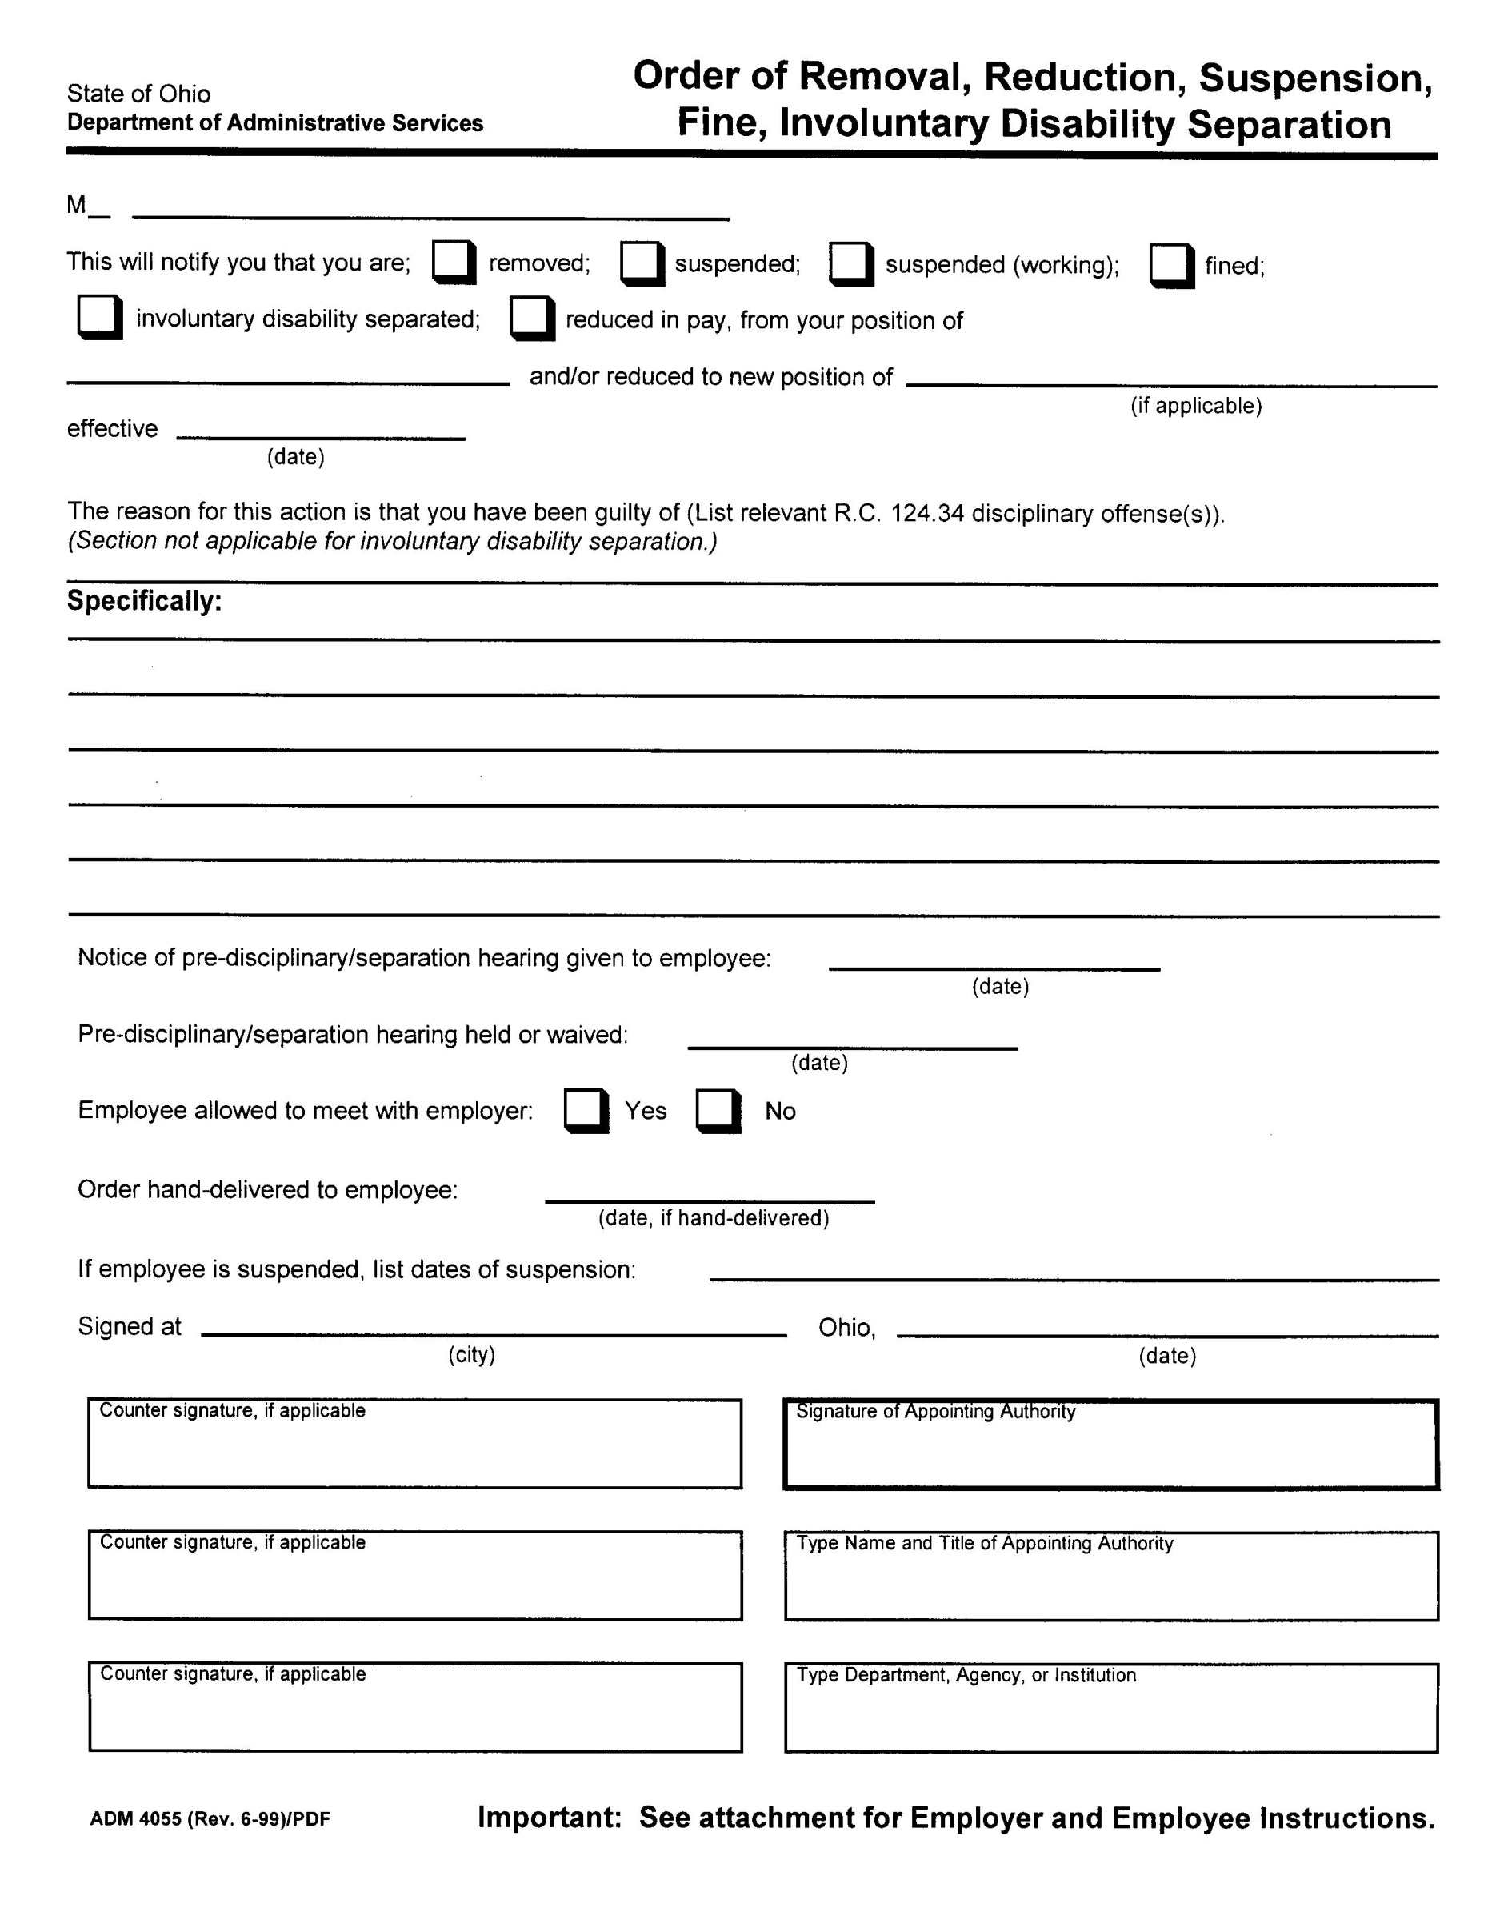
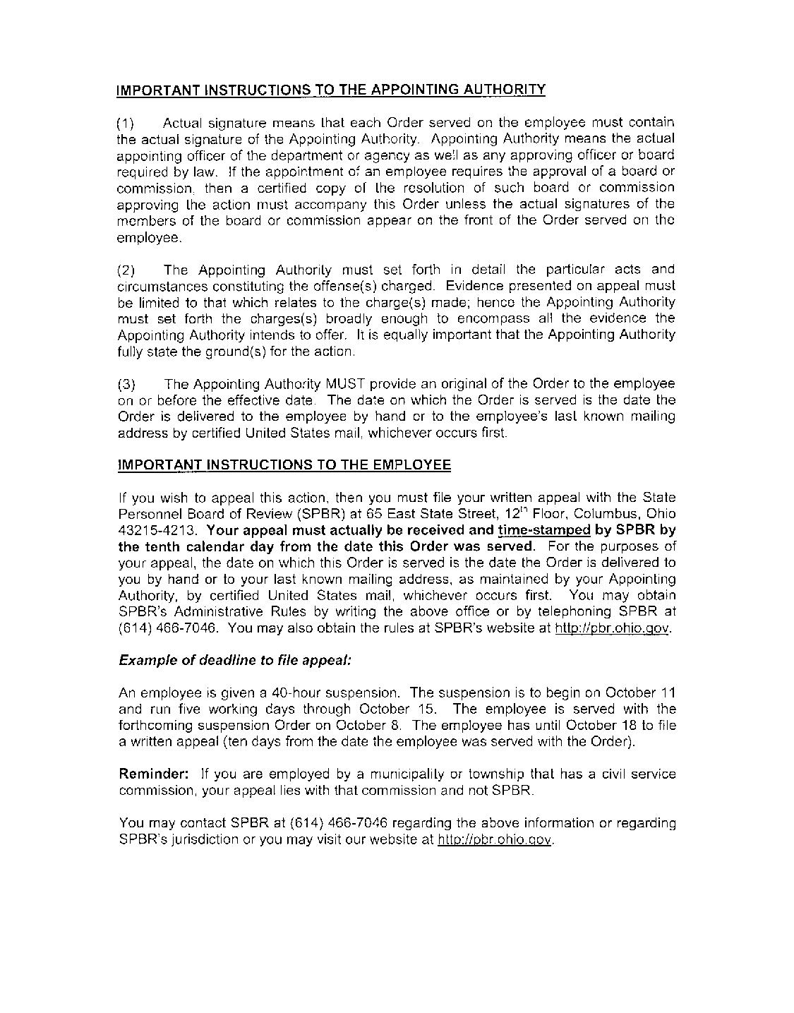

STATE OF OHIO
STATE PERSONNEL BOARD OF REVIEW
Appellant

Name: _____________________________________________________

Address: ___________________________________________________

City: __________________________ State: ______ ZIP: ____________

Telephone: _________________________________________________

Email Address: ______________________________________________

vs.
Appellee

Agency/Dept: _______________________________________________

Address: ___________________________________________________

City: __________________________ State: ______ ZIP: ____________

Telephone: _________________________________________________

NOTICE OF APPEAL

Notice is hereby given that Appellant appeals to the State Personnel Board of Review from the Order or Notice of:

Removal | Layoff | Reduction in Pay or Position
Transfer | Abolishment | Fine
Investigation | Reclassification | Involuntary Disability Separation
Other: | Suspension : ( one) | Retaliatory Discipline: ( one)
__________ | Working | Whistleblower
 | Non-Working | OSHA
 | _____ # of days

Which was received on (specify date): __________________________________________

And which was effective on (specify date): ______________________________________

If Applicable

Attorney for Appellant: ________________________________________________

Address: ____________________________________________________________

City: __________________________ State: ______ ZIP: ____________________

Telephone: ______________________Fax: _______________________________

Email Address: _______________________________________________________

TERMINATION CHECKLIST
- AT TERMINATION
  - Planning for the Termination:
    - Investigate and determine the reasons for the termination decision
    - Policy should explain who is responsible for termination decisions
    - Have all termination decisions thoroughly researched by legal counsel or SPHR
    - Determine if any possible claims exist or problems are present
    - Have two persons present during termination decision
    - Have documentation of decision and outline of exit interview prepared.
  - Severance:
    - Is this needed?
      - Can avoid litigation when used appropriately.
      - Consider in all possible ADEA cases.
    - Benefits to employee to consider:
      - Lump sum or salary continuation?
      - Pay out sick and vacation?
      - Reference letter?
      - Provision for insurance and retirement benefits
      - Outplacement services?
      - Company property returned?
      - Contest unemployment?
      - Forgiveness of debt?
    - Benefits to Employer:
      - Waiver of reinstatement and future litigation
      - Release of any and all claims against company
      - Confidentiality provision
      - Non-compete clause?
      - Non-solicitation clause?
      - Damages for breach by employee?
    - Always offer time for employee to have legal review of severance conducted (required if employee is over 40)

    - Always have these prepared by legal counsel!
  - Exit Interview
    - Tips:
      - Be direct and to the point (give business reason for decision)
      - Advise employee that decision is final
      - Treat employee fairly and with dignity
      - Avoid confrontation
      - Explain benefits (COBRA notice)
      - Offer/explain severance (if applicable)
      - Keep meeting short
      - Include witnesses during interview
  - Unemployment Compensation
    - Remember that you may still incur costs even after an employee is terminated due to the employee’s receipt of unemployment compensation.
    - Purpose of Unemployment is to serve as a “safety net” for the unemployed individual who is actively seeking employment. The program is designed to be pro-employee.
    - Unless employer can prove “just cause” for their removal of the employee, the employee will be entitled to benefits.
    - Hearings last 45 minutes

Section II

Discrimination and Harassment
Accuser Questions 33
Internal Complaint Form 35
Questions to Ask the Alleged Harasser 37

Meeting With: ___________________________________Date: ___________________
Meeting Conducted By: _________________________________________________________
______________________________________________________________________________
Introduction:
Appreciate EEs time & cooperation.
Nature of what we are investigating.
Matter under investigation is serious, and the department has a commitment/obligation to investigate this claim.
No conclusion will be made until all of the facts have been gathered and analyzed.
Any attempt to influence the outcome of the investigation by discussing it with others, retaliation against anyone who participates, providing false information or failure to be forthcoming can be the basis for corrective action up to and including termination.
Foundation Questions:
1. Who committed the alleged inappropriate behavior?
2. What exactly happened?
3. How did you react?
4. Did you ever indicate that you were offended or somehow displeased by the act or offensive treatment?
5. When did the incident occur or is it ongoing?
6. Where did the incident occur?
7. Who else may have seen or heard the incident?
8. Have you discussed the incident with anyone?
9. How has the behavior affected you and your job?
10. Did you seek any medical treatment or counseling as a result of the incident?
11. When did you first learn of the County’s Unlawful Harassment and EEO Policy? (If not provide a written copy of the policy and note below).
12. Is there anyone else who may have relevant information?
13. Do you have any other relevant information?
14. What action do you want the agency/office to take?

INTERNAL COMPLAINT FORM

- Name of complainant: Position title (if employee): Address (if non-employee):

2. Date of Incident: ___________________________________________

3. Is this a complaint of discrimination and/or harassment? If so, please tell us the type of discrimination/harassment alleged (check all that apply):

□Racial | □Religious |  | □Sex | □National Origin
□Color | □Disability |  | □Age | □ Harassment
□Other, please explain:

- Name(s) of individual(s) involved in the alleged incident:

- What occurred? Describe the nature of your complaint (add attachment if more space needed):

- Where did the incident occur?

- Please describe any adverse employment action which you believe has resulted from the alleged incident, if any:

- Potential Witnesses:

- Are there any other incidents involving this individual in which you either witnessed or were involved?

- What remedy are you requesting?

________________________________ ________________
Name Date
Meeting With: _______________________________ Date: ___________________
Meeting Conducted By:

__________________________________________________________________________
Introduction:
Appreciate employee’s time & cooperation.
Describe what we are investigating.
Matter under investigation is serious, and the department has a commitment/obligation to investigate this claim.
No conclusion will be made until all of the facts have been gathered and analyzed.
Any attempt to influence the outcome of the investigation by discussing it with others, retaliation against anyone who participates, providing false information or failure to be forthcoming can be the basis for corrective action up to and including termination.
Foundation Questions:
- Explain allegations that have been made.
- What is your response to the allegations?
- If you believe the allegations are false, why might the complainant lie?
- Are there any persons who have relevant information?
- Are there any notes, physical evidence, or other documentation regarding the incident(s)?
- Do you know of any other relevant information?

Section III

Ethics-Public Records

Ohio Ethics Commission – Financial Disclosure Statement/Instructions 39

Model Public Records Policy 54

Request to Redact Address 57

Request to Redact Personal Information 59

Social Security Administration – Consent for Release of Information 61
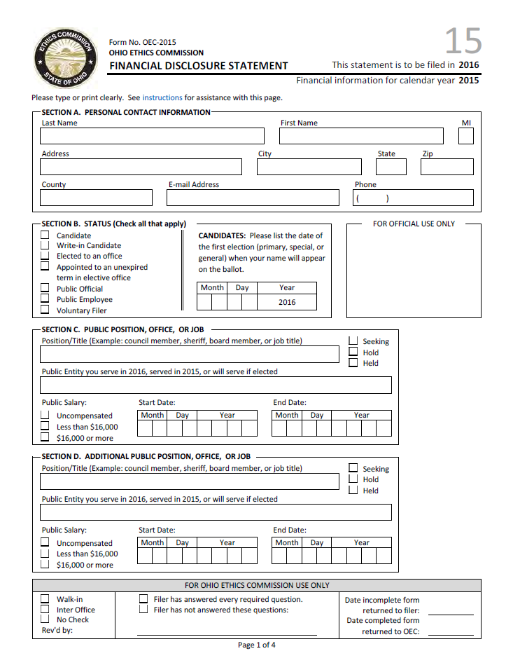
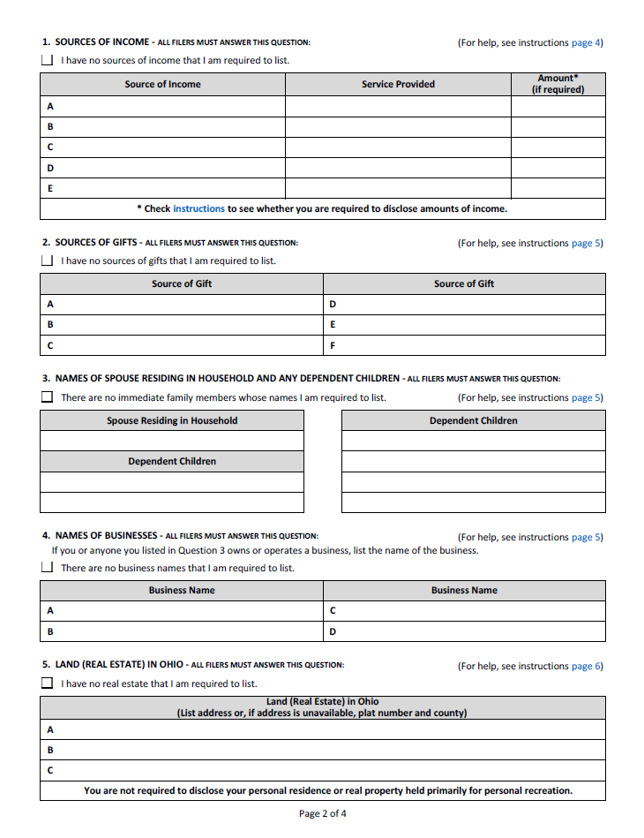
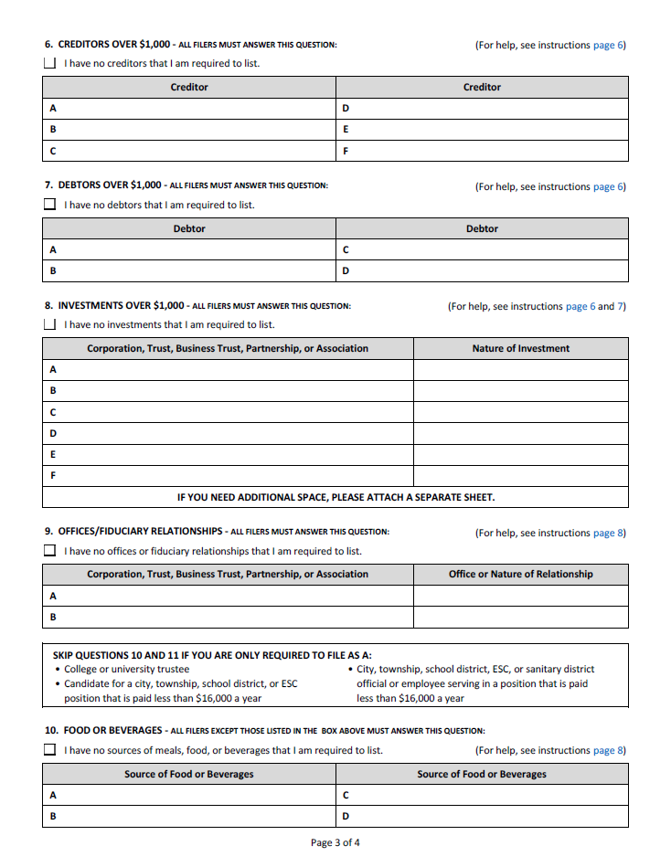
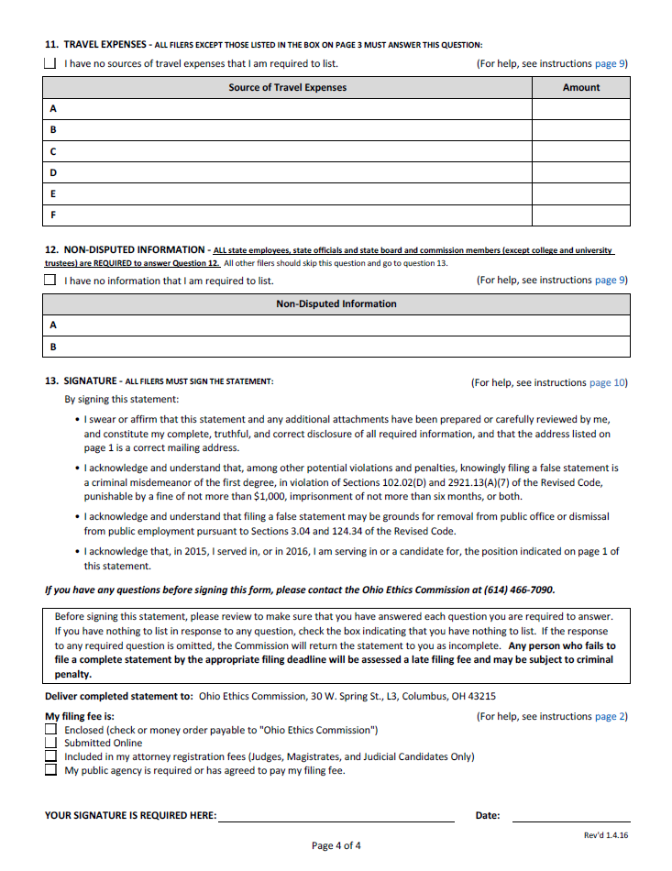
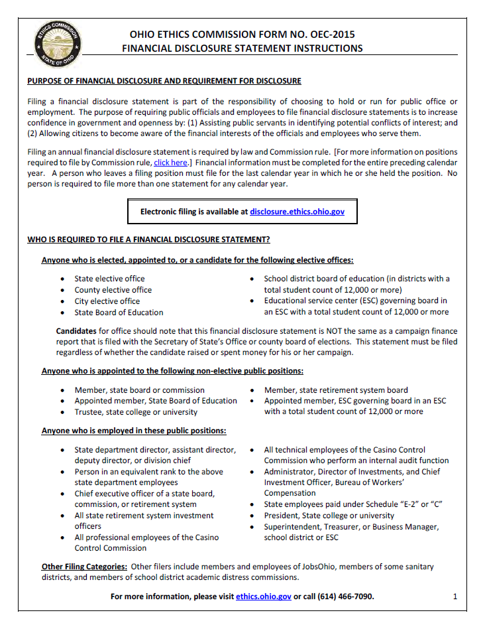
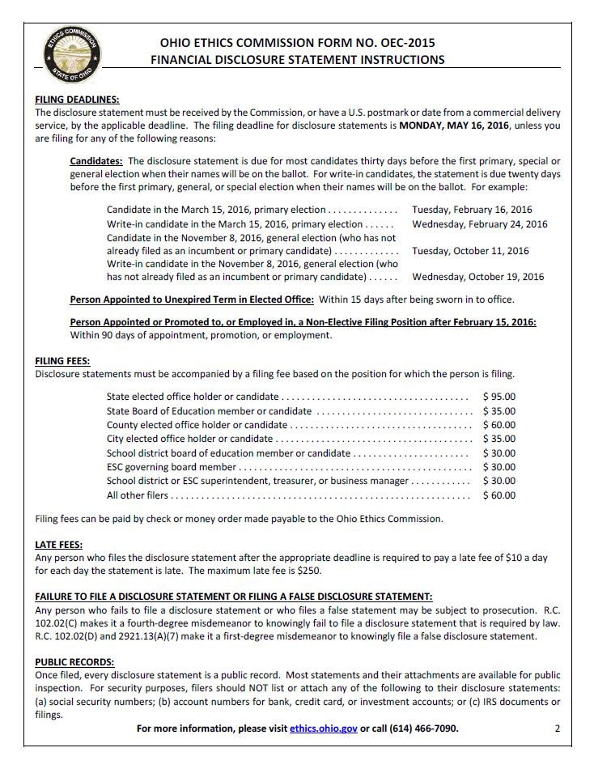
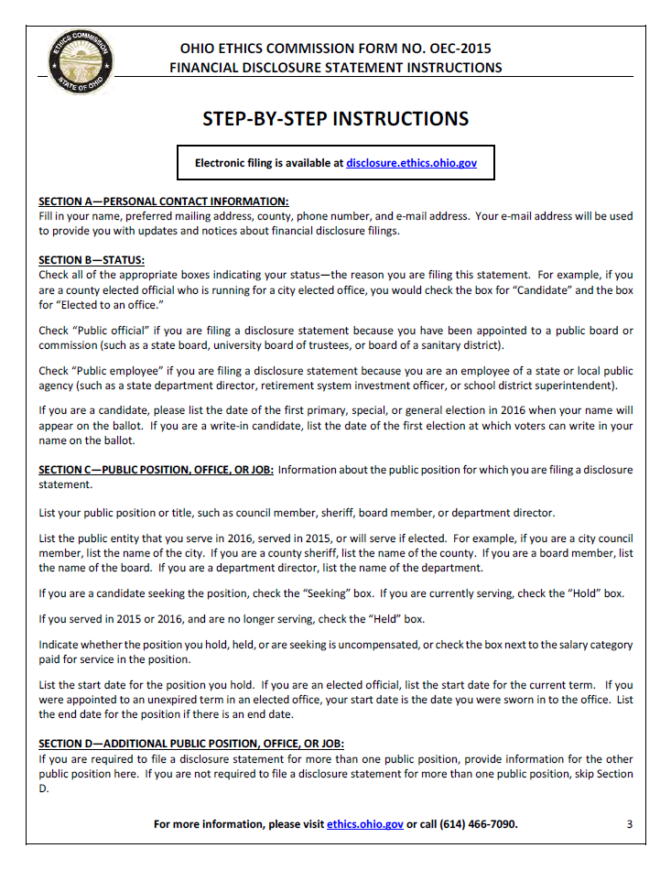
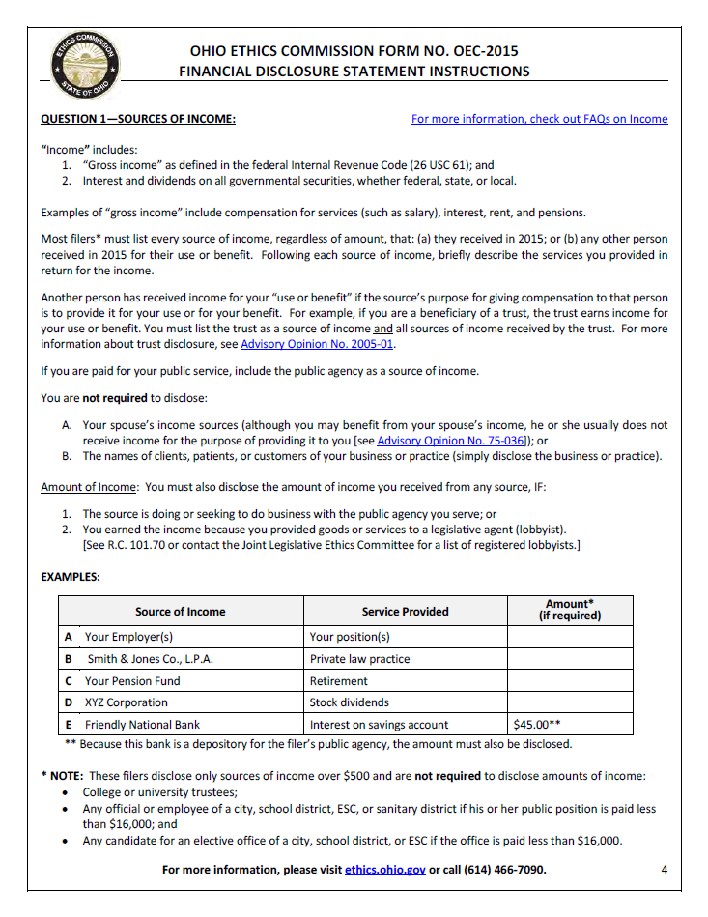
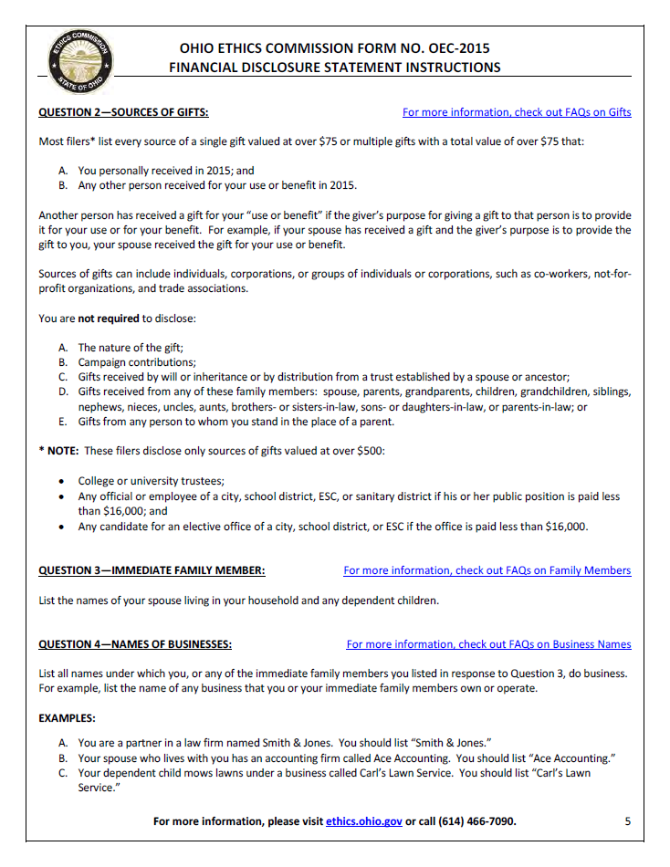
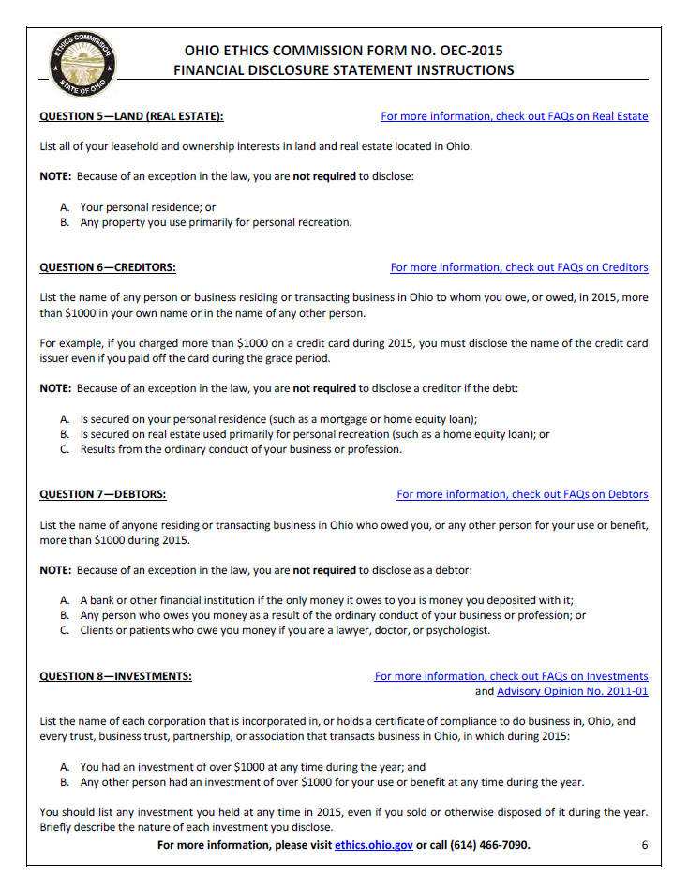
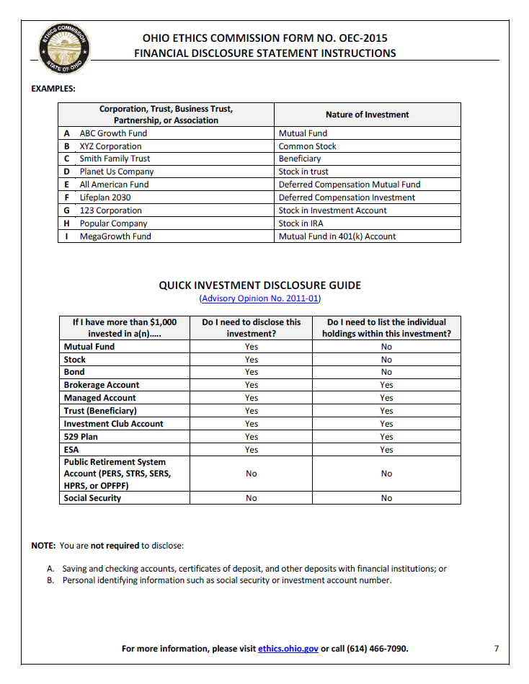
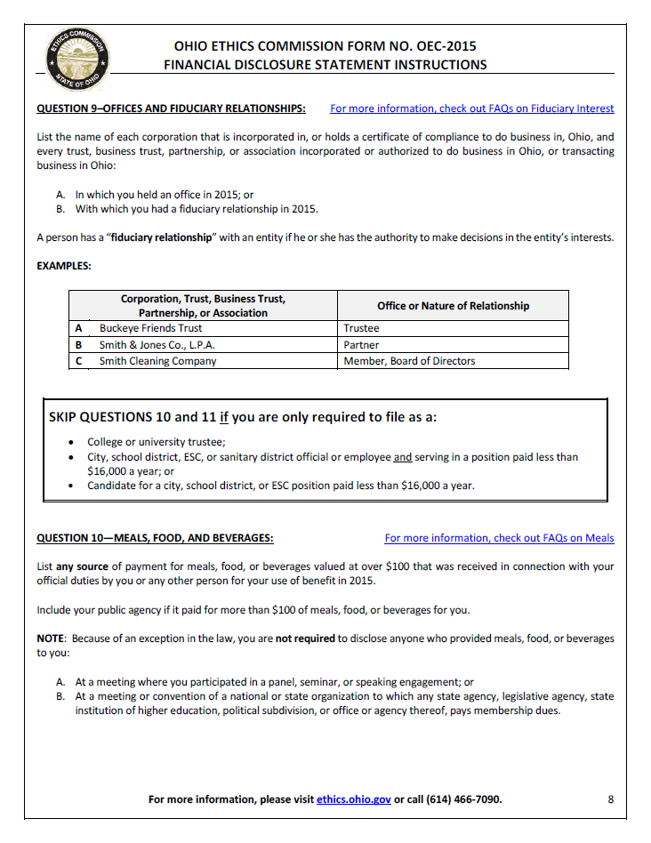
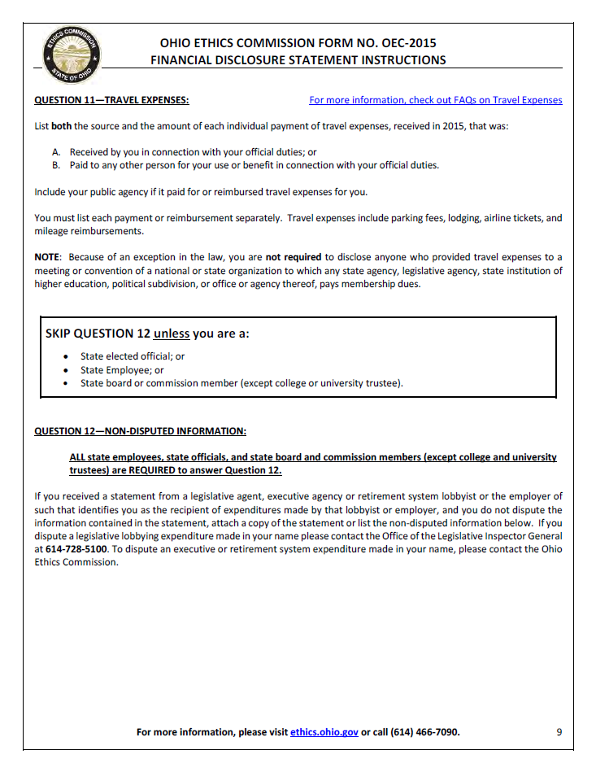
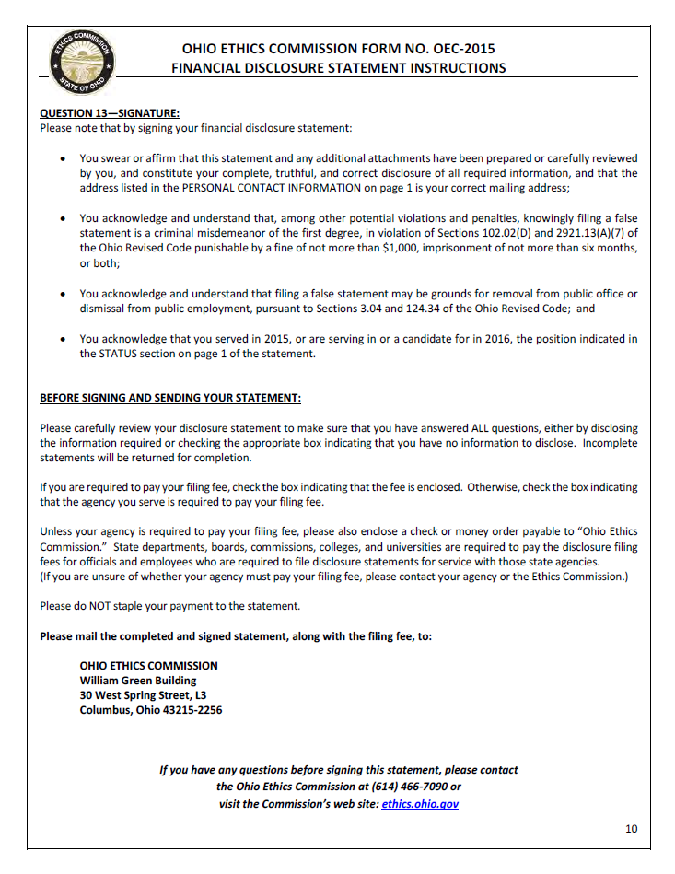
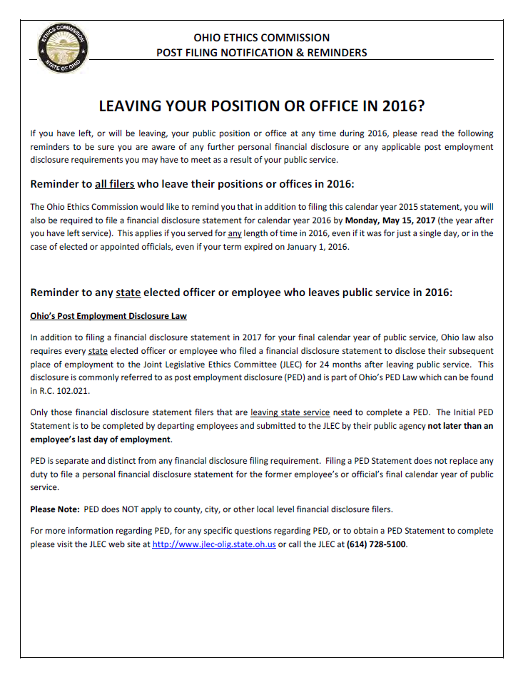
This Model Policy was created by the Ohio Attorney General’s Office and may be found at www.ohioattorneygeneral.gov

MODEL PUBLIC RECORDS POLICY
MISSION STATEMENT
Openness leads to a better informed citizenry, which leads to better government and better public policy. Consistent with the premise that government at all levels exists first and foremost to serve the interests of the people, it is the mission and intent of [public office] to at all times fully comply with and abide by both the spirit and the letter of Ohio’s Public Records Act.

DEFINING PUBLIC RECORDS

All records kept by [public office] are public unless they are exempt from disclosure under Ohio law. All public records must be organized and maintained in such a way that they can be made available for inspection and copying.

A record is defined to include the following: A document in any format
– paper, electronic (including, but not limited to, business e-mail) – that is created, received by, or comes under the jurisdiction of [public office] that documents the organization, functions, policies, decisions, procedures, operations, or other activities of the office.

RESPONSE TIMEFRAME

Public records are to be available for inspection during regular business hours, with the exception of published holidays. Public records must be made available for inspection promptly. Copies of public records must be made available within a reasonable period of time. “Prompt” and “reasonable” take into account the volume of records requested; the proximity of the location where the records are stored; and the necessity for any legal review and redaction of the records requested.

It is the goal of [public office] that all requests for public records should be acknowledged in writing or, if possible, satisfied within [X] business days following the office’s receipt of the request.

HANDLING REQUESTS

No specific language is required to make a request for public records. However, the requester must at least identify the records with sufficient clarity to allow the office to identify, retrieve, and review the records. If it is not clear what records are being sought, the office must contact the requester for clarification, and should assist the requester in revising the request by informing the requester of the manner in which the office keeps its public records.

The requester does not have to put a records request in writing, and does not have to provide his or her identity or the intended use of the requested public record. It is this office’s general policy that this information is not to be requested. However, the law does permit the office to ask for a written request, the requestor’s identity, and/or the intended use of the information requested, but only (1) if a written request or disclosure of identity or intended use would benefit the requestor by enhancing the office’s ability to identify, locate, or deliver the public records that have been requested; and (2) after telling the requestor that a written request is not required and that the requester may decline to reveal the requestor’s identity or intended use.

In processing the request, the office does not have an obligation to create new records or perform new analysis of existing information. An electronic record is deemed to exist so long as a computer is already programmed to produce the record through simple sorting, filtering, or querying. Although not required by law, the office may accommodate the requestor by generating new records when it makes sense and is practical under the circumstances.

In processing a request for inspection of a public record, an office employee must accompany the requester during inspection to make certain original records are not taken or altered.

A copy of the most recent edition of the Ohio Sunshine Laws manual is available via the Attorney General’s internet website (www.ohioattorneygeneral.gov) for the purpose of keeping employees of the office and the public educated as to the office’s obligations under the Ohio Public Records Act, Open Meetings Act, records retention laws and Personal Information Systems Act.

ELECTRONIC RECORDS

Records in the form of e-mail, text messaging, and instant messaging, including those sent and received via a hand-held communications device (such as a Blackberry) are to be treated in the same fashion as records in other formats, such as paper or audiotape.

Public record content transmitted to or from private accounts or personal devices is subject to disclosure. All employees or representatives of this office are required to retain their e-mail records and other electronic records in accordance with applicable records retention schedules.

DENIAL OR REDACTION OF RECORDS

If the requester makes an ambiguous or overly broad request or has difficulty in making a request for public records, the request may be denied, but the denial must provide the requester an opportunity to revise the request by informing the requester of the manner in which records are maintained and accessed by the office.

Any denial of public records requested must include an explanation, including legal authority. If the initial request was made in writing, the explanation must also be in writing. If portions of a record are public and portions are exempt, the exempt portions may be redacted and the rest released. When making public records available for public inspection or copying, the office shall notify the requestor of any redaction or make the redaction plainly visible. If there are redactions, each redaction must be accompanied by a supporting explanation, including legal authority.

COPYING AND MAILING COSTS

Those seeking public records may be charged only the actual cost of making copies, not labor. The charge for paper copies is [X] cents per page. The charge for electronic files downloaded to a compact disc is [X] per disc.

A requester may be required to pay in advance for costs involved in providing the copy. The requester may choose whether to have the record duplicated upon paper, upon the same medium in which the public record is kept, or upon any other medium on which the office determines that the record can reasonably be duplicated as an integral part of the office’s normal operations.

If a requester asks that documents be mailed, he or she may be charged the actual cost of the postage and mailing supplies. There is no charge for documents e-mailed.

MANAGING RECORDS

[Public office] records are subject to records retention schedules. The office’s current schedules are available at [location], a location readily available to the public as required by §149.43(B)(2), Ohio Revised Code.

REQUEST TO REDACT ADDRESS
Pursuant to O.R.C. 149.45(D)(1), a peace officer, parole officer, probation officer, bailiff, prosecuting attorney, assistant prosecuting attorney, correctional employee, community-based correctional facility employee, youth services employee, firefighter, EMT or Bureau of Criminal Identification and Investigation investigator may file this form with a public office, other than a county auditor’s office, to request that the address* of the person making the request be redacted from any record made available by that office to the public on the internet. *For purposes of this law, “address” is defined as “actual personal residence” by O.R.C. 149.43(A)(7)(a). This form is required to “include a place to provide any information that identifies the location of the address [of the individual] to be redacted.” O.R.C. 149.45 (D)(4). If redaction is not practible, the public office shall, within five business days after receiving the written request, explain to the individual why the redaction is impractible. O.R. C. 149.45(D)(2)
Instructions:

Complete entire form below and send directly to the public office that maintains the records to be redacted. Each individual requesting redaction is required to send the completed form to the appropriate public office. The Ohio Attorney General will not forward requests on behalf of the requesting individual.
- The Ohio Attorney General is not required or permitted to review and/or approve a request for redaction.

I, , request that the office of
(print full name) (print full name of public office)

redact the address of my actual personal residence from any record made available to the general public on the internet that includes my residential and familial information.
Requester is currently employed as a (Check only the ONE that applies):
☐ | Peace Officer ☐ Assistant Attorney | Prosecuting ☐ | Firefighter | ☐ | Probation Officer
☐ | BCI&I Investigator ☐ Correctional Employee ☐ |  | EMT | ☐ | Bailiff

Prosecuting Attorney ☐ Youth Services Employee ☐ Parole Officer ☐ Community-Based
Correctional Facility Employee
(Use separate forms if Requester is currently employed and/or commissioned in more than one category.)

To verify employment or commission status, please provide:
Employer: Employer Address/Contact Information:
For each known instance, please identify the location of your actual personal residential address within any record made available by this office to the public on the internet:
Document Title and Description:
Specific Web Address (URL):
Location Within Document of Address to be Redacted:
(Use the second page of this form to identify additional locations of address to be redacted)

Signature of Requester:________________________________ Date______________

If a requested redaction is impractible, we will provide you with an explanation within five (5) business days after receiving your written request. Please provide contact information below, or indicate that you will contact this office to receive an explanation.
Address:

Telephone Number: ( )
E-mail Address:

I do not wish to provide contact information. I will contact the office for an explanation.
Date Request Received / / (To be completed by the public office)
*This document is a public record, and the information you provide may be released in response to a public records request.*

Request to Redact Address
Page 2
Document Title and Description:
Specific Web Address (URL):
Location Within Document of Address to be Redacted:

Document Title and Description:
Specific Web Address (URL):
Location Within Document of Address to be Redacted:

Document Title and Description:
Specific Web Address (URL):
Location Within Document of Address to be Redacted:

Document Title and Description:
Specific Web Address (URL):
Location Within Document of Address to be Redacted:

Document Title and Description:
Specific Web Address (URL):
Location Within Document of Address to be Redacted:

Document Title and Description:
Specific Web Address (URL):
Location Within Document of Address to be Redacted:

Document Title and Description:
Specific Web Address (URL):
Location Within Document of Address to be Redacted:

REQUEST TO REDACT PERSONAL INFORMATION
Under paragraph 149.45(C)(1) of the Ohio Revised Code, an individual may request that a public office or a person responsible for a public office’s public records redact specified types of personal information of that individual from any record made available to the general public on the internet. An individual who makes a request for redaction “shall…provide any information that identifies the location of that personal information within a document that contains that personal information.” O.R.C. 149.45(C)(1) If redaction is not practicable, the public officer or person responsible for the public office’s public records shall verbally or in writing within five business days after receiving the written request explain to the individual why the redaction is impracticable. O.R.C. 149.45 (C) (3)
I, request that the
(Print full name)
Office of redact the following items of personal information from being made available to the public on the Internet:

(Please check all that apply)

Social security number
Checking account number
Tax identification number
Savings account number
Driver’s license number
Credit card number

State identification number as issued by the Ohio Bureau of Motor Vehicles

For each item of personal information checked above, please identify the location of that information within any record made available by this office to the public on the internet:
Document Title and Description:
Specific Web Address (URL):
Location of information within document:
(Use the back of this form to identify additional locations of personal information items) Signature of Requester:

The public office may need to contact you:
- To request additional information to locate your specific personal information to be redacted or to identify the appropriate public office responsible for redacting your personal information.
- To provide you with an explanation within five (5) business days after receiving your written request, if a requested redaction is impracticable. Please provide contact information below, or indicate that you will contact this office to receive any explanation. This form is a public record, and the information you provide may be released in response to a public records request.

Address:

Telephone Number (_____) _________ Email Address: _______________________
I do not wish to provide contact information. I will contact the office for any explanation.

Date Request Received / / (To be completed by the public office)

Document Title and Description:
Specific Web Address (URL):
Location of information within document:

Document Title and Description:
Specific Web Address (URL):
Location of information within document:

Document Title and Description:
Specific Web Address (URL):
Location of information within document:

Document Title and Description:
Specific Web Address (URL):
Location of information within document:

Document Title and Description:
Specific Web Address (URL):
Location of information within document:

Document Title and Description:
Specific Web Address (URL):
Location of information within document:

Social Security Administration | Form Approved
Consent for Release of Information | OMB No. 0960-0566

Instructions for Using this Form

Complete this form only if you want us to give information or records about you, a minor, or a legally incompetent adult, to an individual or group (for example, a doctor or an insurance company). If you are the natural or adoptive parent or legal guardian, acting on behalf of a minor child, you may complete this form to release only the minor's non-medical records. We may charge a fee for providing information unrelated to the administration of a program under the Social Security Act.

NOTE: Do not use this form to:

- Request the release of medical records on behalf of a minor child. Instead, visit your local Social Security office or call our toll-free number, 1-800-772-1213 (TTY-1-800-325-0778), or

- Request detailed information about your earnings or employment history. Instead, complete and mail form SSA-7050-F4. You can obtain form SSA-7050-F4 from your local Social Security office or online at www.ssa.gov/online/ssa-7050.pdf.
How to Complete this Form

We will not honor this form unless all required fields are completed. An asterisk (*) indicates a required field. Also, we will not honor blanket requests for "any and all records" or the "entire file." You must specify the information you are requesting and you must sign and date this form. We may charge a fee to release information for non-program purposes.

- Fill in your name, date of birth, and social security number or the name, date of birth, and social security number of the person to whom the requested information pertains.

- Fill in the name and address of the person or organization where you want us to send the requested information.

- Specify the reason you want us to release the information.

- Check the box next to the type(s) of information you want us to release including the date ranges, where applicable.

- You, the parent or the legal guardian acting on behalf of a minor child or legally incompetent adult, must sign and date this form and provide a daytime phone number.

- If you are not the individual to whom the requested information pertains, state your relationship to that person. We may require proof of relationship.
PRIVACY ACT STATEMENT

Section 205(a) of the Social Security Act, as amended, authorizes us to collect the information requested on this form. We will use the information you provide to respond to your request for access to the records we maintain about you or to process your request to release your records to a third party. You do not have to provide the requested information. Your response is voluntary; however, we cannot honor your request to release information or records about you to another person or organization without your consent. We rarely use the information provided on this form for any purpose other than to respond to requests for SSA records information. However, the Privacy Act (5 U.S.C. § 552a(b)) permits us to disclose the information you provide on this form in accordance with approved routine uses, which include but are not limited to the following:

1.To enable an agency or third party to assist Social Security in establishing rights to Social Security benefits and or coverage; 2.To make determinations for eligibility in similar health and income maintenance programs at the Federal, State, and local level; 3.To comply with Federal laws requiring the disclosure of the information from our records; and,

4.To facilitate statistical research, audit, or investigative activities necessary to assure the integrity of SSA programs.

We may also use the information you provide when we match records by computer. Computer matching programs compare our records with those of other Federal, State, or local government agencies. We use information from these matching programs to establish or verify a person's eligibility for Federally-funded or administered benefit programs and for repayment of incorrect payments or overpayments under these programs. Additional information regarding this form, routine uses of information, and other Social Security programs is available on our Internet website, www.socialsecurity.gov, or at your local Social Security office.
PAPERWORK REDUCTION ACT STATEMENT

This information collection meets the requirements of 44 U.S.C. § 3507, as amended by section 2 of the Paperwork Reduction Act of 1995. You do not need to answer these questions unless we display a valid Office of Management and Budget control number. We estimate that it will take about 3 minutes to read the instructions, gather the facts, and answer the questions. SEND

OR BRING THE COMPLETED FORM TO YOUR LOCAL SOCIAL SECURITY OFFICE. You can find your local Social Security office through SSA's website at www.socialsecurity.gov. Offices are also listed under U.S. Government agencies in your telephone directory or you may call 1-800-772-1213 (TYY 1-800-325-0778). You may send comments on our time estimate above to: SSA, 6401 Security Blvd., Baltimore, MD 21235-6401. Send only comments relating to our time estimate to this address, not the completed form.

Form SSA-3288 (07-2013) EF (07-2013) Destroy Prior Editions

*I want this information released because:
We may charge a fee to release information for non-program purposes.
*Please release the following information selected from the list below:
You must specify the records you are requesting by checking at least one box. We will not honor a request for "any and all records" or "my entire file." Also, we will not disclose records unless you include the applicable date ranges where requested.
*ADDRESS OF PERSON OR ORGANIZATION:

*My Social Security Number
You must complete all required fields. We will not honor your request unless all required fields are completed. (*signifies a required field).
TO: Social Security Administration

*NAME OF PERSON OR ORGANIZATION:
*My Full Name *My Date of Birth (MM/DD/YYYY)
I authorize the Social Security Administration to release information or records about me to:

Social Security Administration
Social Security Administration
Consent for Release of Information

1. Social Security Number
2. Current monthly Social Security benefit amount
3. Current monthly Supplemental Security Income payment amount
4. My benefit or payment amounts from date _____ to date _______
5. My Medicare entitlement from date ______ to date _________
6. Medical records from my claims folder(s) from date _______ to date_____
If you want us to release a minor child’s medical records, do not use this form. Instead, contact your local Social Security office.
7. Complete medical records from my claims folder(s).
8. Other records from my file (you must specify the records you are requesting, e.g. doctor report, application, determination or questionnaire).

I am the individual, to whom the requested information or record applies, or the parent or legal guardian of a minor, or the legal guardian of a legally incompetent adult. I declare under penalty of perjury (28 CFR § 16.41(d)(2004)) that I have examined all the information on this form, and any accompanying statements or forms, and it is true and correct to the best of my knowledge. I understand that anyone who knowingly or willfully seeks or obtain access to records about another person under false pretenses is punishable by a fine of up to $5,000. I also understand that I must pay all applicable fees for requesting information for a non-program-related purpose.

*Signature: |  |  | *Date:
*Address:
Relationship (if not the subject of the record): |  |  | *Daytime Phone:

Witnesses must sign this form ONLY if the above signature is by mark (X). If signed by mark (X), two witnesses to the signing who know the signee must sign below and provide their full addresses. Please print the signee's name next to the mark (X) on the signature line above.
1.Signature of witness | 2.Signature of witness
Address(Number and street,City,State, and Zip Code) | Address(Number and street,City,State, and Zip Code)
Form SSA-3288 (07-2013) EF (07-2013)

Section IV

Hiring
Application for Employment 64
Consent to Conduct Background Investigation and Release 68
Request for Copy of Background Check Procedures 69
Ohio Bureau of Criminal Investigation - Civilian Background Check Procedures 70
Ohio Bureau of Criminal Investigation – BCI Reason Fingerprint Codes 71
Sample Pre-Employment Drug Testing Consent Form 74
Equal Employment Opportunity Poster 75
Application for Employment
Return to: ___________________
Equal access to programs, services and employment is available to all persons. Those applicant requiring accommodation to the application and/or interview process should notify the Human Resources Department. We consider all applicants for all positions without regard to race, color, religion, creed, gender, national origin, age, disability, marital or veteran status, or any other legally protected status.
Position(s) applied for: ___________________________________________________________
Date of Application: _____________
How did you hear about the position?
Advertisement: ___ Relative: ___ Inquiry: ___ Website: ___ Friend: ___
Employment Agency___ Other: ____________________________________________
Name : ____________________________________________________________________________________
Last First Middle

Mailing Address:_____________________________________________________________________________
Street Apt. City State Zip

Telephone #: (_________)______________________ Mobile/Other: (__________) ________________________

E-mail: _____________________________________ Best time to contact you at home is: ____am / pm

Have you ever submitted an application to (County Name)? _________ If Yes, when?_______________________

Have you ever been employed by (County Name)? _________ If Yes, when?______________________________

Are you legally eligible for employment in the United States?____________________________________________

If you are under 18, can you furnish a work permit? __________
Do you have a valid driver’s license? __________ State / Number: _______________________________________

Are you able to meet all of the attendance requirements of this position? ___________________________________

Are you able to work overtime if necessary? _________ Will you travel if the position requires it? _____________

Do you have any friends / relatives currently employed by_____County?___________________________________

If Yes, who? _____________________________________________________________________________________________

What is your desired salary range or rate of pay: $ ______________________ per __________________________

Date available for work: __________________
Type of employment desired: ◻ Full Time ◻ Part Time ◻ Seasonal
Employment History: Starting with your most recent employer, provide the following information. Include any relevant volunteer activities, but exclude any organizations that would reveal race, color, religion, sex, national origin, citizenship, age, mental or physical disabilities, veteran/reserve National Guard or any other similarly protected status.
1. From/To___________________ Employer/Organization___________________________________________________

Telephone # ________________ Address_________________________________________________________________

Job Title:___________________ Supervisor_______________________________________ May We Contact?________

Job Duties/Responsibilties_____________________________________________________________________________

Reason for Leaving________________________________________________ Final Rate of Pay: ___________________

2. From/To___________________ Employer/Organization___________________________________________________

Telephone # ________________ Address_________________________________________________________________

Job Title:___________________ Supervisor_______________________________________ May We Contact?________

Job Duties/Responsibilties_____________________________________________________________________________

Reason for Leaving________________________________________________ Final Rate of Pay: ___________________

3. From/To___________________ Employer/Organization___________________________________________________

Telephone # ________________ Address_________________________________________________________________

Job Title:___________________ Supervisor_______________________________________ May We Contact?________

Job Duties/Responsibilties_____________________________________________________________________________

Reason for Leaving________________________________________________ Final Rate of Pay: ___________________

4. From/To___________________ Employer/Organization___________________________________________________

Telephone # ________________ Address_________________________________________________________________

Job Title:___________________ Supervisor_______________________________________ May We Contact?________
Job Duties/Responsibilties_____________________________________________________________________________
Reason for Leaving________________________________________________ Final Rate of Pay: ___________________

Please Explain Any Gaps In Employment:
_______________________________________________________________
_______________________________________________________________
Have you ever been fired or asked to resign from a job? ___________________________________________
If yes, please explain _______________________________________________________________
_______________________________________________________________
_______________________________________________________________
EDUCATION

 | Name and Address of School | Course of Study | Years Completed | Diploma/Degree  Obtained
High School

Undergraduate
College

Graduate
Professional

Other (specify)

Related Information: Please list any relevant professional or trade organizations of which you are a member. Exclude memberships that would reveal race, color, religion, sex, national origin, citizenship, age, mental or physical disabilities, veteran/reserve National Guard or any other similarly protected status.
Organization | Offices Held

Please discuss your interest in employment with ___________ County and any qualifications beyond what is reflected in your application. Use additional sheets if needed.
_________________________________________________________________________________________________________________________________________________________________________________________________________________________________________________________________________________________________________________________________________________________
References: Please provide the names and telephone numbers of three professional references who are not related to you and are not previous supervisors. If professional references are not available, provide school or personal references who are not related to you.
Name: ________________________________________________ Title: _____________________
Relationship: ____________________ Telephone: _______________________________________
Email: __________________________________________

Name: ________________________________________________ Title: _____________________
Relationship: ____________________ Telephone: _______________________________________
Email: __________________________________________

Name: ________________________________________________ Title: _____________________
Relationship: ____________________ Telephone: _______________________________________
Email: __________________________________________
Applicant Statement and Signature:
I certify that all information I have provided in order to apply for and obtain employment with _______ County is true, complete, and correct. I agree and understand that omissions, misstatements, and falsifications will cause forfeiture on my part of all eligibility to any employment with _______ County and may be cause for rejection of this application, removal of my name from eligibility lists, or discharge from County service, whenever it is discovered. I give _______ County the right to investigate and verify any information obtained through the application process. Permission is granted and I release from any and all liability any employer, agency or individual assisting _______ County in providing relevant, job-related information that will assist in this process. I expressly authorize, without reservation, _______ County, its representatives, members or agents to contact and obtain information from all references (personal and professional), employers, public agencies, licensing authorities and educational institutions and to otherwise verify the accuracy of all information provided by me in this application. I hereby waive any and all rights and claims I may have regarding _______ County, its agents, members or representatives, for seeking, gathering, and using such information and all other persons, corporations, or organizations for furnishing such information about me.

I understand that an offer of employment may be contingent upon the successful completion of a pre-employment background criminal investigation, physical, psychological, polygraph, and/or drug and alcohol screen. If employed, I agree to provide proof of identity, relevant licensure or credentials, and authorization for employment in the United States. If I am hired, I understand that, unless otherwise defined by applicable law, any employment relationship with _______ County is of an “at will” nature, which means that I am free to resign at any time and _______ County reserves the same right to terminate my employment at any time. This application does not constitute an agreement or contract for employment for any specified period or definite duration. I understand that all conditions of employment including, but not limited to hours, benefits and salary are subject to change by _______ County at any time. I understand that no representative of _______ County is authorized to make any assurances to the contrary and that no implied, oral or written agreements contrary to the foregoing express language are valid unless they are in writing and signed by the appropriate Appointing Authority.

DO NOT SIGN UNTIL YOU READ THE ABOVE APPLICANT STATEMENT.
I certify that I have read, fully understand, and accept all terms of the foregoing Applicant Statement.

Applicant Signature: ________________________________________________ Date: ____/_____/______

CONSENT TO CONDUCT BACKGROUND INVESTIGATION AND RELEASE

I hereby permit to conduct a background investigation, including my criminal history, concerning matters related to my application for employment. As a

result of this background investigation I understand that
will be seeking

information from prior employers and other individuals, including various law enforcement agencies, that I may or may not have disclosed. By signing this release, I hereby consent all prior employers, law enforcement agencies and educational institutions to provide necessary information to this employer during the background investigation. I hereby release, hold harmless and agree not to sue or file any claim of any kind against any current or former employer, law enforcement agency or educational institution, and any officer or employee of either, that in good-faith furnishes written or oral references as requested by this employer to complete its background investigation.

A photocopy or facsimile of this form that shows my signature is valid as an original.

Dated this _____ day of ________, 20___

________________________ _________________________
Witness Applicant

Civilian Identification
Office 877-224-0043
Fax 740-845-2633

P.O. Box 365
London, OH 43140
www.OhioAttorneyGeneral.gov

REQUEST FOR COPY OF BACKGROUND CHECK PROCEDURE
A request for a copy of a background check may only be submitted if the original background check was processed for working with children, working with the elderly, or certain types of licensing. If you are unsure if you are able to request a copy, please contact the Civilian Identification Dept. toll free at 877-224-0043 for further information.

You may only request a copy of the Ohio BCI background check. The FBI result is not permitted to be sent to any address other than what was requested at the time of the original background check. To obtain a new FBI result, a new FBI background check would have to be submitted.

A request for a copy of a background check must include the reason for processing of the original background check, as well as the individual’s name, social security number, date of birth, address to send the result and the individual’s signature.

The new background check result is valid for one year from the date of the original fingerprint submission.

If the request for copy is made within 30 days of the original background check there is no fee for processing and the request can be faxed to 740-845-2633. If the request for copy is made more than 30 days after the original background check the fee is $8 and is payable by money order, certified check, business check or personal check to Treasurer, State of Ohio. No cash will be accepted. The request and payment can be mailed to: BCI, PO Box 365, London Oh 43140.

Civilian Unit
Identification Department
Bureau of Criminal Identification & Investigation

Revised 3-30-12
Civilian Identification Office 877-224-0043
Fax 740-845-2633

P.O. Box 365 London, OH 43140
www.OhioAttorneyGeneral.gov

BCI CIVILIAN BACKGROUND CHECK PROCEDURES
- Use only the BCI Civilian Background Check card for the State of Ohio background check. A release from submission of electronic fingerprint form must be completed and submitted with the card.

- The fee for a BCI check is $22.00. A money order, certified check, business check or personal check made payable to: Treasurer, State of Ohio, must accompany the card if you do not have a billable agency code established with BCI. Cash or starter checks will not be accepted.

- If payment is being submitted with a card, 1AB002 must be written in the Agency Code box and the address the result is to be sent to must be written in the Send Background Check Results To box. If the card is being billed to an agency code, write the agency code in the Agency Code box and the result will be returned to the address for the agency code.

- Each fingerprint card must be completed with required information (i.e., social security number, date of birth, etc.) this information may be validated with a driver’s license or other photo I.D. All information should be typed or printed legibly.

- When taking fingerprints only fingerprinting ink should be used, and fingers should be rolled nail to nail.

- The Reason Fingerprinted field must be completed. Please check the appropriate box and specify the proper Ohio Revised Code section number that pertains to the reason fingerprinted if the box you check requires an Ohio Revised Code.

- If any of the aforementioned information is incomplete, fingerprint cards will be returned unprocessed. For questions regarding BCI civilian background checks, please call the Civilian Unit of BCI at 877-224-0043. Your cooperation is greatly appreciated.

Civilian Unit Identification Department
Bureau of Identification & Investigation

Revised 09/05/13

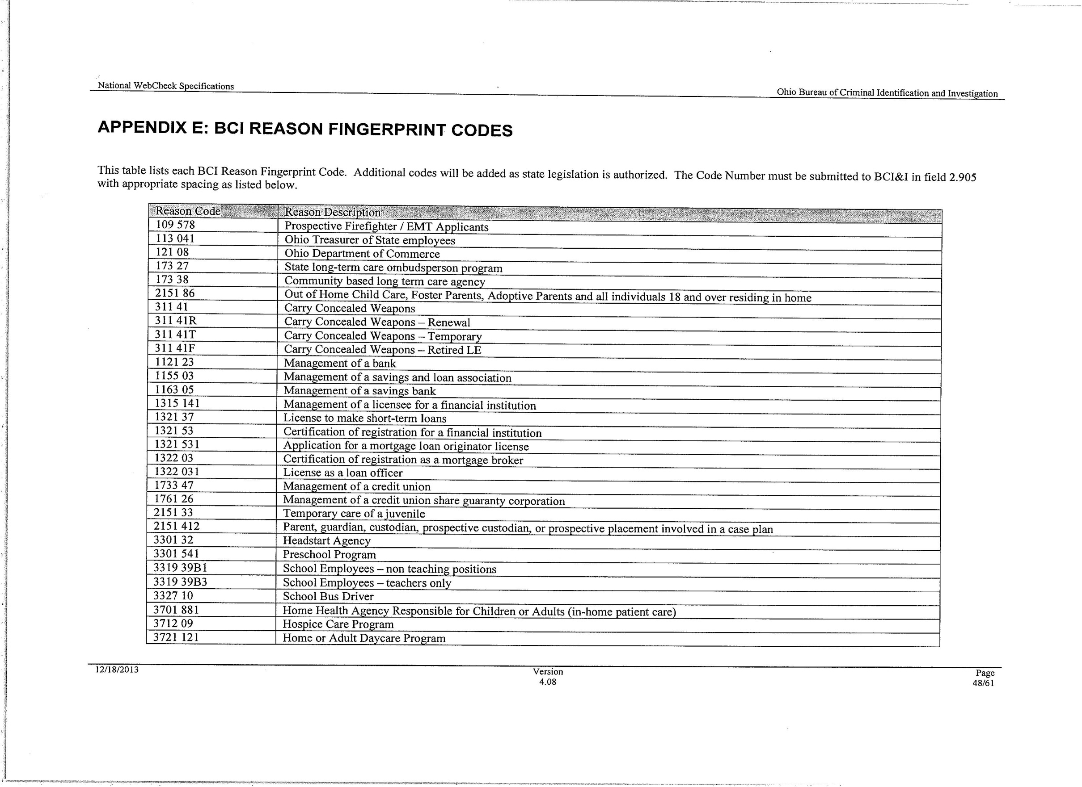
71
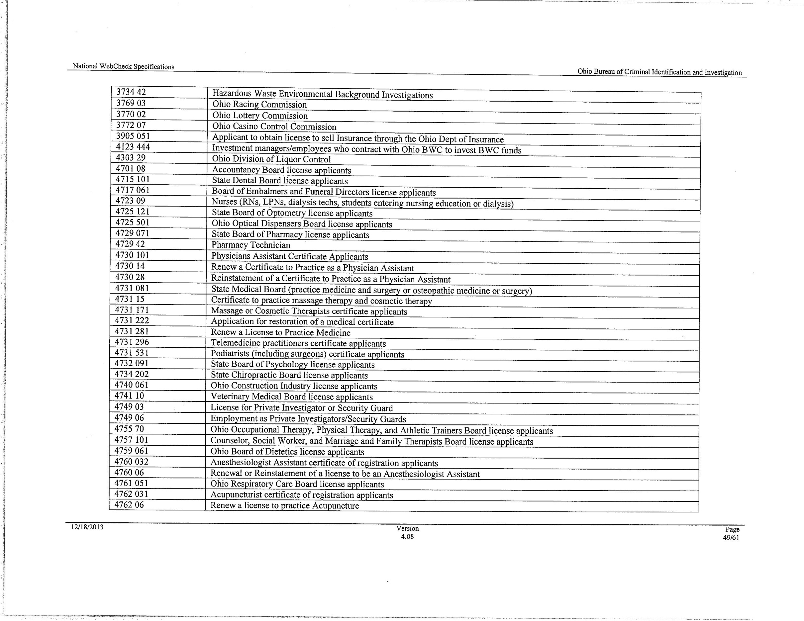
72
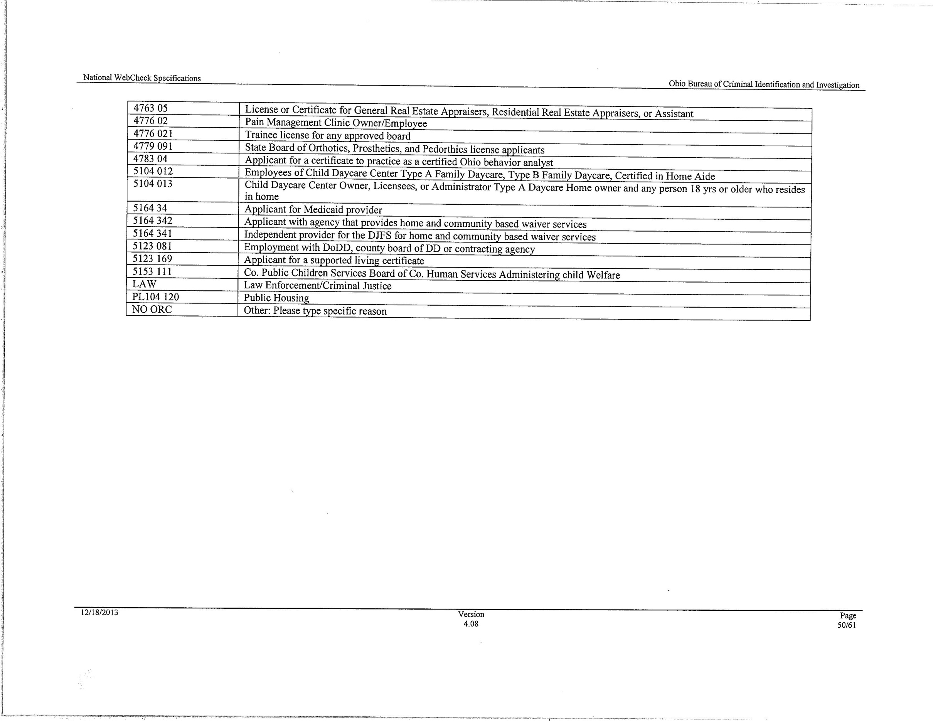
73
SAMPLE PRE-EMPLOYMENT DRUG TESTING CONSENT FORM

I understand that any offer of employment which may be made to me by the [PUBLIC ENTITY] is contingent upon my successfully passing a Drug Screening Test. I hereby give my consent to [PUBLIC ENTITY] to conduct a drug test that will be performed by a laboratory selected by [PUBLIC ENTITY], and which will provide for split sample testing. I also understand and agree that if the pre-employment Drug Screening Test indicates a violation of the Drug Testing Policy, any contingent job offer which may be or has been made to me will be null and void.

I further agree that in the event that the pre-employment Drug Screening Test indicates a violation of the Drug Testing Policy, I will have an opportunity to challenge this violation before [PUBLIC ENTITY HUMAN RESOURCES DEPARTMENT and/or appropriate department] by submitting a written request to the [APPROPRIATE DEPARTMENT] to review the record. I may submit additional written information that I believe to be appropriate to the [PUBLIC ENTITY] for consideration. Additionally, I may, at my cost, have the split sample referenced above tested to ensure the accuracy of the testing procedure. I understand that the decision of the [PUBLIC ENTITY HUMAN RESOURCES DEPARTMENT and/or appropriate department] shall be final.

Signature of Applicant _________________________ Date _____________________

Equal Employment Opportunity is THE LAW
Private Employers, State and Local Governments, Educational Institutions, Employment Agencies and Labor Organizations

Applicants to and employees of most private employers, state and local governments, educational institutions, employment agencies and labor organizations are protected under Federal law from discrimination on the following bases:

RACE, COLOR, RELIGION, SEX, NATIONAL ORIGIN
Title VII of the Civil Rights Act of 1964, as amended, protects applicants and employees from discrimination in hiring, promotion, discharge, pay, fringe benefits, job training, classification, referral, and other aspects of employment, on the basis of race, color, religion, sex (including pregnancy), or national origin. Religious discrimination includes failing to reasonably accommodate an employee’s religious practices where the accommodation does not impose undue hardship.
DISABILITY
Title I and Title V of the Americans with Disabilities Act of 1990, as amended, protect qualified individuals from discrimination on the basis of disability in hiring, promotion, discharge, pay, fringe benefits, job training, classification, referral, and other aspects of employment. Disability discrimination includes not making reasonable accommodation to the known physical or mental limitations of an otherwise qualified individual with a disability who is an applicant or employee, barring undue hardship.
AGE
The Age Discrimination in Employment Act of 1967, as amended, protects applicants and employees 40 years of age or older from discrimination based on age in hiring, promotion, discharge, pay, fringe benefits, job training, classification, referral, and other aspects of employment.
SEX (WAGES)
In addition to sex discrimination prohibited by Title VII of the Civil Rights Act, as amended, the Equal Pay Act of 1963, as amended, prohibits sex discrimination in the payment of wages to women and men performing substantially equal work, in jobs that require equal skill, effort, and responsibility, under similar working conditions, in the same establishment.
GENETICS
Title II of the Genetic Information Nondiscrimination Act of 2008 protects applicants and employees from discrimination based on genetic information in hiring, promotion, discharge, pay, fringe benefits, job training, classification, referral, and other aspects of employment. GINA also restricts employers’ acquisition of genetic information and strictly limits disclosure of genetic information. Genetic information includes information about genetic tests of applicants, employees, or their family members; the manifestation of diseases or disorders in family members (family medical history); and requests for or receipt of genetic services by applicants, employees, or their family members.
RETALIATION
All of these Federal laws prohibit covered entities from retaliating against a person who files a charge of discrimination, participates in a discrimination proceeding, or otherwise opposes an unlawful employment practice.
WHAT TO DO IF YOU BELIEVE DISCRIMINATION HAS OCCURRED
There are strict time limits for filing charges of employment discrimination. To preserve the ability of EEOC to act on your behalf and to protect your right to file a private lawsuit, should you ultimately need to, you should contact EEOC promptly when discrimination is suspected: The U.S. Equal Employment Opportunity Commission (EEOC), 1-800-669-4000 (toll-free) or 1-800-669-6820 (toll-free TTY number for individuals with hearing impairments). EEOC field office information is available at www.eeoc.gov or in most telephone directories in the U.S. Government or Federal Government section. Additional information about EEOC, including information about charge filing, is available at www.eeoc.gov.
Employers Holding Federal Contracts or Subcontracts
Applicants to and employees of companies with a Federal government contract or subcontract are protected under Federal law from discrimination on the following bases:
RACE, COLOR, RELIGION, SEX, NATIONAL ORIGIN
Executive Order 11246, as amended, prohibits job discrimination on the basis of race, color, religion, sex or national origin, and requires affirmative action to ensure equality of opportunity in all aspects of employment.
INDIVIDUALS WITH DISABILITIES
Section 503 of the Rehabilitation Act of 1973, as amended, protects qualified individuals from discrimination on the basis of disability in hiring, promotion, discharge, pay, fringe benefits, job training, classification, referral, and other aspects of employment. Disability discrimination includes not making reasonable accommodation to the known physical or mental limitations of an otherwise qualified individual with a disability who is an applicant or employee, barring undue hardship. Section 503 also requires that Federal contractors take affirmative action to employ and advance in employment qualified individuals with disabilities at all levels of employment, including the executive level.
DISABLED, RECENTLY SEPARATED, OTHER PROTECTED, AND ARMED FORCES SERVICE MEDAL VETERANS
The Vietnam Era Veterans’ Readjustment Assistance Act of 1974, as amended, 38 U.S.C. 4212, prohibits job discrimination and requires affirmative action to employ and advance in employment disabled veterans, recently separated veterans (within three years of discharge or release from active duty), other protected veterans (veterans who served during a war or in a campaign or expedition for which a campaign badge has been authorized), and Armed Forces service medal veterans (veterans who, while on active duty, participated in a U.S. military operation for which an Armed Forces service medal was awarded).
RETALIATION
Retaliation is prohibited against a person who files a complaint of discrimination, participates in an OFCCP proceeding, or otherwise opposes discrimination under these Federal laws.
Any person who believes a contractor has violated its nondiscrimination or affirmative action obligations under the authorities above should contact immediately:
The Office of Federal Contract Compliance Programs (OFCCP), U.S. Department of Labor, 200 Constitution Avenue, N.W., Washington, D.C. 20210, 1-800-397-6251 (toll-free) or (202) 693-1337 (TTY). OFCCP may also be contacted by e-mail at OFCCP-Public@dol.gov, or by calling an OFCCP regional or district office, listed in most telephone directories under U.S. Government, Department of Labor.
Programs or Activities Receiving Federal Financial Assistance
RACE, COLOR, NATIONAL ORIGIN, SEX
In addition to the protections of Title VII of the Civil Rights Act of 1964, as amended, Title VI of the Civil Rights Act of 1964, as amended, prohibits discrimination on the basis of race, color or national origin in programs or activities receiving Federal financial assistance. Employment discrimination is covered by Title VI if the primary objective of the financial assistance is provision of employment, or where employment discrimination causes or may cause discrimination in providing services under such programs. Title IX of the Education Amendments of 1972 prohibits employment discrimination on the basis of sex in educational programs or activities which receive Federal financial assistance.
INDIVIDUALS WITH DISABILITIES
Section 504 of the Rehabilitation Act of 1973, as amended, prohibits employment discrimination on the basis of disability in any program or activity which receives Federal financial assistance. Discrimination is prohibited in all aspects of employment against persons with disabilities who, with or without reasonable accommodation, can perform the essential functions of the job.
If you believe you have been discriminated against in a program of any institution which receives Federal financial assistance, you should immediately contact the Federal agency providing such assistance.
EEOC 9/02 and OFCCP 8/08 Versions Useable With 11/09 Supplement EEOC-P/E-1 (Revised 11/09)

Section V

Medical-ADA-FMLA-WC
ADA Coordinator, Notice and Grievance Checklist 79
ADA Emergency Management Checklist 84
ADA General Effective Communication Checklist 104
General Effective Communication Requirements Under the ADA 110
ADA Website Accessibility Checklist 117
ADA FMLA & WC Explanation Sheet 124
Certification of Health Care Provider for Employee’s Serious Health Condition 125
Certification of Health Care Provider for Family Member’s Serious Health Condition 129
Certification for Serious Injury of Illness of Veteran for Military Caregiver Leave 133
Certification of Qualifying Exigency for Military Family Leave 138
Certification for Serious Injury or Illness of Veteran for Military Caregiver Leave 141
Notice of Eligibility and Rights and Responsibilities 145
Designation Notice 147
HIPAA Privacy Authorization Form 148
Sample Doctor Letter – Fitness for Duty 150
Sample Doctor Letter for Fitness for Duty Employees 151
Sample Medical and Hospital Authorization Letter 152

ADA Best Practices Tool Kit for State and Local Governments
Chapter 2 Addendum:

Title II Checklist
(ADA Coordinator, Notice & Grievance Procedure)

PURPOSE OF THIS CHECKLIST: This checklist is designed for use as an assessment of (1) the requirements and tasks of an ADA Coordinator, (2) the government entity’s provision of the ADA notice, and (3) the government entity’s ADA grievance procedures.

MATERIALS AND INFORMATION NEEDED: To assess compliance with these administrative requirements, you will need:
- a copy of the written position description for an ADA Coordinator, if applicable;

- information about the procedures followed by the ADA Coordinator to ensure compliance with the ADA, how complaints are processed, and other tasks performed by the ADA Coordinator;

- a copy of the written notice or notices used by the state or local government; and

- a copy of the written grievance procedures used by the state or local government.
ADA Coordinator
1. Does the state or local government have an ADA Coordinator? All state and local governments with 50 or more employees are required to designate at least one responsible employee to coordinate ADA compliance.
- Yes, the state or local government has an ADA Coordinator.

- No, the state or local government does not have an ADA Coordinator but an ADA Coordinator is not required because the public entity has fewer than 50 employees, including all part-time and full-time employees.

- No, the state or local government does not have an ADA Coordinator even though it has 50 or more employees.

2. Does the ADA Coordinator have the time and expertise necessary to coordinate the government’s efforts to comply with and carry out its responsibilities under the ADA?
ACTIONS:
If the local government has fewer than 50 employees, it is not required to have an ADA coordinator. HOWEVER, it is strongly recommended that an ADA coordinator be appointed.
If the state or local government has 50 or more employees, it must have a designated ADA Coordinator. Any state or local government that does not have an ADA coordinator is in violation of federal law. An ADA Coordinator must be designated.
- Yes
- No
3. Does the ADA coordinator actually carry out these duties?
- Yes
- No
4. Does the ADA Coordinator investigate all complaints communicated to the government alleging that the government does not comply with the ADA?
- Yes
- No
5. Does the government make available to all interested people the name, office address, and telephone number of the ADA Coordinator?
- Yes
- No
Notice
1. Does the state or local government make information available to the general public regarding the fact that the ADA applies to the services, programs, and activities of the government?
ACTIONS:
If you checked “no” for any of the questions above, here are some steps you can take to improve the coordination of your ADA compliance:
- Ensure that the ADA Coordinator has the time and expertise necessary to coordinate the government’s efforts to comply with and carry out its responsibilities under the ADA.
- Ensure that the ADA Coordinator actually carries out these duties.
- Ensure that the ADA Coordinator investigates all complaints communicated to the government alleging that the government does not comply with the ADA.
- Make available to all interested people the name, office address, and telephone number of the ADA coordinator.
- Yes
- No
2. Does the state or local government use the Department of Justice’s model “Notice Under the Americans with Disabilities Act” or a similarly comprehensive notice?
- Yes
- No
3. Does the state or local government post this information in public areas or make it available in other ways as deemed necessary by the head of the government entity to inform people of the protections of the ADA?
- Yes
- No
4. Is the ADA notice available in alternate formats – i.e., large print, Braille, audio format, accessible electronic format (e.g., via email, in HTML format on its website)?
- Yes
- No

ACTIONS:
If you checked “no” for any of the questions above, your office may be violating the requirement for providing notice.
- Make information available to all interested members of the general public regarding the prohibition of discrimination against people with disabilities.
- Consider using the Department of Justice’s model “Notice Under the Americans with Disabilities Act,” or use a similarly comprehensive notice.
- Make this information available by posting it in common areas of public buildings, posting it on the government’s website, or otherwise disseminating it as necessary to inform the public of the ADA’s protections.
- Make the ADA notice available in alternate formats.
Grievance Procedures
1. Does the state or local government have a grievance procedure? All state and local governments with 50 or more employees are required to adopt and publish grievance procedures providing for prompt and fair resolution of complaints of discrimination on the basis of disability.
- Yes, the state or local government has a grievance procedure.
- No, the state or local government has fewer than 50 employees, including all part-time and full-time employees, and is not required to have a grievance procedure.
- No, the state or local government does not have a grievance procedure even though it has 50 or more employees.
2. Does the local government use the Department of Justice’s model “Grievance Procedure under the Americans with Disabilities Act” or a similarly comprehensive grievance procedure (i.e., a grievance procedure for complaints made by any member of the public under the ADA related to any program, service, or activity)?
- Yes
- No
- No, Not applicable, no grievance procedure is required because the public entity has fewer than 50 employees.
3. Is the grievance procedure available in alternate formats?
- Yes
- No
ACTIONS:
If the local government has fewer than 50 employees, it is not required to have a grievance procedure. HOWEVER, it is strongly recommended that a grievance procedure be adopted and published by all localities subject to title II of the ADA.
If the state or local government has 50 or more employees, it must have a published grievance procedure. Any state or local government that does not have a grievance procedure is in violation of federal law. A grievance procedure must be adopted and published.
- Consider using the Department of Justice’s model “Grievance Procedure under the Americans with Disabilities Act,” or use a similarly comprehensive grievance procedure.
- Provide copies of your procedure in alternate formats upon request.

Chapter 2 Addendum: Title II Checklist
(ADA Coordinator, Notice & Grievance Procedure
(December 5, 2006)

ADA Best Practices Tool Kit for State and Local Governments
Chapter 7 Addendum 1:

Title II Checklist
(Emergency Management)

PURPOSE OF THIS CHECKLIST: This checklist is designed for use as a preliminary assessment of your emergency management programs, policies, procedures, and shelter facilities. The goal is to look at your programs, policies, procedures, and shelter facilities to see if there are any potential ADA problems.
MATERIALS AND INFORMATION NEEDED: To assess the accessibility of your emergency management programs, policies, procedures, and shelter facilities, you will need:
- a copy of your emergency planning and preparedness documents;
- a copy of materials used to train employees and volunteers who perform emergency management functions;
- a copy of materials distributed to the public on emergency preparedness and emergency management and the procedures used for distribution of such materials;
- a copy of any current contracts or other documents reflecting your relationship with other public entities and/or private organizations to provide any services related to emergency management, such as planning, prevention, preparedness, evacuation, transportation, sheltering, medical services, lodging, housing, response, social services, recovery, clean-up, and remediation;
- a list of notification methods, procedures, materials, and equipment used to communicate information about emergencies to the public, including people with disabilities (in particular, communication with people who are deaf or hard of hearing and people who are blind or have low vision);
- a copy of your policies and procedures on emergency notification, evacuation, transportation, emergency shelters, emergency food and medical supplies, temporary lodging and housing, medical services, social services, and other emergency management services;
- a list of accessible transportation and lodging resources that can be used in an emergency for evacuation, return home following an evacuation, and/or temporary lodging and housing;
- a list of the facilities designated as emergency shelters, including mass care shelters, special needs shelters, and medical shelters;
- eligibility criteria, if any, for participation in emergency management programs, services, and activities, including mass care, special needs, and medical shelters; and
- copies of the “ADA Checklist for Emergency Shelters,” located in Addendum 3 to this Chapter and at , and survey tools (metal tape measure, electronic (digital) level, pressure gauge, and digital camera).
General Emergency Management Policies and Procedures
1. If you have a contract or other arrangement with any third party entities, such as the American Red Cross or another local government, to provide emergency planning and/or emergency management or response services, does your contract or other documentation of your arrangement contain policies and procedures to ensure that the third party entities comply with ADA requirements, as outlined in Chapter 7 of this Tool Kit, including Addenda 2 and 3?
- Yes
- No
- N/A
2. Do you have written procedures to ensure that you regularly seek and use input from persons with a variety of disabilities and organizations with expertise in disability issues in all phases of your emergency planning, such as those addressing preparation, notification, evacuation, transportation, sheltering, medical and social services, temporary lodging and/or housing, clean-up, and remediation?
- Yes
- No
3. Do you seek input and participation from people with disabilities and organizations with expertise on disability issues when you stage emergency simulations and otherwise test your preparedness?
- Yes
- No
Planning for Emergency Notification and Evacuation
ACTIONS:
If the answer to any of the above questions is “No,” this is a red flag that your emergency management program may not be fully accessible to people with disabilities. Here are some steps to ensure that your emergency management programs, policies, and procedures are accessible to people with disabilities.
- If your entity contracts or arranges with third party organizations to help with emergency preparedness or management, formalize in your agreements with those organizations their commitment to compliance with the requirements of Title II of the ADA, as set out in this Chapter, including the Addenda.
- On an ongoing basis, seek and use input from people with different types of disabilities (i.e., mobility, vision, hearing, cognitive, psychiatric, and other disabilities) and organizations with expertise on disability issues regarding all phases of your emergency management plan.
- When you stage simulations or otherwise test the effectiveness of your emergency planning and preparedness, include people with a variety of disabilities in your testing. For example, enlist people with disabilities to role-play during simulation exercises and provide feedback.

This section helps you identify potential ADA-related problems in your plans for the emergency notification and evacuation of people with disabilities. To ensure an accurate assessment of ADA compliance, this checklist should be completed with the input and assistance of those employees and contractors who are involved in your entity’s emergency planning, notification, and evacuation programs, services, and activities.
4. For planning purposes, have you determined the extent to which, in an emergency or disaster, people with disabilities who reside or visit your community are likely to need individualized notification, evacuation assistance, and/or transportation, including accessible transportation?
- Yes
- No
5. Has your emergency planning identified the resources you will use to meet the needs of individuals with disabilities who require individualized notification, evacuation assistance, and/or transportation, including accessible transportation?
- Yes
- No
6. If your emergency warning systems use sirens or other audible alerts, do you have written procedures to ensure the use of a combination of methods to provide prompt notification of emergencies to persons who are deaf or hard of hearing? (Note: Examples of methods that may be effective in communicating emergencies to people who are deaf or hard of hearing include auto-dialed TTY and taped telephone messages, text messaging, emails, open captioning on emergency broadcasts on local television stations, and dispatching qualified sign language interpreters to assist with emergency announcements that are televised.)
- Yes
- No
7. Does your plan address the needs of people with disabilities who will require assistance leaving their homes?
- Yes
- No
8. Do you have written procedures to ensure that your community evacuation plans enable people with a wide variety of disabilities to safely self-evacuate and, for those who cannot self-evacuate, to receive evacuation assistance? (Note: The plans should address the evacuation needs of people who have mobility disabilities, people who are blind or have low vision, people who are deaf or hard of hearing, people with cognitive and psychiatric disabilities, people with disabilities who use service animals, and other people with disabilities who reside or visit your community who may need evacuation assistance.)
- Yes
- No
9. Have you established a voluntary, confidential registry for persons with disabilities to request individualized notification, evacuation assistance, and transportation?
- Yes
- No
a. If you maintain such a registry, do you have written procedures to ensure that it is voluntary, it has appropriate confidentiality controls, the information in the registry is regularly updated, and outreach to persons with disabilities and organizations with expertise on disability issues is conducted to inform them of its availability?
- Yes
- No
- N/A
10. Does your emergency transportation plan identify accessible transportation resources that will be available to evacuate persons with mobility disabilities, including people who use wheelchairs or scooters, people who use medical equipment, such as oxygen tanks, and people who use service animals? (Accessible transportation consists of wheelchair lift-equipped vehicles.)
- Yes
- No
11. Do your emergency plans, policies, and procedures provide for people with disabilities to be evacuated and transported to shelters together with their families?
- Yes
- No
12. Do your emergency management plans, policies, and procedures ensure that people with disabilities are not separated from their service animals during evacuation and transportation?
- Yes
- No
ACTIONS:
If the answer to any of the above questions is “No,” this is a red flag that your emergency management program may not be fully accessible to people with disabilities. Here are some steps to ensure that your emergency notification and evacuation policies, procedures, and programs are accessible to people with disabilities.
- If you use emergency warning systems such as sirens or audible alerts, provide alternate ways to provide prompt notification of emergencies to people who are deaf or hard of hearing. Combine visual and audible alerts to reach a greater audience than either method would reach by itself. Consider using telephone calls with pre-recorded messages, auto-dialed TTY (teletypewriter) messages, text messaging, emails, and direct door-to-door contact with pre-registered individuals. Also use open captioning on emergency broadcasts on local television stations and dispatch qualified sign language interpreters when emergency announcements are televised.

- Adopt policies to ensure that your community evacuation plans enable people with disabilities, including those who have mobility, vision, hearing, cognitive, and psychiatric disabilities, to safely self-evacuate or be evacuated by others.

- Create voluntary, confidential registries of persons with disabilities who may need individualized notification, evacuation assistance, and/or transportation. Establish procedures to ensure that the registries are voluntary, guarantee confidentiality to those who register, and include a process to periodically update the information contained in the registry. Widely publicize the registries, including outreach to people with disabilities, organizations with expertise on disability issues, organizations that provide services to people with disabilities, and paratransit riders. Outreach should explain the purpose of the registries, provide assurances of confidentiality, explain procedures for registering, and include procedures for people who, because of their disabilities, need assistance in registering.

- Identify accessible modes of transportation, such as wheelchair lift-equipped school buses, transit buses, paratransit vans, and taxi cabs that will be available to help evacuate people with disabilities during an emergency. Ensure that your plan addresses the needs of people with disabilities, including those who use wheelchairs, scooters, medical equipment, and service animals as well as those who will need assistance getting from their homes to emergency transportation pickup locations or staging areas.
Training First Responders, Staff, and Volunteers
13. Have the following categories of individuals been trained on the information provided in Chapter 7, including Addenda 2 and 3?
- Emergency planners, those who designate facilities to be used as shelters, and those who make advance arrangements to address emergency staffing, equipment, medical supplies, food and beverages, and other emergency-related needs?

- Yes
- No

- Staff and volunteers who participate in notification activities?

- Yes
- No

- First responders and other staff and volunteers who deal with evacuation, transportation, and emergency-related security issues?

- Yes
- No

- Shelter staff and volunteers and those who will be involved in routing people to shelters and deciding shelter placements for people with disabilities and their families?

- Yes
- No

- Individuals involved in establishing and operating temporary housing or lodging programs?

- Yes
- No

- Individuals who will establish and operate emergency-related medical and social service programs?

- Yes
- No

- Individuals who will be responsible for repair, rebuilding, and continuity of program operations following an emergency or disaster?

- Yes
- No
Physical Accessibility in Emergency Shelter Programs
ACTIONS:
If the answer to any of the above questions is “No,” this is a red flag that your training programs for emergency management personnel and volunteers may not adequately address access issues for people with disabilities. Here are some steps to ensure that your training policies, procedures, and programs ensure access for people with disabilities.
- Ensure that emergency planners, those involved in emergency preparedness, first responders, and those involved in all other aspects of emergency management are trained in the requirements of Title II of the ADA, including the information provided in Chapter 7 and Addenda 2 and 3.

- Develop instructions for staff and volunteers who will perform duties related to emergency notification, evacuation, transportation, and the routing of people with disabilities and their families to, and placement of these individuals in, shelters.

- Develop site-specific instructions and training materials for “mass care,” “medical,” and “special needs” shelter volunteers and staff to ensure compliance with ADA requirements to provide access to programs, services, and activities offered at the shelter, and to address any concerns raised by, people with disabilities. Include in the instructions and training materials, the information in this Chapter, including Addenda 2 and 3, on shelter accessibility, eligibility criteria, effective communication, reasonable modifications in policies, practices, and procedures for service animals, and other reasonable modifications.

- Train individuals involved in the emergency management process to recognize issues that may affect people with a variety of disabilities and on the procedures to follow when access issues for individuals with disabilities arise during the course of an emergency or disaster, such as contacting your entity’s ADA Incident Manager for guidance.
This section helps you identify architectural barriers to access in your emergency shelter facilities. To ensure an accurate assessment of ADA compliance, this checklist should be completed with the input and assistance of those employees, volunteers, and representatives of third party organizations that are involved in your emergency planning and sheltering programs.
14. Have you conducted an accessibility survey of all of your emergency shelter facilities, whether owned by government or a private entity to determine if they comply with ADA requirements? See “Checklist for Accessible Emergency Shelters,” included in Addendum 3 to this Chapter.
- Yes
- No
15. Have you identified access barriers at any of the shelter facilities?
- Yes
- No
16. If you found barriers at emergency shelters, have you taken steps to ensure that the barriers are removed to provide (at a minimum) the following accessible features that comply with the requirements of the ADA Standards for Accessible Design (ADA Standards): parking, exterior route from the parking to the entrance, entrance, sleeping area, dining area, toilet facilities, bathing facilities, recreational areas, emergency exit, and interior routes to all of these areas?
- Yes
- No
- N/A
17. If all barriers have not been removed from a shelter, have you identified an appropriate number of alternate shelters that provide (at a minimum) the following accessible features that comply with the requirements of the ADA Standards: parking, exterior route from the parking to the entrance, entrance, sleeping area, dining area, toilet facilities, bathing facilities, recreational areas, emergency exit, and interior routes to all of these areas?
- Yes
- No
- N/A
18. Until all emergency shelters have the required accessible features referenced above, have you identified and widely publicized to the public and to persons with disabilities and disability organizations the most accessible emergency shelters and the accessible features that each has?
- Ye
- No
- N/A
19. Have you adopted policies and procedures to ensure that shelter staff and volunteers maintain accessible routes for individuals who use wheelchairs and other mobility aids?
- Yes
- No
20. Have you adopted procedures to minimize protruding objects and overhead objects in shelters so that someone who is blind or has low vision can walk safely throughout the shelter?
- Yes
- No
21. Have you adopted policies and procedures for shelter staff and volunteers to offer wayfinding assistance to people who are blind and those with low vision who may need assistance in understanding and navigating the shelter layout and locating shelter facilities (e.g., finding the route to the toilet room when furniture layouts change)?
- Yes
- No
22. Have you established policies and procedures to ensure that, in the future, facilities are surveyed for accessibility and barriers to access are removed before a facility is designated as a shelter?
- Yes
- No
ACTIONS:
If the answer to any of the above questions is “No,” this is a red flag that your emergency shelter program may not be fully accessible to people with disabilities. Here are some steps to ensure that your emergency shelters are physically accessible to people with disabilities.
- Survey your community’s shelters for barriers to access for persons with disabilities. At a minimum, survey the parking, the path to the entrance, the entrance, sleeping and dining areas, toilet facilities, bathing facilities, first aid/medical facilities, recreation areas, and the routes to all of these areas. To conduct your survey, use the Department’s technical assistance publication, “Checklist for Accessible Emergency Shelters,” which is included in Addendum 3 to this Chapter.
- If you find barriers to access, remove the barriers or work with the facility’s owner to remove the barriers.

- If barriers cannot be removed, find another nearby facility that is – or can be made – accessible.

- Until all emergency shelters have the required accessible features (parking, route to the entrance, entrance, sleeping and dining areas, toilet facilities, bathing facilities, first aid/medical facilities, recreation areas, and the routes to all of these areas), identify and widely publicize the location and features of the most accessible emergency shelters to the public, including specific outreach to persons with disabilities, disability rights organizations, and organizations that provide services to people with disabilities.

- Adopt procedures to ensure that shelter staff and volunteers maintain accessible routes and minimize protruding objects. Beds and other furniture must be placed to ensure that accessible routes are not blocked, and that protruding and overhead objects are minimized in all areas of the shelter.

- Also include procedures for staff and volunteers to offer wayfinding assistance to people who are blind or have low vision to provide orientation to the shelter environment and assistance in locating shelter areas or features.

- Establish policies and procedures to ensure that facilities being considered as possible emergency shelters in the future are surveyed for accessibility using the “ADA Checklist for Emergency Shelters” and that barriers to access are removed before facilities are designated as emergency shelters.
Policies and Procedures in Emergency Shelters
23. Do you have supplies of informational materials routinely handed out at emergency shelters available in alternative formats (Braille, large print) for people who are blind or have low vision?
- Yes
- No
24. Have you adopted policies and procedures for shelter staff and volunteers to provide assistance to people who are blind or have low vision by reading and completing forms and other written materials that are not available in alternative formats?
- Yes
- No
25. Do any of your shelters have low-stimulation “stress-relief zones,” such as an empty classroom in a school building used as an emergency shelter?
- Yes
- No
- If you offer “stress-relief zones,” have you adopted policies and procedures to make these areas available on a priority basis to people whose disabilities are aggravated by stress?
- Yes
- No
- N/A
26. Have you adopted emergency shelter eligibility policies and procedures to ensure that people with disabilities are housed at “mass care” shelters unless they are medically fragile?
- Yes
- No
27. Have you adopted “mass care” shelter procedures to ensure that shelter staff and volunteers do not turn away people with disabilities who may need assistance with activities of daily living even though their personal care aides may not be with them?
- Yes
- No
28. Have you adopted policies and procedures to ensure that “mass care,” “special needs,” and “medical” shelter staff and volunteers are trained and monitored so they provide safe, appropriate assistance with activities of daily living (e.g., eating, dressing, personal hygiene, transferring to and from wheelchairs) that some people with disabilities may require?
- Yes
- No
29. If you provide a “special needs” or “medical” shelter, have you adopted eligibility policies and procedures to ensure that people with disabilities are not housed in such shelters just because they have a disability? (Note: Special needs and medical shelters are for medically fragile people who require the type of care provided in hospitals and nursing homes. Most people with disabilities are not medically fragile. The ADA requires emergency managers and shelter operators to accommodate people with disabilities in the most integrated setting appropriate to their needs.)
- Yes
- No
- N/A
30. Have your shelter staff and volunteers received training with site-specific instructions for providing people with disabilities access to all services, activities, and programs at “mass care,” “medical,” and “special needs” shelters?
- Yes
- No
31. Do you have written policies and procedures to ensure that people who are deaf or hard of hearing, people with speech disabilities, and people who are blind or have low vision are provided with effective communication during their stay at a shelter?
- Yes
- No
32. Do you provide a TTY at each emergency shelter for use by people who
are deaf, are hard of hearing, or have speech disabilities?
- Yes
- No
33. Do you have written procedures to ensure that persons with disabilities who use service animals are not separated from their service animals when using emergency shelters and have full access to shelter programs, services, and activities, even if pets are normally prohibited in shelters or in certain areas of shelters?
- Yes
- No
34. Do you have written procedures to ensure that food, water, and a receptacle and plastic bags for the disposal of service animal waste are available at emergency shelters?
- Yes
- No
35. Have you established security procedures at shelters that allow people with service animals to take their animals outside for relief without unnecessary delays for security screening upon re-entry?
- Yes
- No
36. Do you have written procedures to ensure that emergency shelters have back-up generators and a way to keep medications refrigerated (such as a refrigerator or a cooler with ice)?
- Yes
- No
37. Do your written procedures on back-up generators include a plan for routinely notifying the public and disability groups of the location of shelters providing electricity and refrigeration?
- Yes
- No
38. Does your emergency management plan provide an effective way for people with disabilities to request and receive durable medical equipment and medication while in shelters?
- Yes
- No
39. Have you established procedures for people with disabilities to request and receive cots or beds, modifications to cots or beds, securement of cots or beds to allow safe transfer to a wheelchair, and placement of cots or beds in specific locations when needed?
- Yes
- No
40. Have you adopted kitchen access policies to provide immediate access to food and refrigerated medications for shelter residents and volunteers whose disabilities may require it?
- Yes
- No
41. Does your emergency management plan ensure that at least some kinds of foods and beverages are available in emergency shelters for people with dietary restrictions, such as people who have diabetes or severe food allergies?
- Yes
- No
- available on a priority basis to people whose disabilities require access to electricity and
ACTIONS:
If the answer to any of the above questions is “No,” this is a red flag that your emergency shelter program may not be fully accessible to people with disabilities. Here are some steps to ensure that the policies and procedures relating to your emergency shelter programs are accessible to people with disabilities.
- Adopt procedures to provide effective communication for people who are deaf or hard of hearing, people with severe speech disabilities, and people who are blind or have low vision. Train staff on the basic procedures for providing effective communication, including exchanging notes or posting written announcements to go with spoken announcements. Provide a TTY in each shelter for persons who are deaf, are hard of hearing, or have speech disabilities. Provide interpreters when necessary to ensure effective communication. Train staff and volunteers to read printed information, upon request, to persons who are blind or who have low vision.

- If space permits, offer low-stimulation “stress-relief zones.” Adopt policies and procedures to make these areas available on a priority basis to people whose disabilities are aggravated by stress.

- Adopt eligibility policies and procedures that ensure that people with disabilities are housed in “mass care” shelters unless they are medically fragile. The procedures should ensure that shelter staff and volunteers accept people with disabilities who need some assistance with activities of daily living even though their personal care aides may not be with them. Also, provide training and monitoring for staff and volunteers on safe, appropriate procedures for providing assistance in daily living activities to people with disabilities who require such assistance.

- If you provide a “special needs” or “medical” shelter, adopt eligibility policies and procedures to ensure that emergency managers do not require people with disabilities to stay in these shelters solely because they have a disability. Special needs and medical shelters are intended to house people who are medically fragile, such as those who require hospital or nursing home care. The ADA requires emergency managers and shelter operators to accommodate people with disabilities in the most integrated setting appropriate to their needs.

- Modify “no pets” policies to allow people with disabilities to stay in shelters – and participate in shelter programs, services, and activities – with their service animals. Also, provide food, water, and waste disposal supplies for service animals.

- Ensure that a reasonable number of shelters have back-up generators and a way to keep medications refrigerated (such as a refrigerator or a cooler with ice). Make these shelters refrigeration. Until all shelters have back-up generators and refrigeration
Medical and Social Services
capacity, routinely notify the public about the location of the shelters that have these features.

- Establish policies and procedures ensuring that people who need electricity for life-sustaining equipment have priority access to it when it is available and that priority access is also provided, where feasible, for people with disabilities who rely on electrically powered mobility devices.

- Establish policies and procedures, and make advance arrangements for resources to ensure that there is an effective way for people with disabilities to request and receive durable medical equipment and medication.

- Establish policies and procedures and make advance resource arrangements so that people with disabilities can request cots and beds, modifications to cots and beds, securement of cots and beds, and specific placement of cots, beds, or sleeping mats when needed. In shelters where people will generally be expected to use sleeping mats placed on the floor, ensure that some cots and beds are available for people with disabilities who are unable to use sleeping mats. The procedures on cots and beds should provide for staff and volunteers to consult with people with disabilities about their needs and provide necessary accommodations.

- Modify kitchen-access policies so that residents and volunteers whose disabilities may require it can obtain immediate access to food and refrigerated medication. Also, in planning food supplies for shelters, ensure that at least some kinds of foods and beverages are available for people with dietary restrictions, such as diabetes or severe food allergies.
42. Have you established policies and procedures to ensure that medical and social services and other benefit programs are accessible to people with disabilities, including people who use wheelchairs, scooters, and other mobility aids, individuals who cannot leave shelters because of their disabilities, and people who use service animals?
- Yes
- No
43. Have you established policies and procedures to ensure that application processes for benefit programs are designed so they do not exclude people with disabilities whose disabilities prevent them from using one particular type of application process (e.g., web-based application processes, telephone-based application processes, procedures requiring applicants to have a valid driver’s license, or procedures requiring applicants to apply in person)?
- Yes
- No
44. Do you have policies and procedures to ensure that your medical, social service, and other benefit programs provide effective communication to people with disabilities, including people who are deaf or hard of hearing and people who are blind or have low vision?
- Yes
- No
- Do your policies and procedures include primary consideration of
the communication method preferred by an individual with a
disability?
- Yes
- No
- N/A
ACTIONS:
If the answer to any of the above questions is “No,” this is a red flag that the medical and social services your entity provides may not be fully accessible to people with disabilities. Here are some steps to ensure that the policies and procedures relating to your medical and social services are accessible to people with disabilities.
- Establish policies and procedures to ensure that medical, social service, and other benefit programs are accessible to people with disabilities, including people who use wheelchairs, scooters, and other mobility aids and people who use service animals.
- Establish policies and procedures to ensure that medical, social service, and other benefit programs do not have eligibility criteria that screen out or tend to screen out people with disabilities, or application processes or procedures that deny access to people with disabilities.
- Establish policies and procedures to ensure that medical, social service, and other benefit programs provide effective communication to people with disabilities, including primary consideration of the method of communication preferred by an individual with a disability.

Post-Sheltering Policies and Procedures
45. Have you adopted procedures to provide additional time, transportation, and search assistance for people with disabilities in emergency shelters to locate accessible temporary housing and support services in the community following an emergency?
- Yes
- No
46. If you have a program to provide temporary housing to persons when they leave emergency shelters but cannot yet return home (e.g., housing in dormitories, rooms at lodging facilities, trailers), have you adopted a plan for providing prompt, equivalent temporary housing to persons with disabilities, including accessible housing for people who use wheelchairs, scooters, and other mobility aids and people who are deaf or hard of hearing?
- Yes
- No
- N/A
47. If you have a temporary housing program, do your information materials on temporary housing include information on accessible housing (such as the specific location of accessible hotel rooms within the community or in nearby communities and transportation resources available in that area)?
- Yes
- No
- N/A
Post-Emergency Repair, Rebuilding, and Resumption of Program Operations
ACTIONS:
If the answer to any of the above questions is “No,” this is a red flag that your emergency management and post-shelter programs may not be fully accessible to people with disabilities. Here are some steps to ensure that your post-shelter policies, procedures, and programs are accessible to people with disabilities.
- Modify policies, as necessary, to provide transportation, search assistance, and additional time in shelters to individuals with disabilities who are attempting to locate housing.

- Identify temporary accessible housing (such as accessible hotel rooms within the community or in nearby communities) that could be used if people with disabilities cannot immediately return home after a disaster. Consider establishing temporary housing procedures to ensure that accessible hotel rooms are available on a priority basis to people with disabilities who need them.

- Establish policies and procedures to ensure that temporary housing information distributed to the public or to shelter residents includes information on accessible housing and transportation resources.
48. Have you established policies and procedures to ensure that the repair and rebuilding of government facilities comply with the accessibility requirements of Title II of the ADA?
- Yes
- No
49. Have you established policies to ensure that programs relocated from a damaged facility on a temporary or permanent basis remain accessible to people with disabilities?
- Yes
- No
ACTIONS:
If the answer to any of the above questions is “No,” this is a red flag that your post-emergency policies and procedures may not be fully accessible to people with disabilities. Here are some steps to ensure that your post-emergency policies and procedures ensure access for people with disabilities.
- Establish policies and procedures to ensure that facilities constructed or altered because of emergency- or disaster-related damage comply with the accessibility requirements of Title II of the ADA. Facilities constructed after January 26, 1992, and repairs to such facilities, must comply with Title II’s new construction requirements. Alterations to facilities constructed before the ADA became effective, must comply with Title II’s requirements for alterations to existing facilities. Alterations may not decrease accessibility.

- Establish policies and procedures to ensure that programs relocated from a damaged facility remain accessible to people with disabilities, whether the relocation is permanent or temporary. Ensure that continuity of operations plans address continuity of access to programs, services, and activities for people with disabilities. Ensure that repair and clean-up activities include the maintenance of accessible features.
Chapter 7 Addendum 1: Title II Checklist
(Emergency Management)
(July 26, 2007)

ADA Best Practices Tool Kit for State and Local Governments
Chapter 3 Addendum:

Title II Checklist

(General Effective Communication)

PURPOSE OF THIS CHECKLIST: This checklist is designed for use as an assessment of a state or local government’s provision of effective communication.
MATERIALS AND INFORMATION NEEDED: To assess compliance with the general effective communication requirements, you will need:
- a copy of any policies or procedures related to providing sign language interpreters, oral interpreters, cued speech interpreters, notetakers, computer-aided transcription services, etc., when requested by members of the general public. If different departments have different policies, you should review each of the policies.
- a list of printed materials provided to the public by the locality and an indication of whether these materials are provided, upon request, in an accessible format, such as in large print, Braille, or audio recording.
- a list of any videos or television programs produced by the locality and an indication of whether these videos or programs have captioning and audio descriptions.
- a list of where teletypewriters (TTYs) are provided by the locality.
- a copy of any training materials used in training government employees about providing effective communication to members of the general public whose disabilities affect communication.
Interpreters (Sign Language, Oral, and Cued Speech)
1. Does each department of your state or local government have a policy and procedures in place to deal with requests from the general public for sign language, oral, and cued speech interpreters?
- Yes
- No
2. If policies and procedures are in place, do they:
  - Specify that sign language, oral, and cued speech interpreters can be obtained within a short period of time when necessary? (For example, when needed for hospital emergency rooms, interpreters should be available either in person or by using video relay systems within a reasonable period of time, 24 hours a day, 7 days a week – in this setting, reasonable usually means within an hour of a request. In non-emergency situations, a public entity can require reasonable advance notice for interpreter requests.)

- Yes
- No

- Make clear that it is generally inappropriate to request family members and companions of deaf persons to serve as sign language interpreters?

- Yes
- No

- Specify that deaf persons requesting interpreters should not be charged for the cost of the interpreter?

- Yes
- No

- Specify that the public entity’s decision to deny an interpreter based on undue financial and administrative burden must be made after considering all resources available for use in funding the operation of the program and must be accompanied by a written statement of the reasons for reaching the conclusion?

- Yes
- No

- Specify that, in any instance where the provision of an interpreter would result in an undue financial and administrative burden, the entity will take any other action that would not result in an undue financial and administrative burden but would nevertheless ensure that the individual with a disability receives the benefits or services provided?

- Yes
- No
3. Does your state or local government have employees on staff who are qualified interpreters or have arrangements with one or more vendors to provide interpreting services when needed?
- Yes
- No
4. Have the employees who interact with the public been trained on the correct procedures to follow when a person requests an interpreter?
- Yes
- No
5. Review documentation and speak with agency personnel responsible for responding to requests for interpreter services. When requests for interpreters have been made in the past, were they granted:
  - For events such as meetings, interviews, hearings, medical appointments, court proceedings, and training and counseling sessions?

- Yes
- No

- Without the state or local government asking the individual who requested the interpreter charged to pay for the services?

- Yes
- No
ACTIONS:
If you checked “no” to any of the questions above, these are red flags indicating that your state or local government may not be complying with the effective communication requirements of Title II of the ADA.
- If your entity does not have policies and procedures on the provision of interpreters, they need to be established.

- If your entity has policies and procedures, make sure they include the following provisions:
- Sign language, oral, and cued speech interpreters can be obtained within a short period of time when necessary. In emergency situations, sign language interpreters will be available either in person or by using video relay systems within a reasonable period, 24 hours a day, 7 days a week – usually, within an hour of receiving the request. In non-emergency situations, sign language interpreters will be available when reasonable advance notice is provided.
- Family members and companions of deaf persons will not be asked to serve as sign language interpreters.
- Deaf persons requesting interpreters will not be charged or asked to pay for the cost of an interpreter.
Other Auxiliary Aids and Services
- In situations where agency personnel believe that an undue financial and administrative burden may be involved, the decision to deny an interpreter will be made considering all funding available for the operation of the program.
- Where undue financial and administrative burden is the basis for the denial of an interpreter, the agency will take any other action that would not result in an undue financial and administrative burden but would ensure that the individual with a disability receives the benefits or services provided.

- Make the policy and procedures on the provision of interpreters available to your employees and the public by posting it on your entity’s website.

- Train employees so they know the policies and the appropriate procedures to follow when they receive a request for an interpreter.

- Make arrangements with vendors or hire employees so interpreters are available when needed.
6. Does your state or local government have policies and procedures in place to deal with requests from the general public for documents in Braille, large print, audio recording, and accessible electronic format (that is, an email or compact disc containing the document in plain text, word processing format, HTML or some other format that can be accessed with screen reader software)?
- Yes
- No
7. Does your state or local government have policies and procedures in place to deal with requests from the general public for notetakers, computer-assisted real-time transcription services, and other auxiliary aids and services for providing effective communication?
- Yes
- No
8. Does your state or local government have the equipment or arrangements with vendors so it can provide written materials in alternative formats (e.g., Braille, large print, audio format, electronic format)?
- Yes
- No
9. Does your state or local government provide written materials in alternative formats when asked to do so? (For example, does your entity communicate with blind people by using Braille, large print, or email when asked to do so?)
- Yes
- No
10. Does your state or local government give primary consideration to the requests of the person with a disability when determining what type of auxiliary aid or service to provide?
- Yes
- No
11. Does your entity ensure that all videos and television programs it produces and all videos it makes available to the public on its internet website are available with captioning and audio description?
- Yes
- No
ACTIONS:
If you checked “no” for any of the questions above, your state or local government may not be providing effective communication. Consider taking the following steps:
- Ensure that policies and procedures are in place to provide auxiliary aids and services needed to ensure effective communications. Policies and procedures should address common requests, such as (1) making documents available upon request in Braille, large print, audio recording, and an accessible electronic format, and (2) providing notetakers, computer-aided real-time transcription, assistance in reading and completing forms, and other common auxiliary aids and services. See the list of common auxiliary aids and services on page 3 of Chapter 3.

- Ensure that your entity’s policies and procedures require decision makers to give primary consideration to the auxiliary aid or service requested by the person with a disability when deciding which auxiliary aid or service to provide.

- Purchase equipment or make arrangements with vendors so that documents can be provided in alternative formats when requested.

- Make all videos and television programs that your entity produces, distributes, or makes available to the public accessible to people with hearing and vision disabilities by providing captioning and audio description of important visual images, unless doing so
TTYs
would be a fundamental alteration of your program or impose an undue financial and administrative burden.

- Train your entity’s employees who interact with the public so they know what to do when they receive a request for an auxiliary aid or service.

- Publish your effective communication policy on the entity’s website in an accessible format so people with disabilities know about any reasonable advance notice requirements that your entity adopts.

- Meet with people in your community who have different disabilities to find out how well your entity’s effective communication policies and procedures are working and to solicit suggestions for improvement.
12. Where telephones are available to the public for making outgoing calls, are TTYs available for people with hearing and speech disabilities?
- Yes
- No
13. Does your state or local government handle calls placed using a Telecommunications Relay Service or a Video Relay Service in the same way as other telephone calls?
- Yes
- No
Chapter 3 Addendum: Title II Checklist
General Effective Communication
(February 23, 2007)
ACTIONS:
If you checked “no” for either of the questions above, your entity may be violating the requirement for providing equally effective telecommunication systems for people with hearing and speech disabilities.
- Provide access to a TTY wherever telephones are available for making outgoing calls.

- Provide written policies and training to employees who answer the telephone to ensure that incoming calls made through a relay service are handled as quickly and effectively as other calls.

- Meet with deaf people in your community to find out their experiences when using a relay service to call your entity.
ADA Best Practices Tool Kit for State and Local Governments
Chapter 3

General Effective Communication Requirements

Under Title II of the ADA

In this chapter, you will learn about the requirements of Title II of the ADA for effective communication. Questions answered include:
- What is effective communication?
- What are auxiliary aids and services?
- When is a state or local government required to provide auxiliary aids and services?
- Who chooses the auxiliary aid or service that will be provided?
A. Providing Equally Effective Communication
Under Title II of the ADA, all state and local governments are required to take steps to ensure that their communications with people with disabilities are as effective as communications with others.1 This requirement is referred to as “effective communication”2 and it is required except where a state or local government can show that providing effective communication would fundamentally alter the nature of the service or program in question or would result in an undue financial and administrative burden.
What does it mean for communication to be “effective”? Simply put, “effective communication” means that whatever is written or spoken must be as clear and understandable to people with disabilities as it is for people who do not have disabilities. This is important because some people have disabilities that affect how they communicate.
How is communication with individuals with disabilities different from communication with people without disabilities? For most individuals with disabilities, there is no difference. But people who have disabilities that affect hearing, seeing, speaking, reading, writing, or understanding may use different ways to communicate than people who do not.
The effective communication requirement applies to ALL members of the public with disabilities, including job applicants, program participants, and even people who simply contact state or local government agencies seeking information about programs, services, or activities.

1 DeDepartment of Justice Nondiscrimination on the Basis of State and Local Government Services Regulations, 28 C.F.R. Part 35, § 35.160 (2005). The Department’s Title II regulation is available at www.ada.gov/reg2.htm.
2 See Department of Justice Americans with Disabilities Act Title II Technical Assistance Manual II-7.1000 (1993). The Technical Assistance Manual is available at www.ada.gov/taman2.html.

1. Providing Equal Access with Auxiliary Aids and Services
There are many ways that you can provide equal access to communications for people with disabilities. These different ways are provided through “auxiliary aids and services.” “Auxiliary aids and services” are devices or services that enable effective communication for people with disabilities.3
Title II of the ADA requires government entities to make appropriate auxiliary aids and services available to ensure effective communication.4 You also must make information about the location of accessible services, activities, and facilities available in a format that is accessible to people who are deaf or hard of hearing and those who are blind or have low vision.5
Generally, the requirement to provide an auxiliary aid or service is triggered when a person with a disability requests it.
3 28 C.F.R. §§ 35. 104, 35.160.
4 28 C.F.R. Part 35.160(b)(1).
5 28 C.F.R. § 35.163 (a).
2. Different Types of Auxiliary Aids and Services
Here are some examples of different auxiliary aids and services that may be used to provide effective communication for people with disabilities. But, remember, not all ways work for all people with disabilities or even for people with one type of disability. You must consult with the individual to determine what is effective for him or her.
- qualified interpreters  - notetakers  - screen readers  - computer-aided real-time transcription (CART)  - written materials  - telephone handset amplifiers  - assistive listening systems  - hearing aid-compatible telephones  - computer terminals  - speech synthesizers  - communication boards  - text telephones (TTYs)  - open or closed captioning  - closed caption decoders  - video interpreting services | - videotext displays  - description of visually presented materials  - exchange of written notes  - TTY or video relay service  - email  - text messaging  - instant messaging  - qualified readers  - assistance filling out forms  - taped texts  - audio recordings  - Brailled materials  - large print materials  - materials in electronic format (compact disc with materials in plain text or word processor format)
B. Speaking, Listening, Reading, and Writing: When Auxiliary Aids and Services Must be Provided
Remember that communication may occur in different ways. Speaking, listening, reading, and writing are all common ways of communicating. When these communications involve a person with a disability, an auxiliary aid or service may be required for communication to be effective. The type of aid or service necessary depends on the length and complexity of the communication as well as the format.
1. Face-to-Face Communications
For brief or simple face-to-face exchanges, very basic aids are usually appropriate. For example, exchanging written notes may be effective when a deaf person asks for a copy of a form at the library.
For more complex or lengthy exchanges, more advanced aids and services are required. Consider how important the communication is, how many people are involved, the length of the communication anticipated, and the context.
Examples of instances where more advanced aids and services are necessary include meetings, hearings, interviews, medical appointments, training and counseling sessions, and court proceedings. In these types of situations where someone involved has a disability that affects communication, auxiliary aids and services such as qualified interpreters, computer-aided real-time transcription (CART), open and closed captioning, video relay, assistive listening devices, and computer terminals may be required. Written transcripts also may be appropriate in pre-scripted situations such as speeches.
2. Wri2. Written Communications
Computer-Aided Real-Time Transcription (CART)
Many people who are deaf or hard of hearing are not trained in either sign language or lip-reading. CART is a service in which an operator types what is said into a computer that displays the typed words on a screen.
Accessing written communications may be difficult for people who are blind or have low vision and individuals with other disabilities. Alternative formats such as Braille, large print text, emails or compact discs (CDs) with the information in accessible formats, or audio recordings are often effective ways of making information accessible to these individuals. In instances where information is provided in written form, ensure effective communication for people who cannot read the text. Consider the context, the importance of the information, and the length and complexity of the materials.
When you plan ahead to print and produce documents, it is easy to print or order some in alternative formats, such as large print, Braille, audio recordings, and documents stored electronically in accessible formats on CDs. Some examples of events when you are likely to produce documents in advance include training sessions, informational sessions, meetings, hearings, and press conferences. In many instances, you will receive a request for an alternative format from a person with a disability before the event.
If written information is involved and there is little time or need to have it produced in an alternative format, reading the information aloud may be effective. For example, if there are brief written instructions on how to get to an office in a public building, it is often effective to read the directions aloud to the person. Alternatively, an agency employee may be able to accompany the person and provide assistance in locating the office.
3. Primar3. Primary Consideration: Who Chooses the Auxiliary Aid or Service?
Don’t forget . . .
Even tax bills and bills for water and other government services are subject to the requirement for effective communication. Whenever a state or local government provides information in written form, it must, when requested, make that information available to individuals who are blind or have low vision in a form that is usable by them.
When an auxiliary aid or service is requested by someone with a disability, you must provide an opportunity for that person to request the auxiliary aids and services of their choice, and you must give primary consideration to the individual’s choice.6 “Primary consideration” means that the public entity must honor the choice of the individual with a disability, with certain exceptions.7 The individual with a disability is in the best position to determine what type of aid or service will be effective.
The requirement for consultation and primary consideration of the individual’s choice applies to aurally communicated information (i.e., information intended to be heard) as well as information provided in visual formats.
The requesting person’s choice does not have to be followed if:
- the public entity can demonstrate that another equally effective means of communication is available;
- use of the means chosen would result in a fundamental alteration in the service, program, or activity; or
- the means chosen would result in an undue financial and administrative burden.
Video Remote Interpreting (VRI) or Video Interpreting Services (VIS)
VRI or VIS are services where a sign language interpreter appears on a videophone over high speed internet lines. Under some circumstances, when used appropriately, video interpreting services can provide immediate, effective access to interpreting services seven days per week, twenty-four hours a day, in a variety of situations including emergencies and unplanned incidents.
On-site interpreter services may still be required in those situations where the use of video interpreting services is otherwise not feasible or does not result in effective communication. For example, using VRI/VIS may be appropriate when doing immediate intake at a hospital while awaiting the arrival of an in-person interpreter, but may not be appropriate in other circumstances, such as when the patient is injured enough to have limited mobility or needs to be moved from room to room.
VRI/VIS is different from Video Relay Services (VRS) which enables persons who use sign language to communicate well with voice telephone users through a relay service using video equipment. VRS may only be used when consumers are connecting to one another through a telephone connection.

6 28 C.F.R. Part 35.160 (b)(2).
7 See Title II Technical Assistance Manual II-7.1100.
4. Providing Qualified Interpreters and Qualified Readers
When an interpreter is requested by a person who is deaf or hard of hearing, the interpreter provided must be qualified.
A “qualified interpreter” is someone who is able to sign to the individual who is deaf what is being spoken by the hearing person and who can voice to the hearing person what is being signed by the person who is deaf. Certification is not required if the individual has the necessary skills. To be qualified, an interpreter must be able to convey communications effectively, accurately, and impartially, and use any necessary specialized vocabulary.8
Similarly, those serving as readers for people who are blind or have low vision must also be “qualified.”9 For example, a qualified reader at an office where people apply for permits would need to be able to read information on the permit process accurately and in a manner that the person requiring assistance can understand. The qualified reader would also need to be capable of assisting the individual in completing forms by accurately reading instructions and recording information on each form, in accordance with each form’s instructions and the instructions provided by the individual who requires the assistance.
Did You Know That There are Different Types of Interpreters?
Sign Language Interpreters
Sign language is used by many people who are deaf or hard of hearing. It is a visually interactive language that uses a combination of hand motions, body gestures, and facial expressions. There are several different types of sign language, including American Sign Language (ASL) and Signed English.
Oral Interpreters
Not all people who are deaf or hard of hearing are trained in sign language. Some are trained in speech reading (lip reading) and can understand spoken words more clearly with assistance from an oral interpreter. Oral interpreters are specially trained to articulate speech silently and clearly, sometimes rephrasing words or phrases to give higher visibility on the lips. Natural body language and gestures are also used.
Cued Speech Interpreters
A cued speech interpreter functions in the same manner as an oral interpreter except that he or she also uses a hand code, or cue, to represent each speech sound.

8 28 C.F.R. § 35.104.
9 28 C.F.R. § 35.104.
5. Television, Videos, Telephones, and Title II of the ADA
The effective communication requirement also covers public television programs, videos produced by a public entity, and telephone communications.10 These communications must be accessible to people with disabilities.
a. Public Television and Videos
If your local government produces public television programs or videos, they must be accessible. A common way of making them accessible to people who are unable to hear the audio portion of these productions is closed captioning. For persons who are blind or have low vision, detailed audio description may be added to describe important visual images.
b. Telephone Communications
Public entities that use telephones must provide equally effective communication to individuals with disabilities. There are two common ways that people who are deaf or hard of hearing and those with speech impairments use telecommunication. One way is through the use of teletypewriters (TTYs) or computer equipment with TTY capability to place telephone calls. A TTY is a device on which you can type and receive text messages. For a TTY to be used, both parties to the conversation must have a TTY or a computer with TTY capability. If TTYs are provided for employees who handle incoming calls, be sure that these employees are trained and receive periodic refreshers on how to communicate using this equipment.
A second way is by utilizing telephone relay services or video relay services. Telephone relay services involve a relay operator who uses both a standard telephone and a TTY to type the voice messages to the TTY user and read the TTY messages to the standard telephone user. Video relay services involve a relay operator who uses both a standard telephone and a computer video terminal to communicate voice messages in sign language to the computer video terminal user and to voice the sign language messages to the standard telephone user.
Public employees must be instructed to accept and handle relayed calls in the normal course of business. Untrained individuals frequently mistake relay calls for telemarketing or collect calls and refuse to accept them. They also may mistakenly assume that deaf people must come into a government office to handle a matter in person even though other people are allowed to handle the same matter over the telephone.
10 28 C.F.R. §§ 35.104, 35.160, 35.161.
C. Planning Ahead to Provide Effective Communication
Even before someone requests an auxiliary aid or service from your public entity, plan ahead to accommodate the communication needs of persons with disabilities. Prepare for the time when someone will request a qualified interpreter, Braille documents, video relay, or another auxiliary aid or service.
- Identify local resources for auxiliary aids and services. Even if you do not think there is anyone with a disability in your community, you need to be prepared.
- Find out how you can produce documents in Braille or acquire other aids or services. Technology is changing, and much of the equipment needed to ensure effective communication is less expensive than it once was. Consider whether it makes sense to procure equipment or obtain services through vendors. If your needs will be best met by using vendors, identify vendors who can provide the aids or services and get information about how much advance notice the vendors will need to produce documents or provide services.
- Contract with qualified interpreter services and other providers so that interpreters and other aids and services will be available on short notice. This is especially critical for time-sensitive situations, such as when a qualified interpreter is necessary to communicate with someone who is arrested, injured, hospitalized, or involved in some other emergency.
- Use the checklist included in this Chapter to assess your agency’s ability to provide effective communication and to figure out the next steps for achieving ADA compliance.
- Train employees about effective communication and how to obtain and use auxiliary aids and services. All employees who interact with the public over the telephone or in person need to know their role in ensuring effective communication.
ADA Best Practices Tool Kit for State and Local Governments
Chapter 5 Addendum:

Title II Checklist
(Website Accessibility)

PURPOSE OF THIS CHECKLIST: This checklist is designed for use in conducting a preliminary assessment of the accessibility of your agency’s website. The goal is to review your website and your agency’s website policies and procedures and see if there are red flags alerting you to ADA accessibility concerns.
MATERIALS AND INFORMATION NEEDED: To assess the accessibility of your website you will need:
- If already created, a copy of your Website Accessibility Policy.
- Information describing specific actions taken to make your existing website accessible to people with disabilities.
- Information about website accessibility training taken by staff and/or contractors responsible for developing and posting webpages and content.
- Information about any procedures used to obtain input from people with disabilities regarding the accessibility of your website.
- Any input provided by people with disabilities about their experiences accessing your website.
- The assistance of your website manager.
Assessing Current Webpages and Content on Your Website
This section will help you determine if your website has some of the most common accessibility problems. It will not identify all website accessibility problems.
1. Does the top of each page with navigation links have a “skip navigation” link? (This feature directs screen readers to bypass the row of navigation links and start at the webpage content, thus enabling people who use screen readers to avoid having to listen to all the links each time they move to a new page.)
- Yes
- No
2. Do all links have a text description that can be read by a screen reader (not just a graphic or “click here”)?
- Yes
- No
3. Do all of the photographs, maps, graphics and other images on the website currently have HTML tags (such as an “alt” tag or a long description tag) with text equivalents of the material being visually conveyed?
- Yes
- No
4. Are all of the documents posted on your website available in HTML or another text-based format (for example, rich text format (RTF) or word processing format), even if you are also providing them in another format, such as Portable Document Format (PDF)?
- Yes
- No
5. If your website has online forms, do HTML tags describe all of the controls (including all text fields, check boxes, drop-down lists, and buttons) that people can use in order to complete and submit the forms?
- Yes
- No
- N/A
6. If your website has online forms, does the default setting in drop-down lists describe the information being requested instead of displaying a response option (e.g., “your age” instead of “18 - 21”)?
- Yes
- No
- N/A
7. If a webpage has data charts or tables, is HTML used to associate all data cells with column and row identifiers?
- Yes
- No
- N/A
8. Do all video files on your website have audio descriptions of what is being displayed to provide access to visually conveyed information for people who are blind or have low vision?
- Yes
- No
- N/A
9. Do all video files on your website have written captions of spoken communication synchronized with the action to provide access to people who are deaf or hard of hearing?
- Yes
- No
- N/A
10. Do all audio files on your website have written captions of spoken communication synchronized with the action to provide access to people who are deaf or hard of hearing?
- Yes
- No
- N/A
11. Have all webpages been designed so they can be viewed using visitors’ web browser and operating system settings for color and font?
- Yes
- No
Website Accessibility Policy and Procedures
This section will help you identify potential problems with the ongoing process of
ensuring website accessibility
12. Do you have a written policy on website accessibility?
- Yes
- No
13. Is the website accessibility policy posted on your website in a place where it can be easily located?
- Yes
- No
- N/A
14. Have procedures been developed to ensure that content is not added to your website until it has been made accessible?
- Yes
- No
15. Does the website manager check the HTML of all new webpages to confirm accessibility before the pages are posted?
- Yes
- No
16. When documents are added to your website in PDF format, are text-based versions of the documents (e.g., HTML, RTF, or word processing format) added at the same time as the PDF versions?
- Yes
- No
- N/A
17. Have in-house staff and contractors received information about the website accessibility policy and procedures to ensure website accessibility?
- Yes
- No
- N/A
18. Have in-house and contractor staff received appropriate training on how to ensure the accessibility of your website?
- Yes
- No
19. Have in-house and contractor staff who create web content or post it on your website received copies of the Department of Justice’s technical assistance document “Accessibility of State and Local Government Websites to People with Disabilities”?
- Yes
- No
20. If your website contains inaccessible content, is a specific written plan including timeframes in place now to make all of your existing web content accessible?
- Yes
- No
- N/A - website is completely accessible
21. Have you posted on your website a plan to improve website accessibility and invited suggestions for improvements?
- Yes
- No
22. Does your website home page include easily locatable information, including a telephone number and email address, for use in reporting website accessibility problems and requesting accessible services and information?
- Yes
- No
23. Do you have procedures in place to assure a quick response to website visitors with disabilities who are having difficulty accessing information or services available via the website?
- Yes
- No
24. Have you asked disability groups representing people with a wide variety of disabilities to provide feedback on the accessibility of your website? (Note: Feedback from people who use a variety of assistive technologies is helpful in ensuring website accessibility.)
- Yes
- No
25. Have you tested your website using one of the products available on the Internet to test website accessibility? (Note: Products available for testing website accessibility include no-cost and low-cost options. These products may not identify all accessibility issues and may flag issues that are not accessibility problems. However, they are, nonetheless, a helpful tool in improving website accessibility.)
- Yes
- No
26. Are alternative ways of accessing web-based information, programs, activities, and services available for people with disabilities who cannot use computers?
- Yes
- No

- Periodically enlist people with a variety of disabilities to test your webpages for
ACTIONS:
If the answer to any of the above questions is “No,” there may be accessibility problems with your website. Here are some steps to take to ensure that your website – and the programs and services offered on it – are accessible to people with disabilities.
- Establish a policy that your webpages will be accessible and create a process for implementation.
- Check the HTML of all new webpages. Make sure that accessible elements are used, including “alt” tags, long descriptions, and captions, as needed.
- Ensure that your webpages are designed in a manner that allows them to be displayed using a visitor’s own settings for color and fonts.
- If images are used, including photos, graphics, scanned images, or image maps, make sure to include text equivalents for them, using “alt” tags and/or long descriptions for each. Ensure that the text equivalents convey the meaningful information presented visually by the image.
- If you use online forms and tables, make those elements accessible.
- Ensure that videos appearing on your website include appropriately synchronized audio description and captions.
- When posting new documents on the website, always provide them in HTML or another text-based format (even if you are also providing them in another format, such as PDF). If documents are provided in both formats, provide both formats at the same time so people with disabilities have the same degree of access as others.
- Develop a plan for making your existing web content accessible, including specific steps and timeframes. Describe your plan on an accessible webpage that can be easily located from your home page. Encourage input on accessibility improvements, including which pages should be given high priority for change. Let citizens know about the standards or guidelines that are being used to provide accessibility. Make accessibility modifications to the more popular webpages on your website a priority.
- Ensure that in-house staff and contractors responsible for webpages and webpage content development are properly trained on your web accessibility policy and procedures.
- Provide a way for visitors to request accessible information or services and provide feedback about accessibility problems by posting a telephone number and email address on your home page. Establish procedures to assure a quick response to people with disabilities who use this contact information to access web-based information or services.
accessibility and ease of use; use this information to increase your website accessibility.
- Consider using one of the no-cost or low-cost resources available on the Internet to test the accessibility of your website. (Please note, however, that these products may not identify all accessibility problems on your website.)
- Ensure that alternative means are available for people with disabilities who are unable to use computers to access information, programs, and services that are normally provided on your website

THE ADA, FMLA, AND WORKERS’ COMPENSATION

 | ADA | FMLA | WC
Purpose | Prohibits discrimination | Sets minimum leave standards | Provides for payment of compensation; rehabilitation
Who is subject to law | Employers with 15 or more employees | Employers with 50 or more employees | All employers
Who is protected | Qualified employee or applicant | Employee who has worked one year and 1,250 hours; 75 mile radius rule | Employee
What triggers protection | Disability; having an impairment; having had same, or being regarded as having had the same | A serious health condition, birth or adoption | Sustaining an injury or occupational disease.
Protection | Reasonable accommodation vs. undue hardship | 12 weeks of leave | None
Medical leave, continuous or intermittent | Reasonable accommodation vs. undue hardship | 12 weeks of leave if qualifies | None
Family Leave | No | Family member with serious health condition | No nursing services?
Medical certification of disability or condition | Employer can obtain if job-related or consistent with business necessity | Employer “may” require | No prohibition, but employee must submit medical proof to receive benefits
Time limit | Non-reasonable accommodation and undue hardship | 12 weeks per year | Temporary total and wage loss issues
Light duty or restricted duty | May be reasonable accommodation | Focus is on position at time of request for leave | Loss of total disability benefits but may be eligible for wage loss

Certification of Health Care Provider for Employee’s Serious Health Condition (Family and Medical Leave Act
U.S. Department of Labor
Wage and Hour Division
OMB Control Number: 1235-0003 Expires: 5/31/2018
SECTION I: For Completion by the EMPLOYER
INSTRUCTIONS to the EMPLOYER: The Family and Medical Leave Act (FMLA) provides that an employer may require an employee seeking FMLA protections because of a need for leave due to a serious health condition to submit a medical certification issued by the employee’s health care provider. Please complete Section I before giving this form to your employee. Your response is voluntary. While you are not required to use this form, you may not ask the employee to provide more information than allowed under the FMLA regulations, 29 C.F.R. §§ 825.306-825.308. Employers must generally maintain records and documents relating to medical certifications, recertifications, or medical histories of employees created for FMLA purposes as confidential medical records in separate files/records from the usual personnel files and in accordance with 29 C.F.R. § 1630.14(c)(1), if the Americans with Disabilities Act applies, and in accordance with 29 C.F.R. § 1635.9, if the Genetic Information Nondiscrimination Act applies.
Employer name and contact: __________________________________________________________________
Employee’s job title: _____________________________ Regular work schedule: _______________________
Employee’s essential job functions: _____________________________________________________________
Check if job description is attached: _____

SECTION II: For Completion by the EMPLOYEE
INSTRUCTIONS to the EMPLOYEE: Please complete Section II before giving this form to your medical provider. The FMLA permits an employer to require that you submit a timely, complete, and sufficient medical certification to support a request for FMLA leave due to your own serious health condition. If requested by your employer, your response is required to obtain or retain the benefit of FMLA protections. 29 U.S.C. §§ 2613, 2614(c)(3). Failure to provide a complete and sufficient medical certification may result in a denial of your FMLA request. 29 C.F.R. § 825.313. Your employer must give you at least 15 calendar days to return this form. 29 C.F.R. §825.305(b).
Your name: __________________________________________________________________________________ First Middle Last
SECTION III: For Completion by the HEALTH CARE PROVIDER
INSTRUCTIONS to the HEALTH CARE PROVIDER: Your patient has requested leave under the FMLA. Answer, fully and completely, all applicable parts. Several questions seek a response as to the frequency or duration of a condition, treatment, etc. Your answer should be your best estimate based upon your medical knowledge, experience, and examination of the patient. Be as specific as you can; terms such as “lifetime,” “unknown,” or “indeterminate” may not be sufficient to determine FMLA coverage. Limit your responses to the condition for which the employee is seeking leave. Do not provide information about genetic tests, as defined in 29 C.F.R. § 1635.3(f), genetic services, as defined in 29 C.F.R. § 1635.3(e), or the manifestation of disease or disorder in the employee’s family members, 29 C.F.R. § 1635.3(b). Please be sure to sign the form on the last page.
Provider’s name and business address: ___________________________________________________________
Type of practice / Medical specialty: ____________________________________________________________
Telephone: (________)____________________________ Fax:(_________)_____________________________

PART A: MEDICAL FACTS
1. Approximate date condition commenced: ______________________________________________________
Probable duration of condition: ______________________________________________________________
Mark below as applicable:
Was the patient admitted for an overnight stay in a hospital, hospice, or residential medical care facility? ___No__Yes. If so, dates of admission:
Date(s) you treated the patient for condition:
Will the patient need to have treatment visits at least twice per year due to the condition? ___No ___ Yes.
Was medication, other than over-the-counter medication, prescribed? ___No ___Yes.
Was the patient referred to other health care provider(s) for evaluation or treatment (e.g., physical therapist)? ____No___Yes. If so, state the nature of such treatments and expected duration of treatment:
2. Is the medical condition pregnancy? ___No ___Yes. If so, expected delivery date: ____________________
3. Use the information provided by the employer in Section I to answer this question. If the employer fails to provide a list of the employee’s essential functions or a job description, answer these questions based upon the employee’s own description of his/her job functions.

Is the employee unable to perform any of his/her job functions due to the condition: ____ No ____ Yes.

If so, identify the job functions the employee is unable to perform:
4. Describe other relevant medical facts, if any, related to the condition for which the employee seeks leave (such medical facts may include symptoms, diagnosis, or any regimen of continuing treatment such as the use of specialized equipment):

PART B: AMOUNT OF LEAVE NEEDED
5. Will the employee be incapacitated for a single continuous period of time due to his/her medical condition, including any time for treatment and recovery? ___No___Yes.

If so, estimate the beginning and ending dates for the period of incapacity: _______________________
6. Will the employee need to attend follow-up treatment appointments or work part-time or on a reduced schedule because of the employee’s medical condition? ___No ___Yes.
If so, are the treatments or the reduced number of hours of work medically necessary? ___No ___Yes.
Estimate treatment schedule, if any, including the dates of any scheduled appointments and the time required for each appointment, including any recovery period:
Estimate the part-time or reduced work schedule the employee needs, if any:
__________ hour(s) per day; __________ days per week from _____________ through _____________
7. Will the condition cause episodic flare-ups periodically preventing the employee from performing his/her job functions? ____NoYes ____.
Is it medically necessary for the employee to be absent from work during the flare-ups?
____ No Yes____ . If so, explain:
Based upon the patient’s medical history and your knowledge of the medical condition, estimate the frequency of flare-ups and the duration of related incapacity that the patient may have over the next 6 months (e.g., 1 episode every 3 months lasting 1-2 days):

Frequency: _____ times per _____ week(s) month(s) _____
Duration: _____ hours or ___ day(s) per episode
ADDITIONAL INFORMATION: IDENTIFY QUESTION NUMBER WITH YOUR ADDITIONAL ANSWER.

PAPERWORK REDUCTION ACT NOTICE AND PUBLIC BURDEN STATEMENT

If submitted, it is mandatory for employers to retain a copy of this disclosure in their records for three years. 29 U.S.C. § 2616; 29 C.F.R. § 825.500.Persons are not required to respond to this collection of information unless it displays a currently valid OMB control number. The Department of Labor estimates that it will take an average of 20 minutes for respondents to complete this collection of information, including the time for reviewing instructions, searching existing data sources, gathering and maintaining the data needed, and completing and reviewing the collection of information. If you have any comments regarding this burden estimate or any other aspect of this collection information, including suggestions for reducing this burden, send them to the Administrator, Wage and Hour Division, U.S. Department of Labor, Room S-3502, 200 Constitution Ave., NW, Washington, DC 20210. DO NOT SEND COMPLETED FORM TO THE DEPARTMENT OF LABOR; RETURN TO THE PATIENT.

Signature of Health Care Provider Date

Certification of Health Care Provider for Family Member’s Serious Health Condition (Family and Medical Leave Act)
U.S. Department of Labor
Wage and Hour Division
OMB Control Number: 1235-0003 Expires: 5/31/2018
DO NOT SEND COMPLETED FORM TO THE DEPARTMENT OF LABOR; RETURN TO THE PATIENT.
SECTION I: For Completion by the EMPLOYER
INSTRUCTIONS to the EMPLOYER: The Family and Medical Leave Act (FMLA) provides that an employer may require an employee seeking FMLA protections because of a need for leave due to a serious health condition to submit a medical certification issued by the employee’s health care provider. Please complete Section I before giving this form to your employee. Your response is voluntary. While you are not required to use this form, you may not ask the employee to provide more information than allowed under the FMLA regulations, 29 C.F.R. §§ 825.306-825.308. Employers must generally maintain records and documents relating to medical certifications, recertifications, or medical histories of employees created for FMLA purposes as confidential medical records in separate files/records from the usual personnel files and in accordance with 29 C.F.R. § 1630.14(c)(1), if the Americans with Disabilities Act applies, and in accordance with 29 C.F.R. § 1635.9, if the Genetic Information Nondiscrimination Act applies.
Employer name and contact: __________________________________________________________________
SECTION II: For Completion by the EMPLOYEE
INSTRUCTIONS to the EMPLOYEE: Please complete Section II before giving this form to your medical provider. The FMLA permits an employer to require that you submit a timely, complete, and sufficient medical certification to support a request for FMLA leave due to your own serious health condition. If requested by your employer, your response is required to obtain or retain the benefit of FMLA protections. 29 U.S.C. §§ 2613, 2614(c)(3). Failure to provide a complete and sufficient medical certification may result in a denial of your FMLA request. 29 C.F.R. § 825.313. Your employer must give you at least 15 calendar days to return this form. 29 C.F.R. §825.305(b).
Your name: __________________________________________________________________________________ First Middle Last

Name of family member for whom you will provide care:Name of family member for whom you will provide care: _________________________________________
First Middle Last
Relationship of family member to you: _______________________________________________________

If family member is your son or daughter, date of birth ____________________________________

Describe care you will provide to your family member and estimate leave needed to provide care:

_________________________________________________________________________________________

_________________________________________________________________________________________

_______________________________________ ____________________________________
Employee Signature Date

I

Lkjla;skdjf

Jkl;lkjasdf

SECTION III: For Completion by the HEALTH CARE PROVIDER
INSTRUCTIONS to the HEALTH CARE PROVIDER: Your patient has requested leave under the FMLA. Answer, fully and completely, all applicable parts. Several questions seek a response as to the frequency or duration of a condition, treatment, etc. Your answer should be your best estimate based upon your medical knowledge, experience, and examination of the patient. Be as specific as you can; terms such as “lifetime,” “unknown,” or “indeterminate” may not be sufficient to determine FMLA coverage. Limit your responses to the condition for which the employee is seeking leave. Do not provide information about genetic tests, as defined in 29 C.F.R. § 1635.3(f), genetic services, as defined in 29 C.F.R. § 1635.3(e), or the manifestation of disease or disorder in the employee’s family members, 29 C.F.R. § 1635.3(b). Please be sure to sign the form on the last page.
Provider’s name and business address: ___________________________________________________________

PART A: MEDICAL FACTS
1. Approximate date condition commenced: ______________________________________________________
Probable duration of condition: ________________________________________________________________
Was the patient admitted for an overnight stay in a hospital, hospice, or residential medical care facility? ___No__Yes. If so, dates of admission: ________________________________________________________
Date(s) you treated the patient for condition: ____________________________________________________
Will the patient need to have treatment visits at least twice per year due to the condition? ___No ___ Yes.
Was medication, other than over-the-counter medication, prescribed? ___No ___Yes.
Was the patient referred to other health care provider(s) for evaluation or treatment (e.g., physical therapist)? ____No___Yes. If so, state the nature of such treatments and expected duration of treatment:
2. Is the medical condition pregnancy? ___No ___Yes. If so, expected delivery date: ____________________
3. Describe other relevant medical facts, if any, related to the condition for which the patient needs care (such medical facts may include symptoms, diagnosis, or any regimen of continuing treatment such as the use of specialized equipment):
Type of practice / Medical specialty: ____________________________________________________________

Telephone: (________)____________________________ Fax:(_________)_____________________________

4. Will the employee be incapacitated for a single continuous period of time, including any time for treatment and recovery? ___No___Yes.

Estimate the beginning and ending dates for the period of incapacity: ________________________________

During this time, will the patient need care? ___ No ____ Yes.

Explain the care needed by the patient and why such care is medically necessary: ______________________

_______________________________________________________________________________________

_______________________________________________________________________________________

_______________________________________________________________________________________
5. Will the patient require follow-up treatments, including time for recovery? ___No ___Yes.
Estimate treatment schedule, if any, including the dates of any scheduled appointments and the time required for each appointment, including any recovery period:

PART B: AMOUNT OF CARE NEEDED: When answering these questions, keep in mind that your patient’s need for care by the employee seeking leave may include assistance with basic medical, hygienic, nutritional, safety or transportation needs, or the provision of physical or psychological care.
Explain the care needed by the patient, and why such care is medically necessary: ____________________

_______________________________________________________________________________

_______________________________________________________________________________
6.Will the patient require care on an intermittent or reduced schedule basis, including any time for recovery?
__No __ Yes.
Estimate the hours the patient needs care on an intermittent basis, if any:
________ hour(s) per day; ________ days per week from _________________ through ________________ Explain the care needed by the patient, and why such care is medically necessary:______________________
_______________________________________________________________________________________
_______________________________________________________________________________________
_______________________________________________________________________________________
_______________________________________________________________________________________

7. Will the condition cause episodic flare-ups periodically preventing the patient from participating in normal daily activities? _____ No ______ Yes

Based on the patient’s medical history and your knowledge of the medical condition, estimate the frequency of flare-ups and the duration of related incapacity that the patient may have over the next 6 months (e.g. 1 episode every 3 months lasting 1-2 days):
Frequency _______ times per ____ week(s) _________month(s)

Duration: _____ hours or ____ day(s) per episode

Does the patient need care during these flare-ups? ___ No ___ Yes
Explain the care needed by the patient, and why such care is medically necessary: __________________

______________________________________________________________________________

______________________________________________________________________________
ADDITIONAL INFORMATION: IDENTIFY QUESTION NUMBER WITH YOUR ADDITIONAL ANSWER.

Signature of Health Care Provider Date
If submitted, it is mandatory for employers to retain a copy of this disclosure in their records for three years. 29 U.S.C. § 2616; 29 C.F.R. § 825.500.Persons are not required to respond to this collection of information unless it displays a currently valid OMB control number. The Department of Labor estimates that it will take an average of 20 minutes for respondents to complete this collection of information, including the time for reviewing instructions, searching existing data sources, gathering and maintaining the data needed, and completing and reviewing the collection of information. If you have any comments regarding this burden estimate or any other aspect of this collection information, including suggestions for reducing this burden, send them to the Administrator, Wage and Hour Division, U.S. Department of Labor, Room S-3502, 200 Constitution Ave., NW, Washington, DC 20210. DO NOT SEND COMPLETED FORM TO THE DEPARTMENT OF LABOR; RETURN TO THE PATIENT.
PAPERWORK REDUCTION ACT NOTICE AND PUBLIC BURDEN STATEMENT

U.S. Department of Labor
Wage and Hour Division
or Illness of a Veteran for
OMB Control Number: 1235-0003 Expires: 5/31/20158
The Family and Medical Leave Act (FMLA) provides that an employer may require an employee seeking military caregiver leave under the FMLA leave due to a serious injury or illness of a covered veteran to submit a certification providing sufficient facts to support the request for leave. Your response is voluntary. While you are not required to use this form, you may not ask the employee to provide more information than allowed under the FMLA regulations, 29 CFR 825.310. Employers must generally maintain records and documents relating to medical certifications, recertifications, or medical histories of employees or employees’ family members, created for FMLA purposes as confidential medical records in separate files/records from the usual personnel files and in accordance with 29 CFR 1630.14(c)(1), if the Americans with Disabilities Act applies, and in accordance with 29 CFR 1635.9, if the Genetic Information Nondiscrimination Act applies.

Certification for Serious Injury
Military Caregiver Leave
(Family and Medical Leave Act)

Notice to the EMPLOYER

SECTION I: For completion by the EMPLOYEE and/or the VETERAN for whom the employee is requesting leave

INSTRUCTIONS to the EMPLOYEE and/or VETERAN: Please complete Section I before having Section II completed. The FMLA permits an employer to require that an employee submit a timely, complete, and sufficient certification to support a request for military caregiver leave under the FMLA leave due to a serious injury or illness of a covered veteran. If requested by the employer, your response is required to obtain or retain the benefit of FMLA-protected leave. 29 U.S.C. 2613, 2614(c)(3). Failure to do so may result in a denial of an employee’s FMLA request. 29 CFR 825.310(f). The employer must give an employee at least 15 calendar days to return this form to the employer.

(This section must be completed before Section II can be completed by a health care provider.)

Part A: EMPLOYEE INFORMATION

Name and address of employer (this is the employer of the employee requesting leave to care for a veteran):

__________________________________________________________________________________________________

Name of employee requesting leave to care for a veteran:

_________________________________________________________________________________________________
First Middle Last

Name of veteran (for whom employee is requesting leave):

__________________________________________________________________________________________________
First Middle Last

Relationship of employee to veteran:

Spouse◻ Parent◻ Son◻ Daughter◻ Next of Kin ◻ (please specify relationship):

Part B: VETERAN INFORMATION

(1) Date of the veteran’s discharge:

_____________________________________________________________________________________

(2) Was the veteran dishonorably discharged or released from the Armed Forces (including the National Guard or Reserves)? Yes◻ No◻

___________________________________________________________________________________________

(4) Is the veteran receiving medical treatment, recuperation, or therapy for an injury or illness? Yes◻ No◻
(3) Please provide the veteran’s military branch, rank and unit at the time of discharge:

Part C: CARE TO BE PROVIDED TO THE VETERAN

Describe the care to be provided to the veteran and an estimate of the leave needed to provide the care:

__________________________________________________________________________________________________

__________________________________________________________________________________________________

SECTION II: For completion by: (1) a United States Department of Defense (“DOD”) health care provider; (2) a

United States Department of Veterans Affairs (“VA”) health care provider; (3) a DOD TRICARE network

authorized private health care provider; (4) a DOD non-network TRICARE authorized private health care

provider; or (5) a health care provider as defined in 29 CFR 825.125.

INSTRUCTIONS to the HEALTH CARE PROVIDER: The employee named in Section I has requested leave under the military caregiver leave provision of the FMLA to care for a family member who is a veteran. For purposes of FMLA military caregiver leave, a serious injury or illness means an injury or illness incurred by the servicemember in the line of duty on active duty in the Armed Forces (or that existed before the beginning of the servicemember’s active duty and was aggravated by service in the line of duty on active duty in the Armed Forces) and manifested itself before or after the servicemember became a veteran, and is:

(i) a continuation of a serious injury or illness that was incurred or aggravated when the covered veteran was a member of the Armed Forces and rendered the servicemember unable to perform the duties of the servicemember’s office, grade, rank, or rating; or
(ii) a physical or mental condition for which the covered veteran has received a U.S. Department of Veterans Affairs Service Related Disability Rating (VASRD) of 50 percent or greater, and such VASRD rating is based, in whole or in part, on the condition precipitating the need for military caregiver leave; or
(iii) a physical or mental condition that substantially impairs the covered veteran’s ability to secure or follow a substantially gainful occupation by reason of a disability or disabilities related to military service, or would do so absent treatment; or
(iv) an injury, including a psychological injury, on the basis of which the covered veteran has been enrolled in the Department of Veterans’ Affairs Program of Comprehensive Assistance for Family Caregivers.

A complete and sufficient certification to support a request for FMLA military caregiver leave due to a covered veteran’s serious injury or illness includes written documentation confirming that the veteran’s injury or illness was incurred in the line of duty on active duty or existed before the beginning of the veteran’s active duty and was aggravated by service in the line of duty on active duty, and that the veteran is undergoing treatment, recuperation, or therapy for such injury or illness by a health care provider listed above. Answer fully and completely all applicable parts. Several questions seek a response as to the frequency or duration of a condition, treatment, etc. Your answer should be your best estimate based upon your medical knowledge, experience, and examination of the patient. Be as specific as you can; terms such as “lifetime,” “unknown,” or “indeterminate” may not be sufficient to determine FMLA military caregiver leave coverage. Limit your responses to the veteran’s condition for which the employee is seeking leave. Do not provide information about genetic tests, as defined in 29 CFR 1635.3(f), or genetic services, as defined in 29 CFR 1635.3(e).

(Please ensure that Section I has been completed before completing this section. Please be sure to sign the form on the last page and return this form to the employee requesting leave (See Section I, Part A above). DO NOT SEND THE COMPLETED FORM TO THE WAGE AND HOUR DIVISION.)

Part A: HEALTH CARE PROVIDER INFORMATION

Health care provider’s name and business address:

__________________________________________________________________________________________________

Telephone: ( ) _______________ Fax: ( ) ________________ Email: ______________________________________

Type of Practice/Medical Specialty: ____________________________________________________________________

Please indicate if you are:
◻ a DOD health care provider

◻ a VA health care provider

◻ a DOD TRICARE network authorized private health care provider

◻ a DOD non-network TRICARE authorized private health care provider

◻ other health care provider

PART B: MEDICAL STATUS

Note: If you are unable to make certain of the military-related determinations contained in Part B, you are permitted to rely upon determinations from an authorized DOD representative (such as, DOD Recovery Care Coordinator) or an authorized VA representative.

(1) The Veteran’s medical condition is:

◻ A continuation of a serious injury or illness that was incurred or aggravated when the covered veteran was a member of the Armed Forces and rendered the servicemember unable to perform the duties of the servicemember’s office, grade, rank, or rating.

◻ A physical or mental condition for which the covered veteran has received a U.S. Department of Veterans Affairs Service Related Disability Rating (VASRD) of 50% or higher, and such VASRD rating is based, in whole or in part, on the condition precipitating the need for military caregiver leave.

◻ A physical or mental condition that substantially impairs the covered veteran’s ability to secure or follow a substantially gainful occupation by reason of a disability or disabilities related to military service, or would do so absent treatment.

◻ An injury, including a psychological injury, on the basis of which the covered veteran is enrolled in the Department of Veterans’ Affairs Program of Comprehensive Assistance for Family Caregivers.

◻ None of the above.

(2) Is the veteran being treated for a condition which was incurred or aggravated by service in the line of duty on active duty in the Armed Forces? Yes◻ No◻

(3) Approximate date condition commenced: _________________________________________________________

(4) Probable duration of condition and/or need for care: ________________________________________________

(5) Is the veteran undergoing medical treatment, recuperation, or therapy for this condition? Yes◻ No◻

If yes, please describe medical treatment, recuperation or therapy:

_____________________________________________________________________________________________

PART C: VETERAN’S NEED FOR CARE BY FAMILY MEMBER

“Need for care” encompasses both physical and psychological care. It includes situations where, for example, due to his or her serious injury or illness, the veteran is unable to care for his or her own basic medical, hygienic, or nutritional needs or safety, or is unable to transport him or herself to the doctor. It also includes providing psychological comfort and reassurance which would be beneficial to the veteran who is receiving inpatient or home care.

(1) Will the veteran need care for a single continuous period of time, including any time for treatment and recovery? Yes◻ No◻

If yes, estimate the beginning and ending dates for this period of time: ____________________________________

(2) Will the veteran require periodic follow-up treatment appointments? Yes◻ No◻

If yes, estimate the treatment schedule: _____________________________________________________________

(3) Is there a medical necessity for the veteran to have periodic care for these follow-up treatment appointments? Yes◻ No◻

(4) Is there a medical necessity for the veteran to have periodic care for other than scheduled follow-up treatment appointments (e.g., episodic flare-ups of medical condition)? Yes◻ No◻

If yes, please estimate the frequency and duration of the periodic care:

_____________________________________________________________________________________________

_____________________________________________________________________________________________

Signature of Health Care Provider: ________________________________ Date: _______________________

PAPERWORK REDUCTION ACT NOTICE AND PUBLIC BURDEN STATEMENT
If submitted, it is mandatory for employers to retain a copy of this disclosure in their records for three years, in accordance with 29 U.S.C. 2616; 29 CFR 825.500. Persons are not required to respond to this collection of information unless it displays a currently valid OMB control number. The Department of Labor estimates that it will take an average of 20 minutes for respondents to complete this collection of information, including the time for reviewing instructions, searching existing data sources, gathering and maintaining the data needed, and completing and reviewing the collection of information. If you have any comments regarding this burden estimate or any other aspect of this collection information, including suggestions for reducing this burden, send them to the Administrator, Wage and Hour Division, U.S. Department of Labor, Room S-3502, 200 Constitution Ave., NW, Washington, DC 20210. DO NOT SEND THE COMPLETED FORM TO THE WAGE AND HOUR DIVISION; RETURN IT TO THE EMPLOYEE REQUESTING LEAVE (As shown in Section I, Part “A” above
..
OMB Control Number: 1235-0003
Expires: 5/31/2018
SECTION I: For Completion by the EMPLOYER

Certification of Qualifying Exigency U.S. Department of Labor
For Military Family Leave Wage and Hour Division
(Family and Medical Leave Act)

INSTRUCTIONS to the EMPLOYER: The Family and Medical Leave Act (FMLA) provides that an employer may require an employee seeking FMLA leave due to a qualifying exigency to submit a certification. Please complete Section I before giving this form to your employee. Your response is voluntary, and while you are not required to use this form, you may not ask the employee to provide more information than allowed under the FMLA regulations, 29 CFR 825.309.

Employer name: ____________________________________________________________________________________

Contact Information: _________________________________________________________________________________

SECTION II: For Completion by the EMPLOYEE

INSTRUCTIONS to the EMPLOYEE: Please complete Section II fully and completely. The FMLA permits an employer to require that you submit a timely, complete, and sufficient certification to support a request for FMLA leave due to a qualifying exigency. Several questions in this section seek a response as to the frequency or duration of the qualifying exigency. Be as specific as you can; terms such as “unknown,” or “indeterminate” may not be sufficient to determine FMLA coverage. Your response is required to obtain a benefit. 29 CFR 825.310. While you are not required to provide this information, failure to do so may result in a denial of your request for FMLA leave. Your employer must give you at least 15 calendar days to return this form to your employer.

Your Name: _______________________________________________________________________________________
First Middle Last
Name of military member on covered active duty or call to covered active duty status:
__________________________________________________________________________________________________
First Middle Last

Relationship of military member to you: ___________________________________________________________

Period of military member’s covered active duty: __________________________________________________________

A complete and sufficient certification to support a request for FMLA leave due to a qualifying exigency includes written documentation confirming a military member’s covered active duty or call to covered active duty status. Please check one of the following and attach the indicated document to support that the military member is on covered active duty or call to covered active duty status.

◻ A copy of the military member’s covered active duty orders is attached.
◻ Other documentation from the military certifying that the military member is on covered active duty (or has been notified of an impending call to covered active duty) is attached.
◻ I have previously provided my employer with sufficient written documentation confirming the military member’s covered active duty or call to covered active duty status.

PART A: QUALIFYING REASON FOR LEAVE

1. Describe the reason you are requesting FMLA leave due to a qualifying exigency (including the specific reason you are requesting leave):

___________________________________________________________________________________________

___________________________________________________________________________________________

___________________________________________________________________________________________

___________________________________________________________________________________________

2. A complete and sufficient certification to support a request for FMLA leave due to a qualifying exigency includes any available written documentation which supports the need for leave; such documentation may include a copy of a meeting announcement for informational briefings sponsored by the military; a document confirming the military member’s Rest and Recuperation leave; a document confirming an appointment with a third party, such as a counselor or school official, or staff at a care facility; or a copy of a bill for services for the handling of legal or financial affairs. Available written documentation supporting this request for leave is attached.
Yes ◻ No ◻ None Available ◻

PART B: AMOUNT OF LEAVE NEEDED

1. Approximate date exigency commenced: __________________________________________________________

Probable duration of exigency: __________________________________________________________________

2. Will you need to be absent from work for a single continuous period of time due to the qualifying exigency?
Yes◻ No◻

If so, estimate the beginning and ending dates for the period of absence:

___________________________________________________________________________________________

3. Will you need to be absent from work periodically to address this qualifying exigency? Yes◻ No◻

Estimate schedule of leave, including the dates of any scheduled meetings or appointments: ___________________________________________________________________________________________

___________________________________________________________________________________________

___________________________________________________________________________________________

Estimate the frequency and duration of each appointment, meeting, or leave event, including any travel time
(i.e., 1 deployment-related meeting every month lasting 4 hours):

Frequency: _____ times per _____ week(s) _____ month(s)

Duration: _____ hours ___ day(s) per event.

PART C:

If leave is requested to meet with a third party (such as to arrange for childcare or parental care, to attend counseling, to attend meetings with school, childcare or parental care providers, to make financial or legal arrangements, to act as the military member’s representative before a federal, state, or local agency for purposes of obtaining, arranging or appealing military service benefits, or to attend any event sponsored by the military or military service organizations), a complete and sufficient certification includes the name, address, and appropriate contact information of the individual or entity with whom you are meeting (i.e., either the telephone or fax number or email address of the individual or entity). This information may be used by your employer to verify that the information contained on this form is accurate.

Name of Individual: ______________________________ Title: ______________________________________________

Organization: ______________________________________________________________________________________

Address: __________________________________________________________________________________________

Telephone: (________) ___________________________ Fax: (_______) ______________________________________

Email: ____________________________________________________________________________________________

Describe nature of meeting: ___________________________________________________________________________

__________________________________________________________________________________________________

__________________________________________________________________________________________________

__________________________________________________________________________________________________

__________________________________________________________________________________________________

__________________________________________________________________________________________________

__________________________________________________________________________________________________

__________________________________________________________________________________________________

PART D:
I certify that the information I provided above is true and correct.

Signature of Employee ___________________________________________ Date _______________________________

PAPERWORK REDUCTION ACT NOTICE AND PUBLIC BURDEN STATEMENT
If submitted, it is mandatory for employers to retain a copy of this disclosure in their records for three years. 29 U.S.C. 2616; 29 CFR 825.500. Persons are not required to respond to this collection of information unless it displays a currently valid OMB control number. The Department of Labor estimates that it will take an average of 20 minutes for respondents to complete this collection of information, including the time for reviewing instructions, searching existing data sources, gathering and maintaining the data needed, and completing and reviewing the collection of information. If you have any comments regarding this burden estimate or any other aspect of this collection information, including suggestions for reducing this burden, send them to the Administrator, Wage and Hour Division, U.S. Department of Labor, Room S-3502, 200 Constitution AV, NW, Washington, DC 20210. DO NOT SEND THE COMPLETED FORM TO THE WAGE AND HOUR DIVISION; RETURN IT TO THE EMPLOYER.

OMB Control Number: 1235-0003 Expires: 5/31/2018
SECTION I: For Completion by the EMPLOYEE and/or the CURRENT SERVICEMEMBER for whom the Employee Is Requesting Leave

Certification for Serious Injury or U.S. Department of Labor
Illness of a Veteran Wage and Hour Division
for Military Caregiver Leave
(Family and Medical Leave Act)

Notice to the EMPLOYER

INSTRUCTIONS to the EMPLOYER: The Family and Medical Leave Act (FMLA) provides that an employer may require an employee seeking FMLA leave due to a serious injury or illness of a current servicemember to submit a certification providing sufficient facts to support the request for leave. Your response is voluntary. While you are not required to use this form, you may not ask the employee to provide more information than allowed under the FMLA regulations, 29 CFR 825.310. Employers must generally maintain records and documents relating to medical certifications, recertifications, or medical histories of employees or employees’ family members created for FMLA purposes as confidential medical records in separate files/records from the usual personnel files and in accordance with 29 CFR 1630.14(c)(1), if the Americans with Disabilities Act applies, and in accordance with 29 CFR 1635.9, if the Genetic Information Nondiscrimination Act applies.

INSTRUCTIONS to the EMPLOYEE or CURRENT SERVICEMEMBER: Please complete Section I before having Section II completed. The FMLA permits an employer to require that an employee submit a timely, complete, and sufficient certification to support a request for FMLA leave due to a serious injury or illness of a servicemember. If requested by the employer, your response is required to obtain or retain the benefit of FMLA-protected leave. 29 U.S.C. 2613, 2614(c)(3). Failure to do so may result in a denial of an employee’s FMLA request. 29 CFR 825.310(f). The employer must give an employee at least 15 calendar days to return this form to the employer.

SECTION II: For Completion by a UNITED STATES DEPARTMENT OF DEFENSE (“DOD”) HEALTH CARE PROVIDER or a HEALTH CARE PROVIDER who is either: (1) a United States Department of Veterans Affairs (“VA”) health care provider; (2) a DOD TRICARE network authorized private health care provider; (3) a DOD non-network TRICARE authorized private health care provider; or (4) a health care provider as defined in 29 CFR 825.125

INSTRUCTIONS to the HEALTH CARE PROVIDER: The employee listed on Page 2 has requested leave under the FMLA to care for a family member who is a current member of the Regular Armed Forces, the National Guard, or the Reserves who is undergoing medical treatment, recuperation, or therapy, is otherwise in outpatient status, or is otherwise on the temporary disability retired list for a serious injury or illness. For purposes of FMLA leave, a serious injury or illness is one that was incurred in the line of duty on active duty in the Armed Forces or that existed before the beginning of the member’s active duty and was aggravated by service in the line of duty on active duty in the Armed Forces that may render the servicemember medically unfit to perform the duties of his or her office, grade, rank, or rating.

A complete and sufficient certification to support a request for FMLA leave due to a current servicemember’s serious injury or illness includes written documentation confirming that the servicemember’s injury or illness was incurred in the line of duty on active duty or if not, that the current servicemember’s injury or illness existed before the beginning of the servicemember’s active duty and was aggravated by service in the line of duty on active duty in the Armed Forces, and that the current servicemember is undergoing treatment for such injury or illness by a health care provider listed above. Answer, fully and completely, all applicable parts. Several questions seek a response as to the frequency or duration of a condition, treatment, etc. Your answer should be your best estimate based upon your medical knowledge, experience, and examination of the patient. Be as specific as you can; terms such as “lifetime,” “unknown,” or “indeterminate” may not be sufficient to determine FMLA coverage. Limit your responses to the servicemember’s condition for which the employee is seeking leave. Do not provide information about genetic tests, as defined in 29 CFR 1635.3(f), or genetic services, as defined in 29 CFR 1635.3(e).

SECTION I: For Completion by the EMPLOYEE and/or the CURRENT SERVICEMEMBER for whom the Employee Is Requesting Leave:

(This section must be completed first before any of the below sections can be completed by a health care provider.)

Part A: EMPLOYEE INFORMATION
Name and Address of Employer (this is the employer of the employee requesting leave to care for the current servicemember):
____________________________________________________________________________________________

Name of Employee Requesting Leave to Care for the Current Servicemember:
____________________________________________________________________________________________
First Middle Last
Name of the Current Servicemember (for whom employee is requesting leave to care):
____________________________________________________________________________________________
First Middle Last

Relationship of Employee to the Current Servicemember:

Spouse◻ Parent ◻ Son ◻ Daughter ◻ Next of Kin ◻

Part B: SERVICEMEMBER INFORMATION

(1) Is the Servicemember a Current Member of the Regular Armed Forces, the National Guard or Reserves?
Yes◻ No◻

If yes, please provide the servicemember’s military branch, rank and unit currently assigned to:
_______________________________________________________________________________________

Is the servicemember assigned to a military medical treatment facility as an outpatient or to a unit established for the purpose of providing command and control of members of the Armed Forces receiving medical care as outpatients (such as a medical hold or warrior transition unit)?
Yes◻ No◻

If yes, please provide the name of the medical treatment facility or unit:

_________________________________________

(2) Is the Servicemember on the Temporary Disability Retired List (TDRL)?
Yes◻ No◻

Part C: CARE TO BE PROVIDED TO THE SERVICEMEMBER

Describe the Care to Be Provided to the Current Servicemember and an Estimate of the Leave Needed to Provide the Care:

____________________________________________________________________________________________

____________________________________________________________________________________________

SECTION II: For Completion by a United States Department of Defense (“DOD”) Health Care Provider or a

Health Care Provider who is either: (1) a United States Department of Veterans Affairs (“VA”) health care

provider; (2) a DOD TRICARE network authorized private health care provider; (3) a DOD non-network

TRICARE authorized private health care provider; or (4)
a health care provider as defined in 29 CFR

825.125
If you are unable to make certain of the military-related determinations contained below in Part B, you are permitted to rely upon determinations from an authorized DOD representative (such as a DOD recovery care coordinator).

(Please ensure that Section I above has been completed before completing this section. Please be sure to sign the form on the last page.)

Part A: HEALTH CARE PROVIDER INFORMATION

Health Care Provider’s Name and Business Address:
____________________________________________________________________________________________

Type of Practice/Medical Specialty: _______________________________________________________________

Please state whether you are either: (1) a DOD health care provider; (2) a VA health care provider; (3) a DOD TRICARE network authorized private health care provider; (4) a DOD non-network TRICARE authorized private health care provider, or (5) a health care provider as defined in 29 CFR 825.125: _____________________________________________________________________

Telephone: ( ) _____________ Fax: ( ) ______________ Email: ___________________________________

PART B: MEDICAL STATUS

(1) The current Servicemember’s medical condition is classified as (Check One of the Appropriate Boxes):

◻ (VSI) Very Seriously Ill/Injured – Illness/Injury is of such a severity that life is imminently endangered. Family members are requested at bedside immediately. (Please note this is an internal DOD casualty assistance designation used by DOD healthcare providers.)

◻ (SI) Seriously Ill/Injured – Illness/injury is of such severity that there is cause for immediate concern, but there is no imminent danger to life. Family members are requested at bedside. (Please note this is an internal DOD casualty assistance designation used by DOD healthcare providers.)

◻ OTHER Ill/Injured – a serious injury or illness that may render the servicemember medically unfit to perform the duties of the member’s office, grade, rank, or rating.

◻ NONE OF THE ABOVE (Note to Employee: If this box is checked, you may still be eligible to take leave to care for a covered family member with a “serious health condition” under § 825.113 of the FMLA. If such leave is requested, you may be required to complete DOL FORM WH-380-F or an employer-provided form seeking the same information.)

(2) Is the current Servicemember being treated for a condition which was incurred or aggravated by service in the line of duty on active duty in the Armed Forces? Yes◻ No◻

(3) Approximate date condition commenced: _______________________________________________

(4) Probable duration of condition and/or need for care: ______________________________________

(5) Is the servicemember undergoing medical treatment, recuperation, or therapy for this condition? Yes
◻
No
◻

If yes, please describe medical treatment, recuperation or therapy:

_________________________________________________________________________________________

PART C: SERVICEMEMBER’S NEED FOR CARE BY FAMILY MEMBER

(1) Will the servicemember need care for a single continuous period of time, including any time for treatment and recovery? Yes◻ No◻

If yes, estimate the beginning and ending dates for this period of time: ________________________________

(2) Will the servicemember require periodic follow-up treatment appointments? Yes◻ No◻

If yes, estimate the treatment schedule: __________________________________________

(3) Is there a medical necessity for the servicemember to have periodic care for these follow-up treatment appointments? Yes◻ No◻

(4) Is there a medical necessity for the servicemember to have periodic care for other than scheduled follow-up treatment appointments (e.g., episodic flare-ups of medical condition)?
Yes◻ No◻

If yes, please estimate the frequency and duration of the periodic care:

_________________________________________________________________________________________

_________________________________________________________________________________________

Signature of Health Care Provider: ________________________________ Date: _______________________

PAPERWORK REDUCTION ACT NOTICE AND PUBLIC BURDEN STATEMENT
If submitted, it is mandatory for employers to retain a copy of this disclosure in their records for three years, in accordance with 29 U.S.C. 2616; 29 CFR 825.500. Persons are not required to respond to this collection of information unless it displays a currently valid OMB control number. The Department of Labor estimates that it will take an average of 20 minutes for respondents to complete this collection of information, including the time for reviewing instructions, searching existing data sources, gathering and maintaining the data needed, and completing and reviewing the collection of information. If you have any comments regarding this burden estimate or any other aspect of this collection information, including suggestions for reducing this burden, send them to the Administrator, Wage and Hour Division, U.S. Department of Labor, Room S-3502, 200 Constitution AV, NW, Washington, DC 20210. DO NOT SEND THE COMPLETED FORM TO THE WAGE AND HOUR DIVISION; RETURN IT TO THE PATIENT.

Notice of Eligibility and Rights & Responsibilities
(Family and Medical Leave Act)
U.S. Department of Labor

Wage and Hour Division
OMB Control Number: 1235-0003 Expires: 5/31/2018
In general, to be eligible an employee must have worked for an employer for at least 12 months, meet the hours of service requirement in the 12 months preceding the leave, and work at a site with at least 50 employees within 75 miles. While use of this form by employers is optional, a fully completed Form WH-381 provides employees with the information required by 29 C.F.R. § 825.300(b), which must be provided within five business days of the employee notifying the employer of the need for FMLA leave. Part B provides employees with information regarding their rights and responsibilities for taking FMLA leave, as required by 29 C.F.R. § 825.300(b), (c).
[Part A – NOTICE OF ELIGIBILITY]
TO: ________________________________________ Employee
FROM: ________________________________________ Employer Representative
DATE: ________________________________________
On _____________________, _______________________you informed us that you needed leave beginning on for:
_____ The birth of a child, or placement of a child with you for adoption or foster care;
_____ Your own serious health condition;
_____ Because you are needed to care for your ____ spouse; _____child; ______ parent due to his/her serious health condition.
_____ Because of a qualifying exigency arising out of the fact that your ____ spouse; _____son or daughter; ______ parent is on covered active duty or call to covered active duty status with the Armed Forces.
_____ Because you are the ____ spouse; _____son or daughter; ______ parent; _______ next of kin of a covered servicemember with a serious injury or illness.
This Notice is to inform you that you:
_____ Are eligible for FMLA leave (See Part B below for Rights and Responsibilities)
_____ Are not eligible for FMLA leave, because (only one reason need be checked, although you may not be eligible for other reasons):
_____ You have not met the FMLA’s 12-month length of service requirement. As of the first date of requested leave, you will have worked approximately ___ months towards this requirement
_____ You have not met the FMLA’s hours of service requirement.
_____ You do not work and/or report to a site with 50 or more employees within 75-miles.
If you have any questions, contact ___________________________________________________ or view the FMLA poster located in _________________________________________________________________________.
[PART B-RIGHTS AND RESPONSIBILITIES FOR TAKING FMLA LEAVE]
As explained in Part A, you meet the eligibility requirements for taking FMLA leave and still have FMLA leave available in the applicable 12-month period. However, in order for us to determine whether your absence qualifies as FMLA leave, you must return the following information to us by ___________________________________. (If a certification is requested, employers must allow at least 15 calendar days from receipt of this notice; additional time may be required in some circumstances.) If sufficient information is not provided in a timely manner, your leave may be denied.
____ Sufficient certification to support your request for FMLA leave. A certification form that sets forth the information necessary to support your request ____is/____ is not enclosed.
____ Sufficient documentation to establish the required relationship between you and your family member.
____ Other information needed (such as documentation for military family leave): ________________________________________________________
____ No additional information requested

If your leave does qualify as FMLA leave you will have the following responsibilities while on FMLA leave (only checked blanks apply):
____ Contact _____________________________________ at ___________________________ to make arrangements to continue to make your share of the premium payments on your health insurance to maintain health benefits while you are on leave. You have a minimum 30-day (or, indicate longer period, if applicable) grace period in which to make premium payments. If payment is not made timely, your group health insurance may be cancelled, provided we notify you in writing at least 15 days before the date that your health coverage will laps
____ You will be required to use your available paid ______ sick, _______ vacation, and/or ________other leave during your FMLA absence. This means that you will receive your paid leave and the leave will also be considered protected FMLA leave and counted against your FMLA leave entitlement.
____ Due to your status within the company, you are considered a “key employee” as defined in the FMLA. As a “key employee,” restoration to employment may be denied following FMLA leave on the grounds that such restoration will cause substantial and grievous economic injury to us. We ___have/____ have not determined that restoring you to employment at the conclusion of FMLA leave will cause substantial and grievous economic harm to us.
____ While on leave you will be required to furnish us with periodic reports of your status and intent to return to work every ______________________. (Indicate interval of periodic reports, as appropriate for the particular leave situation).
If the circumstances of your leave change, and you are able to return to work earlier than the date indicated on the this form, you will be required to notify us at least two workdays prior to the date you intend to report for work.
If your leave does qualify as FMLA leave you will have the following rights while on FMLA leave:
• You have a right under the FMLA for up to 12 weeks of unpaid leave in a 12-month period calculated as:
_____ the calendar year (January – December).
_____ a fixed leave year based on _______________________________________________________________________________________.
_____ the 12-month period measured forward from the date of your first FMLA leave usage.
_____ a “rolling” 12-month period measured backward from the date of any FMLA leave usage.
- You have a right under the FMLA for up to 26 weeks of unpaid leave in a single 12-month period to care for a covered servicemember with a serious injury or illness. This single 12-month period commenced on _____________________________________________________________.
- Your health benefits must be maintained during any period of unpaid leave under the same conditions as if you continued to work.
- You must be reinstated to the same or an equivalent job with the same pay, benefits, and terms and conditions of employment on your return from FMLA-protected leave. (If your leave extends beyond the end of your FMLA entitlement, you do not have return rights under FMLA.)
- If you do not return to work following FMLA leave for a reason other than: 1) the continuation, recurrence, or onset of a serious health condition which would entitle you to FMLA leave; 2) the continuation, recurrence, or onset of a covered servicemember’s serious injury or illness which would entitle you to FMLA leave; or 3) other circumstances beyond your control, you may be required to reimburse us for our share of health insurance premiums paid on your behalf during your FMLA leave.
- If we have not informed you above that you must use accrued paid leave while taking your unpaid FMLA leave entitlement, you have the right to have ____ sick, ____vacation, and/or ___ other leave run concurrently with your unpaid leave entitlement, provided you meet any applicable requirements of the leave policy. Applicable conditions related to the substitution of paid leave are referenced or set forth below. If you do not meet the requirements for taking paid leave, you remain entitled to take unpaid FMLA leave.

____Applicable conditions for use of paid leave:___________________________________________________________________________________

____For a copy of conditions applicable to sick/vacation/other leave usage please refer to ____________ available at: ________________________.

It is mandatory for employers to provide employees with notice of their eligibility for FMLA protection and their rights and responsibilities. 29 U.S.C. § 2617; 29 C.F.R. § 825.300(b), (c). It is mandatory for employers to retain a copy of this disclosure in their records for three years. 29 U.S.C. § 2616; 29 C.F.R. § 825.500. Persons are not required to respond to this collection of information unless it displays a currently valid OMB control number. The Department of Labor estimates that it will take an average of 10 minutes for respondents to complete this collection of information, including the time for reviewing instructions, searching existing data sources, gathering and maintaining the data needed, and completing and reviewing the collection of information. If you have any comments regarding this burden estimate or any other aspect of this collection information, including suggestions for reducing this burden, send them to the Administrator, Wage and Hour Division, U.S. Department of Labor, Room S-3502, 200 Constitution Ave., NW, Washington, DC 20210. DO NOT SEND THE COMPLETED FORM TO THE WAGE AND HOUR DIVISION.
Once we obtain the information from you as specified above, we will inform you, within 5 business days, whether your leave will be designated as FMLA leave and count towards your FMLA leave entitlement. If you have any questions, please do not hesitate to contact: _______________________________________________at ______________________________________.
PAPERWORK REDUCTION ACT NOTICE AND PUBLIC BURDEN STATEMENT

Designation Notice  (Family and Medical Leave Act) | U.S. Department of Labor  Wage and Hour Division

Leave covered under the Family and Medical Leave Act (FMLA) must be designated as FMLA-protected and the employer must inform the employee of the amount of leave that will be counted against the employee’s FMLA leave entitlement. In order to determine whether leave is covered under the FMLA, the employer may request that the leave be supported by a certification. If the certification is incomplete or insufficient, the employer must state in writing what additional information is necessary to make the certification complete and sufficient. While use of this form by employers is optional, a fully completed Form H-382 provides an easy method of providing employees with the written information required by 29 C.F.R. §§ 825.300(c), 825.301, and 825.305(c).

OMB Control Number: 1235-0003
Expires: 5/31/2018

To: ______________________________________

Date: _____________________________

We have reviewed your request for leave under the FMLA and any supporting documentation that you have provided.
We received your most recent information on____________________________________
and decided:
_____ Your FMLA leave request is approved. All leave taken for this reason will be designated as FMLA leave.

The FMLA requires that you notify us as soon as practicable if dates of scheduled leave change or are extended, or were initially unknown. Based on the information you have provided to date, we are providing the following information about the amount of time that will be counted against your leave entitlement:
_____ Provided there is no deviation from your anticipated leave schedule, the following number of hours, days, or weeks will be counted against your leave entitlement: _____________________________________________
_____ Because the leave you will need will be unscheduled, it is not possible to provide the hours, days, or weeks that will be counted against your FMLA entitlement at this time. You have the right to request this information once in a 30-day period (if leave was taken in the 30-day period).

Please be advised (check if applicable):
_____ You have requested to use paid leave during your FMLA leave. Any paid leave taken for this reason will count against your FMLA leave entitlement.
_____ We are requiring you to substitute or use paid leave during your FMLA leave.
______You will be required to present a fitness-for-duty certificate to be restored to employment. If such certification is not timely received, your return to work may be delayed until certification is provided. A list of the essential functions of your position ___ is ___ is not attached. If attached, the fitness-for-duty certification must address your ability to perform these functions.

_____ Additional information is needed to determine if your FMLA leave request can be approved:

_____ The certification you have provided is not complete and sufficient to determine whether the FMLA applies to your leave request. You must provide the following information no later than ______________________________, unless it is
(Provide at least seven calendar days)
not practicable under the particular circumstances despite your diligent good faith efforts, or your leave may be denied.
____________________________________________________________________________________________________
(Specify information needed to make the certification complete and sufficient)
____________________________________________________________________________________________________

_____ We are exercising our right to have you obtain a second or third opinion medical certification at our expense, and we will
provide further details at a later time.

_____ Your FMLA Leave request is Not Approved.
_____ The FMLA does not apply to your leave request.
____ You have exhausted your FMLA leave entitlement in the applicable 12-month period.

PAPERWORK REDUCTION ACT NOTICE AND PUBLIC BURDEN STATEMENT
It is mandatory for employers to inform employees in writing whether leave requested under the FMLA has been determined to be covered under the FMLA. 29 U.S.C. § 2617; 29 C.F.R. §§ 825.300(d), (e). It is mandatory for employers to retain a copy of this disclosure in their records for three years. 29 U.S.C. § 2616; 29 C.F.R. §825.500. Persons are not required to respond to this collection of information unless it displays a currently valid OMB control number. The Department of Labor estimates that it will take an average of 10 – 30 minutes for respondents to complete this collection of information, including the time for reviewing instructions, searching existing data sources, gathering and maintaining the data needed, and completing and reviewing the collection of information. If you have any comments regarding this burden estimate or any other aspect of this collection information, including suggestions for reducing this burden, send them to the Administrator, Wage and Hour Division, U.S. Department of Labor, Room S-3502, 200 Constitution Ave., NW, Washington, DC 20210. DO NOT SEND THE COMPLETED FORM TO THE WAGE AND HOUR DIVISION.

HIPAA Privacy Authorization Form

** Authorization for Use or Disclosure of Protected Health Information
(Required by the Health Insurance Portability and Accountability Act, 45 C.F.R. Parts 160 and 164) **
** 1. Authorization **
I authorize__________________________(healthcare provider) to use and disclose the protected health information described below to _________________________(individual seeking the information).
**2. Effective Period**
This authorization for release of information covers the period of healthcare from:
a. _____________ to ___________________.
**OR **
b. all past, present and future periods.
**3. Extent of Authorization**
a. I authorize the release of my complete health record (including records relating to mental healthcare, communicable diseases, HIV or AIDS, and treatment of alcohol and drug abuse).
**OR**
b. I authorize the release of my complete health record with the exception of the following information:
Mental health records
Communicable diseases (including HIV and AIDS)
Alcohol/drug abuse treatment
Other (please specify)______________________________________
4. This medical information may be used by the person I authorize to receive this information for medical treatment or consultation, billing or claims payment, or other purposes as I may direct.
5. This authorization shall be in force and effect until __________(date or event), at which time this authorization expires.
6. I understand that I have the right to revoke this authorization, in writing at any time. I understand that revocation is not effective to the extent that any person or entity has already acted in reliance on my authorization or if my authorization was obtained as a condition of obtaining insurance coverage and the insurer has a legal right to contest a claim.
7. I understand that my treatment, payment, enrollment, or eligibility for benefits will not be conditioned on whether I sign this authorization.
8. I understand that information used or disclosed pursuant to this authorization may be disclosed by the recipient and may no longer be protected by federal or state law.

Signature of patient or personal representative

Printed name of patient or personal representative and his or her relationship to patient

Date

Date

Dr. ___________

Dear Dr. ___________ :

______________ is a patient of yours and also an employee of ______County _____________. At this point, we are attempting to determine if _______________ is fit for duty. Therefore, I am enclosing a signed medical authorization that will allow you to provide our agency information regarding her medical status. I am requesting that you provide an opinion as to whether this employee is able to perform the essential functions of the job with or without an accommodation. For your review, I have enclosed a description of the employee’s job duties.
Specifically, I would ask that you answer the following questions:
  - Does this employee have a physical or mental impairment and/or disability?
  - If she has such impairment, please describe it.
  - To what extent does this disability affect the employee’s daily life activities?
  - Can this employee perform the functions of her position?
  - If the employee cannot perform the functions of her position, are there any accommodations that you can suggest?
  - Is there any risk to the employee by her being in the workplace?

Genetic Information Nondiscrimiation Act of 2008 Disclaimer
The Genetic Information Nondiscrimination Act of 2008 (GINA) prohibits employers and other entities covered by GINA Title II from requesting or requiring genetic information of an individual or family member of an individual, except as specifically allowed by this law. To comply with this law we are asking that you not provide any genetic information when responding to this request for medical information. “Genetic Information” as defined by GINA includes an individual’s family medical history, the results of an individual’s or family member’s genetic tests, the fact that an individual or an individual’s family member sought or received genetic services, and genetic information of a fetus carried by an individual or an individual’s family member or an embryo lawfully held by an individual or family member receiving assistive reproductive services.

Your prompt attention to this matter is appreciated. If there are any costs associated with this report, please bill our agency at the above address. If you have any questions concerning this matter, please feel free to contact me.
Sincerely,

SAMPLE DOCTOR LETTER – FITNESS FOR DUTY

Re: Fitness for duty

Dear Dr._____:
Enclosed is a signed medical authorization from _______ . At this point, we are attempting to determine if____________ is fit for duty. I have enclosed a copy of her job description. Please respond to the following questions.
1. Does __________ have a physical or mental impairment?
2. If she has such impairment, please describe it.
3. Please explain how the impairment may limit____________ in her activities.
4. Is ___________ fit for duty in her current position?
5. Can you suggest any accommodations for _______________?
6. Does ____________ presence in the workplace present a risk to herself or others?
Your prompt attention to this matter is appreciated. If you have any questions concerning this matter, please feel free to contact me.

Sincerely
MEDICAL AND HOSPITAL AUTHORIZATION SAMPLE LETTER

TO:

MEDICAL AND HOSPITAL AUTHORIZATION
This will authorize you to release to __________________, any and all information relating to my fitness for duty, including any records pertaining to my treatment for ____________________ and allow them to copy and photocopy any records which you may have regarding my condition, when under your observation or treatment including, but not limited to, my medical chart, history, x-ray readings and findings, diagnosis, and reports from the physicians, therapists, prognosis, and subsequently any future developments. This document als3o authorizes you to discuss my medical history, current medical status and prognosis with representatives of _______________________ and to fully respond to any questions they may have. This authorization shall stand until you receive written revocation thereof.

___________________________________ ______________________________
Employee Date

__________________________________ ______________________________
Witness Date
Section VI

General HR Stuff
Sample Hours Reduction Agreement 154
Sample FMLA Letter to Employee 155

SAMPLE HOURS REDUCTION AGREEMENT

By signing this document I indicate my agreement to voluntarily reduce my hours of work from _____hours per week to____ hours per week. I agree not to work more than _____hours per week without prior authorization of my supervisor, except in an emergency situation.

I understand that this will result in a proportional reduction in pay; as well as a reduction in the accumulation of those benefits, e.g., sick leave and vacation leave, that are based on my hours of work.

I agree that my hours may be increased as needed, but that I will regularly be assigned to work ______hours per week. I further understand that even if I am authorized or assigned to work more than hours per week, I am not entitled to time and one-half compensation unless and until I work more than forty (40) hours in a workweek in accordance with the County’s current policy for overtime compensation.

I recognize that the County may increase (or return) my work hours to ____ hours per week with at least fourteen days notice.

Employee Signature Date

Print name

Accepted:

Appointing Authority Representatives

CERTIFIED MAIL [Date]

RETURN RECEIPT REQUESTED
Re: Family Medical Leave

Dear Employee :

On [date], you advised us that you were requesting a leave of absence that may qualify as family medical leave under the law. We understand you may be claiming to have a serious health condition which prevents you from performing an essential function of your position [Or insert other FMLA covered reason for leave]. On behalf of [the employer], I wish to extend you our support as well as stress how important it is for you and [the employer] to communicate throughout this process.

All leave will be counted against your annual family medical leave entitlement. Under our policy, a leave of absence that qualifies as FMLA under state or federal law run concurrently with other types of paid or unpaid leave, if any. Your FMLA leave, [number of days/hours], has been provisionally granted as of the date of this letter pending receipt certification from a health care provider as outlined below.

You must have your health care provider complete the enclosed “Certification of Health Care Provider” form and you must return this completed form within 15 calendar days of its receipt. If you fail to complete and return these forms in a timely manner, your leave can be delayed until it is provided. In addition, the failure to submit the completed medical certification form in a timely manner may result in absences being considered unexcused in accordance with our absenteeism policy.

Please note, your completion of other forms, such as workers’ compensation forms, or the previous submission of a note from a health care provider is inadequate. YOU MUST COMPLETE AND RETURN THE ENCLOSED CERTIFICATION OF HEALTH CARE PROVIDER FORM.

If you have any questions regarding the leave policies or the content of this letter, please do not hesitate to contact me.

Sincerely,

Enclosures
(Notice of Eligibility and Rights Form WH-381, Designation Form WH-382 & Responsibilities Form; Medical Certification Form WH-382)

Addendum

Posters

